We are making sure everyone of you gets the right help to learn YOUR way. School will use special tools to see how you are doing and your teacher and Teaching Assistants will keep learning new things to support you even better. (Article 28 and 29 make sure your learning is special, just like you! We’re help you in the way that suits you best.)
We want children to give their ideas and views and will continue to have a School Council, an Eco Council and a United Nations Rights Respecting Steering Group so that all children can be listened to when decisions are made. (Article 12 is all about having your say! We want to hear your ideas, share your thoughts and helping make decisions together.)
We will continue to follow the Cale Green Code so that the behaviour in school is both excellent and respectful. We will have our Cale Green Values at the heart of everything we do:
- Raz, the resilient rhino
- Asha, the aspirational aardvark
- Kingy, the kind kangaroo
- Impy, the inclusive iguana
- Cohen, caring for the community chimp
School is going to make playtimes even more fun and safe! Your playtime helpers will have cool new ideas to help everyone have a great time, look after each other and feel happy. (Article 31 is your right to play! We’re making playtimes fun with new games and ideas, so everyone feels happy, safe and included while having fun.)
We want everyone to love coming to school every day! We will keep chatting with your parents and give extra help if you are off school a lot. We will also keep an eye on who is here so we can make sure everyone gets to join in the fun. By working with other helpers and making school a happy place, we will all be here more often and do our best together. (Article 28 is about your right to learn. We want you to be in school as much as you can!)
School is going to use clever computers to help make school jobs easier and make learning more fun for you, but don’t worry, we will keep all your information super safe. (Article 16 is your right to privacy. When we use clever computers, we make sure your information stays safe and snug just like in a vault.)

We want to make learning even better by letting you help! When we look at books, we will use your thoughts to see how well we are doing and find ways to teach you even more. (Article 12: when you share your thoughts on your books and learning, it helps us teach you better.)
School is going to help everyone get super at talking and sharing ideas. In lessons, we will have special times to chat, work together in groups and help teacher learn more about how to help you have great discussions. (Article 12: your right to share your thoughts and ideas.)

We are making sure your teacher and helpers are really good at helping you learn in Early Years. They will focus on helping you get better at talking, listening and reading so everyone can do their best. (Article 29 is all about making sure you can be the best you can be!)
Children’s Plan
Our ideas for the school this year
2025 / 2026
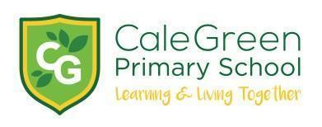
This is what we hope to do this year to keep our school happy and successful.
School will be helping you to become better, more fluent readers. YOU can help by reading more at home. We want all children to enjoy reading and so will buy new books and take part in lots of reading challenges, the Stockport Children’s Book Awards and our reading Bingo.
School will be continuing to ensure that every child has access to a wide range of sports. We will offer as many different sports clubs for children to enjoy and give lots of children the opportunity to represent school in a sporting activity.
School will be helping you to get better at spellings so that you can spell words correctly for your age group.
School have been developing an exciting curriculum – all the facts and skills we learn in school. We will be helping all children to be good at problem solving in Maths, making sure everyone understands online safety, carrying out practical activities in science, enjoying music and art, and completing many other subjects.
Children’s Plan
Our ideas for the school this year 2023 / 2024
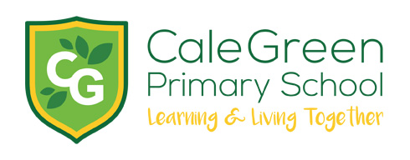
This is what we hope to do this year to keep out school happy and successful.

