13th January 2020

Dear Parents and Carers,

School Linking Network – Year 5

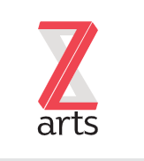

On Tuesday 14th January, Year 5 will be visiting Z-Arts as part of our linking work with Mellor Primary School. We will be taking part in creative workshops and making our own screen prints.

We will leave school at 9.15am and travel by coach, returning to school for home time. There is no charge for this visit. The trip has been risk assessed.

Children who have school dinners will be provided with a school packed lunch. Children will wear full school uniform.

If you have questions about this day please feel free to contact us.

Kind regards,
Mrs C Harding Miss E Brown
Class Teacher Class Teacher

Visit to Z-Arts - Year 5 - Tuesday 14th January 2020

Name of Child:

I give permission for my child to attend the visit to Z-Arts

Medical Conditions:

Emergency Contact details

Signed: Parent / Carer



