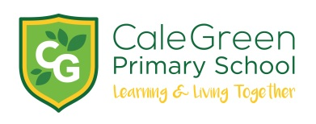
Monday 20th January 2020

Dear Parents / Carers

Careers Related Learning – National Careers Service - Grand Central



The children in Year 6 will be visiting the Careers Service based at Grand Central on Wednesday afternoon – 22nd January.

The service is usually for adults and young people over the age of 13 but they have kindly agreed to talk to our children about the information, advice and resources that will help them make more effective choices about skills, careers, work and life when they are at high school or college.

This activity forms part of our Career Related Learning strategy to help children make links between what they are learning in the classroom and the future world of work they will enter. It really isn’t designed to suggest an occupation but to broaden their horizons and see the endless possibilities which are open to them.

This visit also links in with the work the children have completed with Manchester Metropolitan University, the Stockport Academy Careers Fair and further activities later on in the year.

Please do not hesitate to contact us if you have any questions.

Yours sincerely

D.Marshall N. Lewis
Headteacher Class teacher

Name of Child: Class:

I give permission for my child to attend the careers Service at Grand Central on Wednesday 22nd January.

Medical Conditions:

Emergency Contact details

Signed: Parent / Carer



