
Wednesday 6th March 2019

Dear Parents and Carers
Imperial War Museum - Monday 11th March - BBC Philharmonic Concert
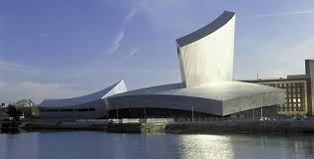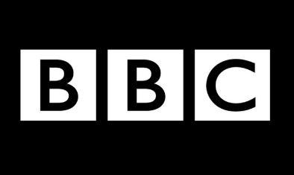
On Monday 11th of March Year 5 will be visiting the Imperial War Museum in Salford and have also been invited to go to the BBC at Media City to watch a performance by the prestigious BBC Philharmonic Orchestra!

To take advantage of this offer, but keep costs to a minimum, we shall be travelling by train from Stockport to Manchester Piccadilly and then travelling by tram to Media City. The cost per child is £3.30.

If your child usually has a school dinner, they will be provided with a school packed lunch unless you indicate otherwise.

We should arrive back at school by approximately 3.40pm.

Payment can be made by Parent Pay or by sending in cash. All money must be paid by Friday 8th March.
Kind regards,
Mrs Carole Harding
Visit to Imperial War Museum and the BBC Media City – Monday 11th March 2019

Name of Child:

I give permission for my child to take part in this visit.

My child will have a school packed lunch / my child will bring their own packed lunch

Emergency Contact Numbers:

Medical Conditions:

Signed: Parent / Carer

