Friday 3rd May, 2019
Dear Parents and Carers,

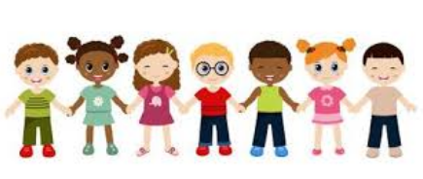

Special Educational Needs / Looked After and Previously Looked After Children / Young Carers

My name is Carole Harding and I am the school’s SENDCo, which means that I have responsibility for children who have special educational needs or disabilities. In addition to this, I also monitor the progress and regularly check in on the children who are, or have been looked after and children who are young carers.

As part of my role I work with teachers, parents and professionals (such as Speech and Language, Occupational Therapy etc.) and can signpost to agencies of support outside school.

There are opportunities for parents to have ‘drop-in’ meetings with me on Fridays, where you will be able to ask questions about your child, share information confidentially and receive support. It would be helpful, if you want to arrange a meeting, to contact the school office who will be able to add it to my diary and make sure it doesn’t clash with any other appointments.

I look forward to meeting with you.

Mrs. Carole Harding
SENDCo



