Monday 25th February 2019

Dear Parents and Carers,

Northern Chamber Orchestra Concert

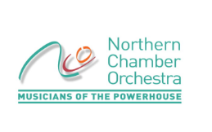
Year 5 has been given an amazing opportunity to be taught by a workshop leader and another musician from the Northern Chamber Orchestra, based on a piece of classical music (which this year is Elgar’s Cello Concerto). The workshop will take place on Wednesday 27th February and will be followed by a performance at Stockport School on Thursday 28th February at 11:10am.

In the 1 hour workshops they will play some musical games as warm ups and sing, listen to sections of the piece (which this year is Elgar’s Cello Concerto) and learn something about the composer and the style. They will then come up with their own responses to the music which we will write down and keep for the next stage of the project- the performance at Stockport School with the professional musicians of the Northern Chamber Orchestra.

Your child will need to bring their guitar in to school on both days. I am sure that they will thoroughly enjoy this experience.

Kind regards,
Mrs. Carole Harding

NCO Concert – Thursday 28th February

Name of Child:

I give permission for my child to attend the concert at Stockport School.

Medical Conditions:

Emergency Contact details

Signed: Parent / Carer



