The Cale Green Journal
Issue 7: February 2025

As February comes to an end, it’s been another super month at Cale Green. Our pupils have continued to excel in their learning across all year groups, showcasing their talents and progress. In English, Key Stage 2 children have been delving into various texts, enhancing their analytical skills and creativity. Key Stage 1 have made remarkable strides in their reading, with many reaching impressive milestones in phonics. (Thanks to those parents who are supporting their children with this at home!) Our children in Early Years have been buzzing with activity as children explore new concepts through play and hands-on activities. Their enthusiasm for learning has been a joy to witness!
We’re excited about our upcoming events in March, including our reading activities across the whole of ‘Whole Book Day’ week. Thank you for your continued support and involvement in our school community. As ever, if you would like further details about anything, please don’t hesitate to email: schooladmin@calegreen.stockport.sch.uk Mrs Sarah McHugh

Dates for your Diary:
Saturday 1st March Start of the month of Ramadan
Monday 3rd March Year 3 / 4 group to Waterstones
Parents Mastering Number workshop – Reception 2pm
Tuesday 4th March ECO Debate - Stockport Town Hall
Wednesday 5th March Year 5 / 6 group to Waterstones
NK Theatre Drama activities -
Early Years and Key Stage 1
Thursday 6th March World Book Day activities
Friday 7th March Chestnut assembly – 9.15am
Thursday 13th March Y5 Science event – Stockport Academy
Girls Under 11s Football Festival
Saturday 15th March Cross County – Woodbank Park
Monday 17th March Year 6 Parents SATs meeting – 3.30pm
Tuesday 18th March Year 3 Sports event – Bridgehall PS
KS2 Choir – Stockport Town Hall 6.30
Friday 21st March KS2 Choir – Stockport Academy 6pm
Friday 28th March Pre-Loved Uniform Sale
Sunday 30th March End of Ramadan (possible date)
Monday 31st March Eid-ul-Fitr (possible date)
Tuesday 2nd April Reception Jodrell Bank visit
Friday 4th April Maple Class assembly

Cross-Country Races at Woodbank
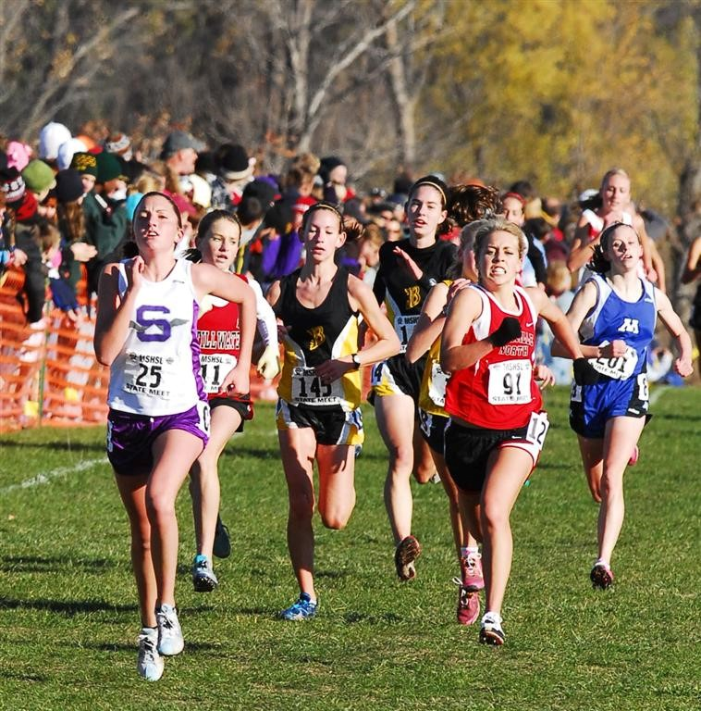
All Children in Key Stage 2 are invited to run in the cross-country sessions that are held almost every month from September to March at Woodbank Park. Well done to everybody who ran in the January race (Make sure you give enough time to park if travelling by car as the car parks can become very busy!) Please note the change of date for the March race.
Match 6 Saturday 15th March 2025 10am – 12pm
Presentation Day 22nd March 2025

End of Theme 3 Class Visits

Advance notice of the end of theme 3 parent and carers’ class visits. These will take place in your child’s classrooms.
Early Years Monday 7th April 2.40pm – 3.10pm
Key Stage 1 Tuesday 8th April 8.50am – 9.20am
Lower Key Stage 2 Wednesday 9th April 8.50am – 9.20am
Upper Key stage 2 Thursday 10th April 8.50am – 9.20am
Nursery Friday 11th April 2.40pm – 3.10pm

Nursery Admissions
Nursery places close on 31st March 2025.

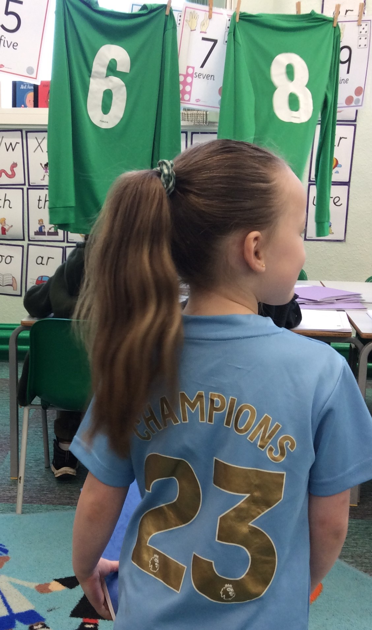
PE and Swimming Days 
We will always try to keep the same PE kit days for at least half a term but there will always be odd changes to the timetable that are late notice and / or unavoidable but we will always try to alert families via email about these. The School website has the most up to date information for the half term.

Reception: Beech and Birch – Wednesday

Key Stage 1: Cedar, Cherry and Chestnut - Tuesday and Friday

Lower Key Stage 2:

Hazel, Holly and Hawthorn - Monday / Holly – Tuesday

Hawthorn and Hazel - swimming Tuesday

Upper Key Stage 2:

Mulberry, Magnolia and Maple - Monday and Tuesday

NSPCC Maths Day

Everyone enjoyed our Number Day recently and managed to raise a super £220 for the NSPCC.
This year, our school is placing a strong emphasis on developing everyone’s maths skills so this was another fun way of focusing on all things number. The children enjoyed dressing up as a digit and we all had a super (and slightly chaotic!) game of bingo!

Acorn Fund

A reminder that we have lots of friends and families of Cale Green who have very kindly donated sums of money to our Acorn Fund. If your family needs some financial support please do contact school.

Cale Green Emerald Award!

A couple of years ago, the School Council noticed that lots of Year 5 (and even Year 4) children were achieving the Gold Award on the Cale Green Star Chart and then had to start again! They decided to create an Emerald Award that children could work towards beyond the Gold!
To achieve the Emerald Award, children have to gain a further 25 stars after the Gold Award. I’m pleased to announce that Rio H and Zahra HZ are the first pupils this year to be awarded the Emerald Award. They received their Emerald Award pins during Friday assemblies in February but will have to wait until the end of the summer term to get their prize which is yet to be decided!
Congratulations to Rio and Zahra, worthy winners and great Cale Green role models for the rest of the school!

Gold Awards

Well done to Ruckaya, Alfie R, Aqib and Inaaya who gained their 50 Stars and gained their Gold Award. They all chose a book prize and were awarded it during a Family Assembly in February. Well done everyone!

The Cale Green Challenge

Well done to everybody who was awarded a Cale Green Challenge badge on the last Friday in February. Jesse received his Challenge 1 badge. Willow B, Amelia-Rae, Dylan G, Myles, Jesse, Harley and William also achieved their Challenge 2 badges and Jesse F and Nile achieved their Challenge 3 badge. Well done gang!
Who is going to receive theirs next month?

Extra-Curricular After-School Clubs
Throughout the year, our staff very kindly offer to run or support sports coaches in after-school clubs. There is never a charge for these clubs so hopefully everybody is able to attend something over the course of the year.
This year we have had art club, a cross-country club, an ECO club, a Year 5 / 6 football club and a Year 3 / 4 football club with coaches from Life Leisure. We also had a cricket club in the autumn term with coaches from Stockport Cricket Club, have a Key Stage 1 choir and a Key Stage 2 choir. Our drama club has just started and they have begun preparing to perform Shakespeare’s ‘The Tempest’ at the Lowry theatre, Salford. We have also just started a girls’ football club ran by Stockport County.
In the summer term, Reception children will get the chance to take part in an outdoor games club, whilst our Year 1 / 2 children can start their football training with Life Leisure. Year 5 / 6 will also get the chance to do some additional football training with Stockport County coaches. There’ll also be some more cricket training, as well as tennis!
Phew! I think you’ll agree, this is a great offer for the children at Cale Green. THANK YOU TO ALL THE STAFF WHO SUPPORT THESE CLUBS!

School Uniform and Pre-Loved Uniform Sale

Families are able to buy uniform from Davensport which is on Bramhall Lane. They stock uniform which has the school’s logo on. You are able to go into the shop and check the sizes before buying.
A reminder that the next Pre-loved Uniform sale will be on Friday 28th March at before and after school. We have lots of uniform, shoes, coats and bags for sale. All items are 50p.
WE ARE GOING TO SET THE STALL UP IN
THE MAIN ENTRANCE THIS TIME.

