The Cale Green Journal
Issue 8: March 2025

As March draws to a close, we want to take a moment to celebrate all the fun we've had! World Book Day was super and we got to celebrate so many great authors and books. Red Nose Day brought lots of laughter as we raised funds for a fantastic cause—thank you for your support!
We're also thrilled to see our children making great strides in their learning. Their enthusiasm is truly inspiring! Plus, let's not forget our talented athletes who have proudly represented Cale Green in various sporting events. Well done to everyone!
Encourage your child to share their experiences at home; it's a wonderful way to reflect on their achievements.
Thank you for being such a fantastic community. We look forward to more adventures and fun in April! As ever, if you would like further details about anything, please don’t hesitate to email: schooladmin@calegreen.stockport.sch.uk Mrs Sarah McHugh

Dates for your Diary:
Wednesday 2nd April Reception Jodrell Bank visit
Year 5 Music Festival -
Cheadle Hulme School
Thursday 3rd April Science workshop (Mulberry) CHS
KS2 choir – recording event
Friday 4th April Maple Class assembly
Monday 7th April Early Years parent class visits 2.40pm
Tuesday 8th April KS1 parent class visits 8.50am
Wednesday 9th April Lower KS2 parent class visits 8.50am
Parent Consultations in-person 1.30pm
Parent Consultations online 4pm
Thursday 10th April Upper KS2 parent class visits 8.50am
Nursery parent class visits 8.50am
Parent Consultations online 10am
Friday 11th April Easter Assembly and Raffle 9.15am
End of Spring 2 term
Monday 28th April Start of Summer 1 term


Cricket at Aquinas

On Wednesday 12th March, a team of nine children from Cale Green Primary School, took part in a Cricket Festival at Aquinas College. There were 4 other schools taking part in the event. First, the children took part in a range of fun activities which developed their cricket skills such as bowling, fielding and batting. Following this they were split into teams with the children from other schools and played a couple of games of cricket. The event ended with a challenge activity, to hit all the targets within three minutes. The children thoroughly enjoyed the event and showed great sportsmanship and respect for the children from other schools.

End of Theme 3 Class Visits

Parent are invited into their child’s class at the end of theme 3. These will take place in your child’s classrooms.
Early Years Monday 7th April 2.40pm – 3.10pm
Key Stage 1 Tuesday 8th April 8.50am – 9.20am
Lower Key Stage 2 Wednesday 9th April 8.50am – 9.20am
Upper Key stage 2 Thursday 10th April 8.50am – 9.20am
Nursery Thursday 10th April 8.50am – 9.20am


Healthy Food Reminders…
Plain water only in water bottles.
Healthy snacks at breaktime.
We are a nut free school – so nothing containing nuts.

PE and Swimming Days 
We will always try to keep the same PE kit days for at least half a term but there will always be odd changes to the timetable that are late notice and / or unavoidable but we will always try to alert families via email about these. The School website has the most up to date information for the half term.

Reception: Beech and Birch – Wednesday

Key Stage 1: Cedar, Cherry and Chestnut - Tuesday and Friday

Lower Key Stage 2:

Hazel, Holly and Hawthorn - Monday / Holly – Tuesday

Hawthorn and Hazel - swimming Tuesday

Upper Key Stage 2:

Mulberry, Magnolia and Maple - Monday and Tuesday

Our Key Stage 2 Choir on tour…

Our Key Stage 2 choir performed beautifully at Stockport Town Hall with 4 other primary schools, singing 3 songs on their own and one with all the other choirs. They sounded amazing and really filled the town hall with their beautiful singing voices.
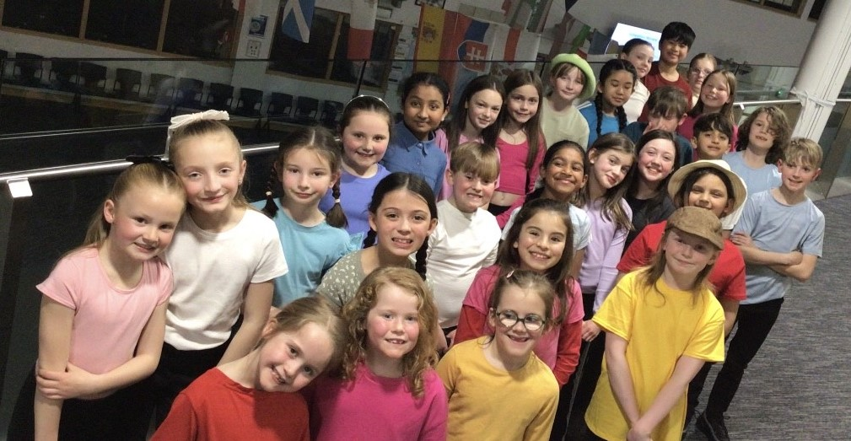
In the same week, our KS2 choir also performed along with 3 other primary schools and the Stockport Youth Orchestra. They sung some songs written specifically for them and composed by the orchestra’s amazing conductor.
As ever, they performed brilliantly at Stockport Academy. A great big thank you to Mrs Lewis, Mrs Buckley and Miss Latimer for leading the choir.

ECO Debate
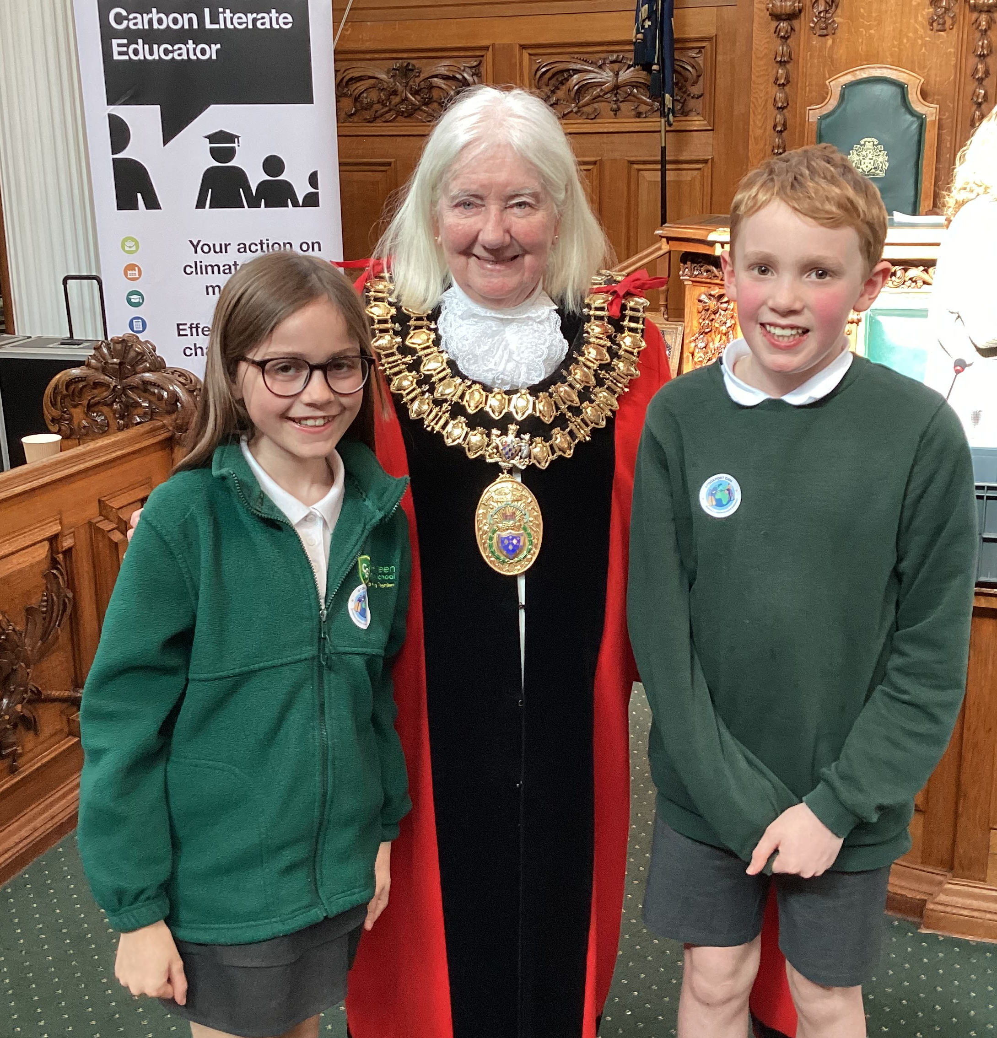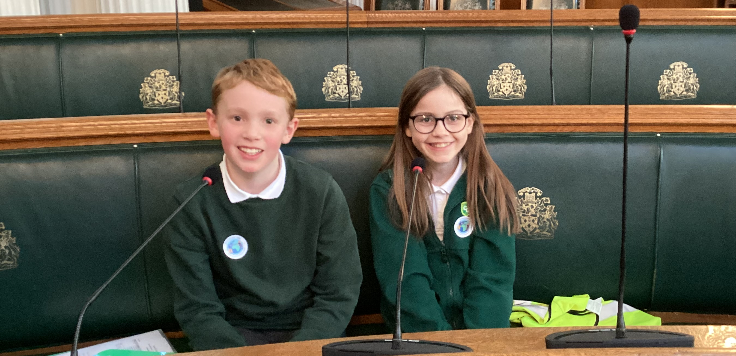
Over the past few months, Cale Green Eco Club have been working hard to accumulate ideas to help the environment around Stockport. One idea which inspired us was to promote composting more in schools. Our Eco club saw this as a simple yet effective solution we could get on board with as a school. We submitted these ideas to Climate Action Now who facilitated a real debate at Stockport's very own town hall. Our Eco-Club were invited to present their ideas to over 20 schools as well as the Mayor, which they spent weeks researching and refining. They proudly represented our school and have worked incredibly hard to make a change to the environment.

Trips to Waterstones Book Shop
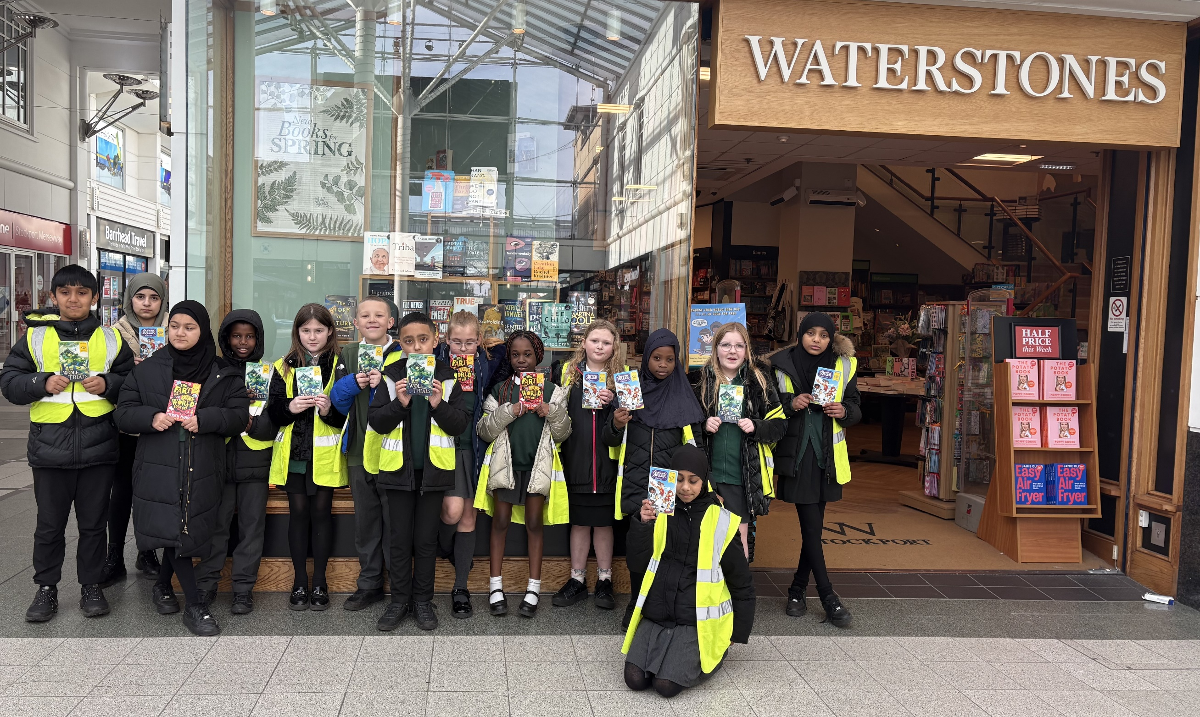
Two groups of children from across Key Stage 2 visited Waterstones bookshop in Stockport during the week of world Book Day. They ‘spent’ their World Book Day vouchers and chose some books for our library.
We’ve also topped up both our phonics book scheme and our reading scheme. Please encourage your children to read at home every evening.

Gold Awards

Well done to Summer, Freddie H, Lewis R and Anaya who gained their 50 Stars and gained their Gold Award. They all chose a book prize and were awarded it during a Family Assembly in March. Well done everyone!

The Cale Green Challenge

Well done to everybody who was awarded a Cale Green Challenge badge on the last Friday in March. Andy received his Challenge 1 badge and Jasper achieved his Challenge 5 badge which means he has completed the Cale Green Challenge. Well done to both of you! Who is going to receive theirs next month?

World Book Day
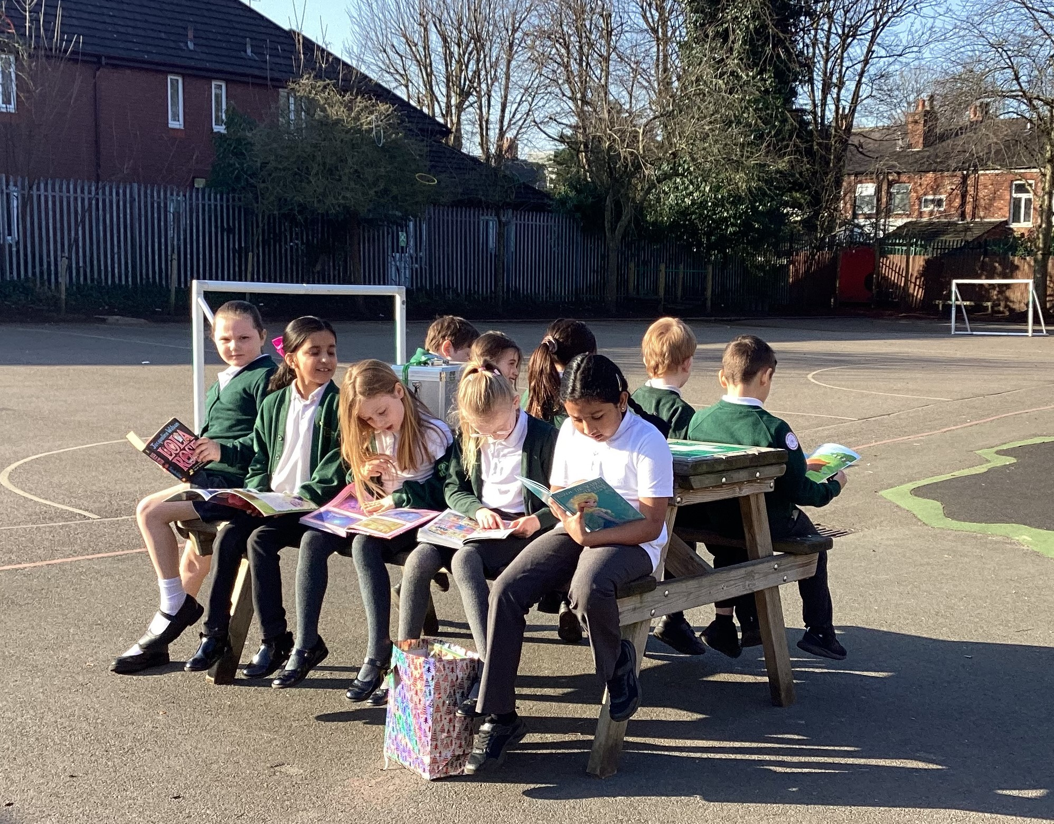
It was a delight to see the school buzzing with reading activities throughout World Book Day. Year 6 embraced reading with younger children during Breakfast club, we had a big ‘Book Swap’ and children in Early Years and Key Stage 1 enjoyed meeting the book characters from NK Theatre Arts. Don’t forget to use your child’s World Book Day voucher which can be redeemed in book shops and lots of supermarkets!

School Uniform and Pre-Loved Uniform Sale

Families are able to buy uniform from Davensport which is on Bramhall Lane. They stock uniform which has the school’s logo on. You are able to go into the shop and check the sizes before buying.
A reminder that the next Pre-loved Uniform sale will be on Friday 11th April before and after school. We have lots of uniform, shoes, coats and bags for sale. All items are 50p. WE ARE GOING TO SET THE STALL UP IN THE MAIN ENTRANCE AGAIN.

Red Nose Day
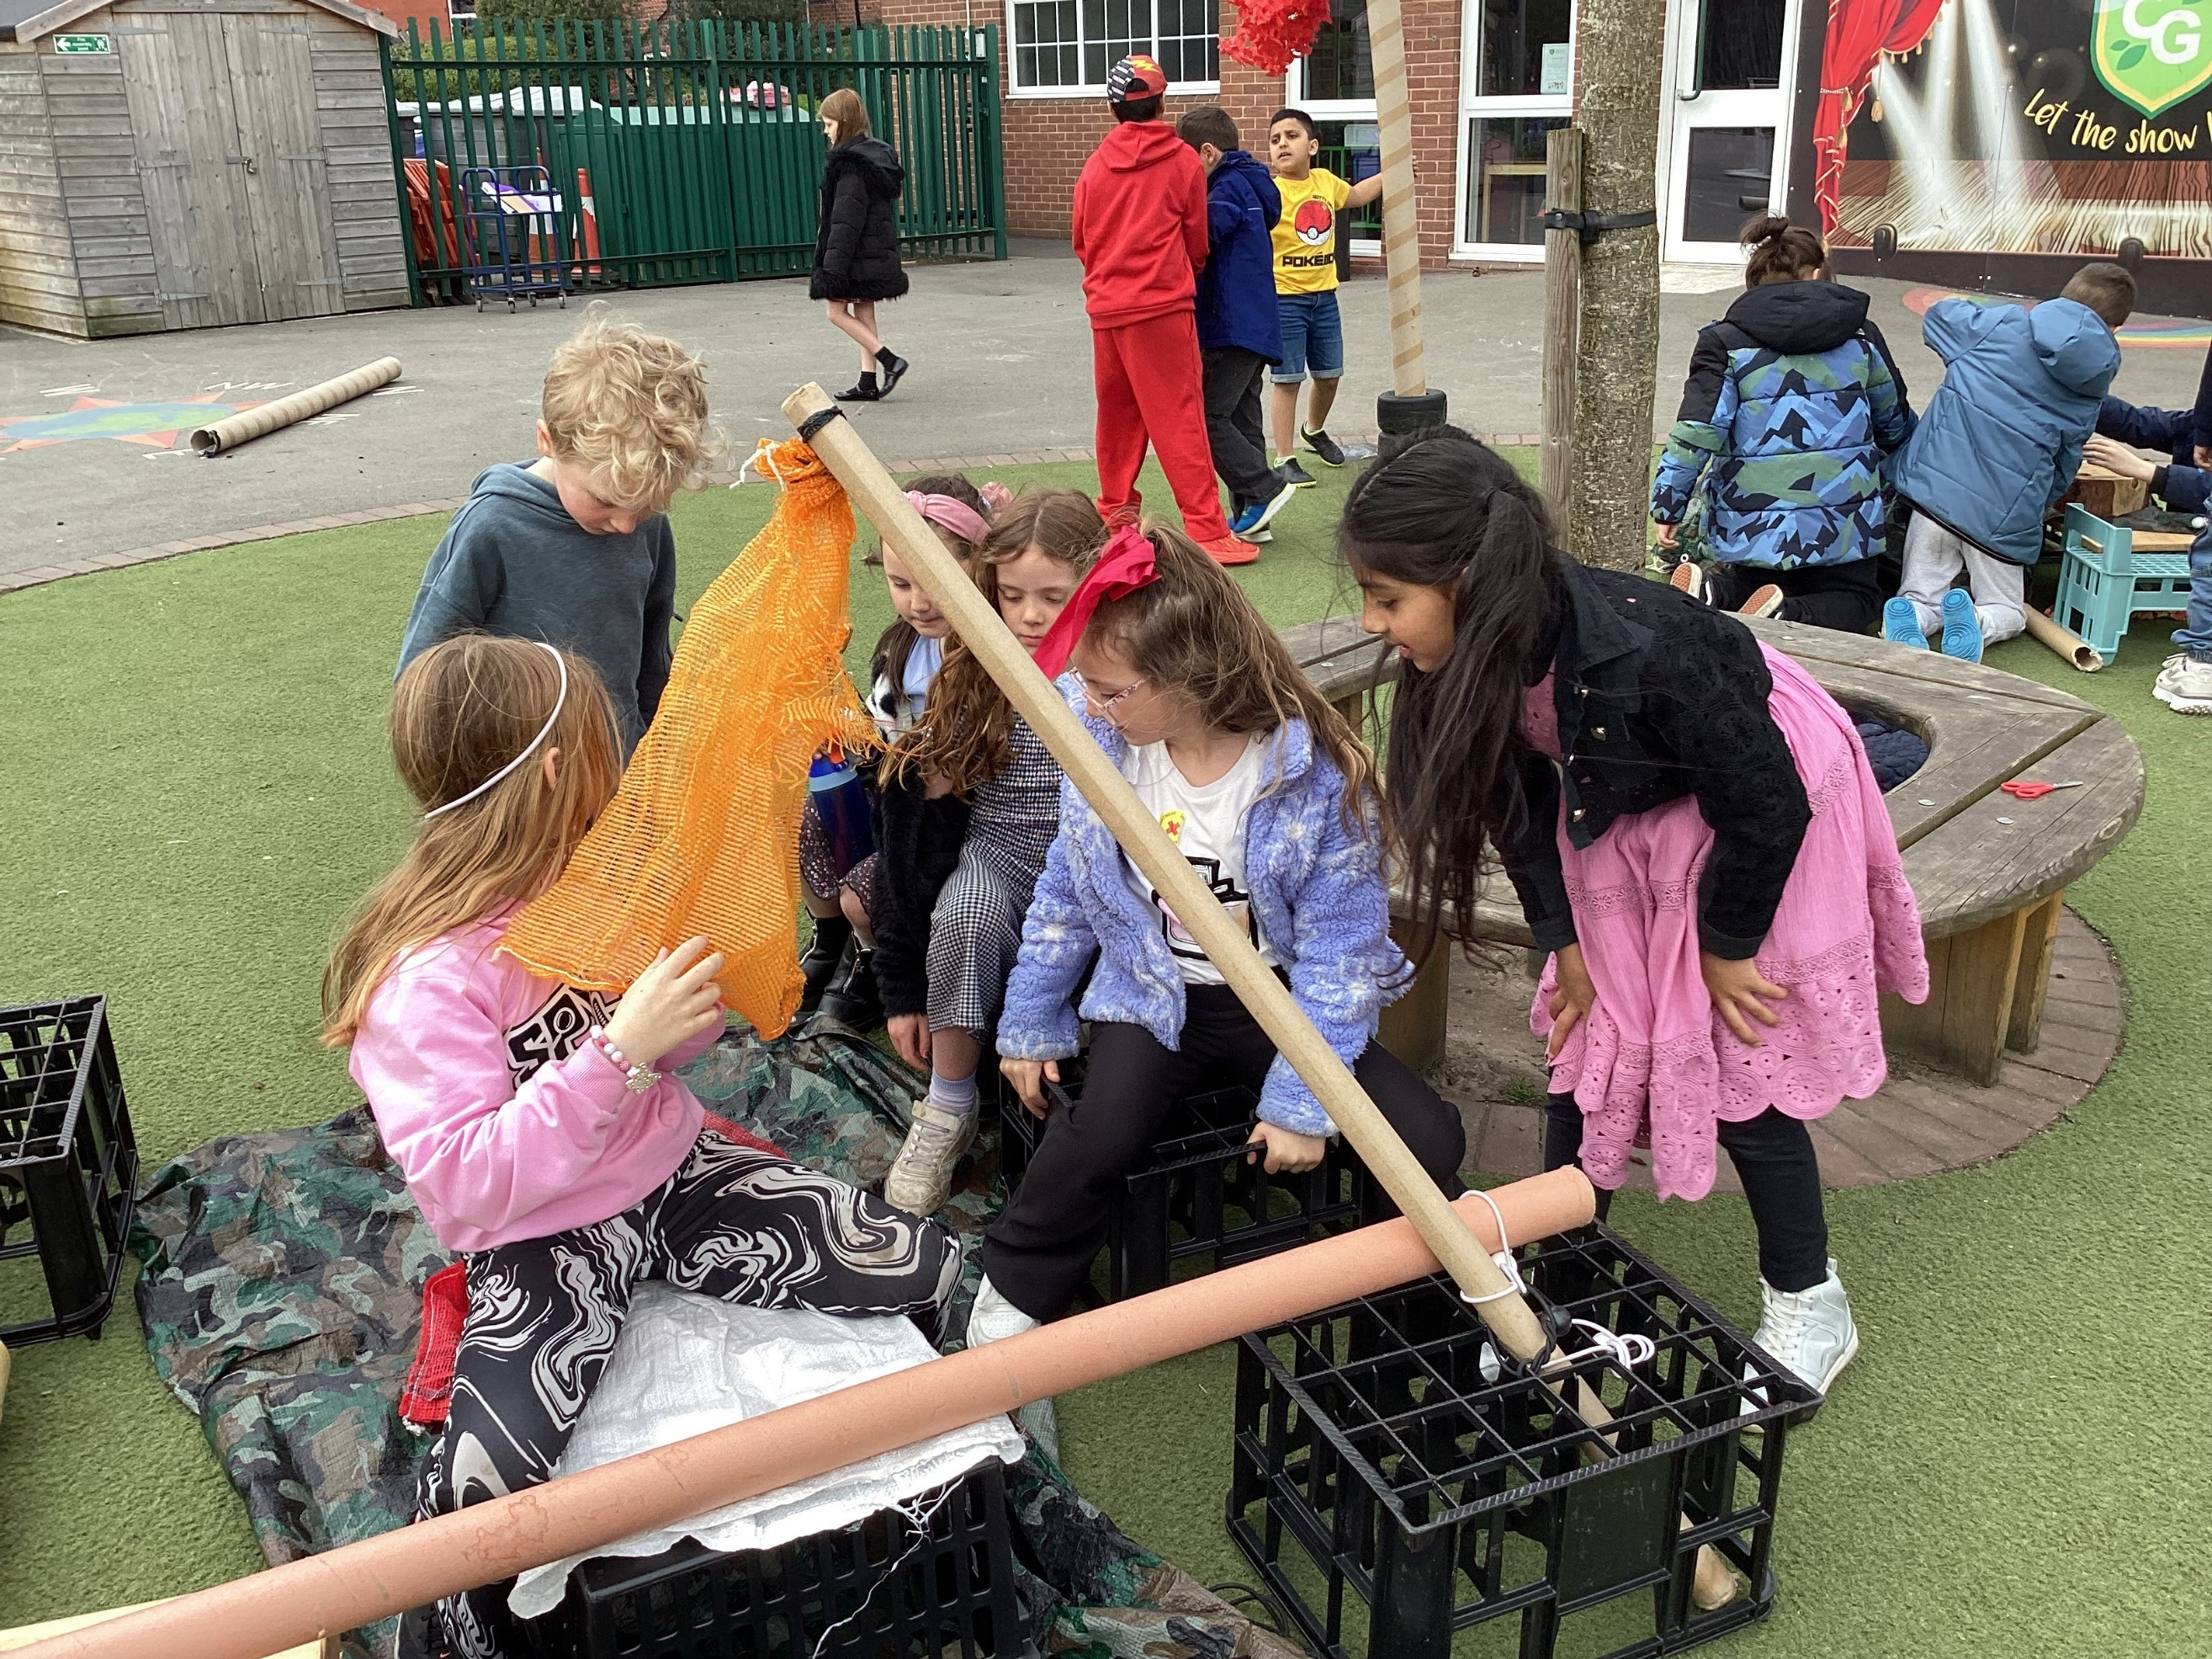
Our School Council organised a super Red Nose Day on Friday 21st March enjoying lots of fun (and cakes) in the spring sunshine. A great big thank you to everyone, we were able to raise an amazing £553 for the Comic Relief Charity!

Mastery in Maths – Reception Parents Workshop
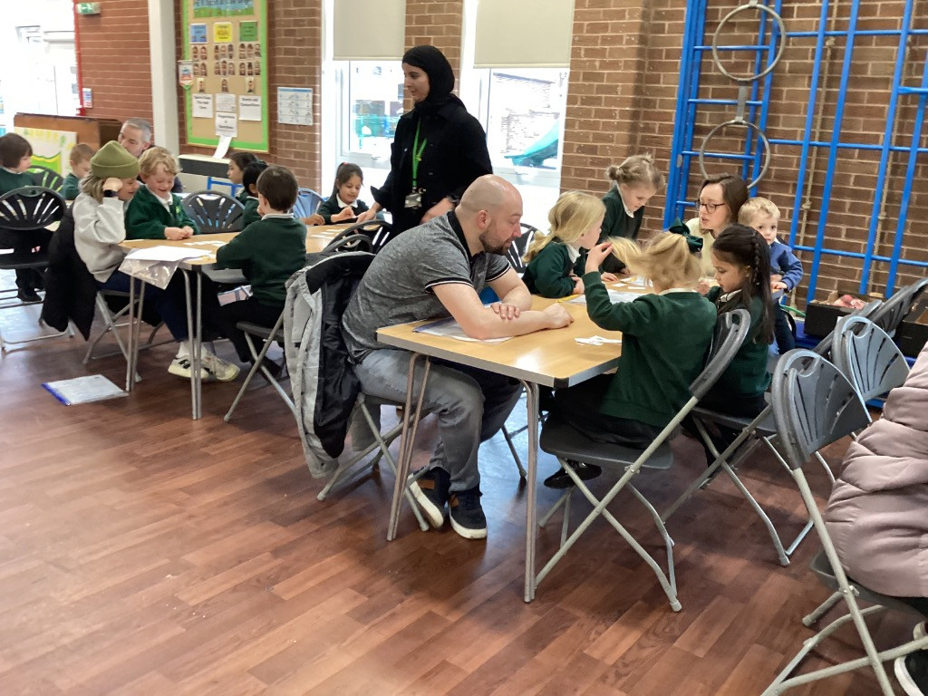
Thanks to all the families in Reception who came into school to take part in a Maths Workshop and who left with a pack of activities and games to play at home.

Under 11s Girls Football Tournament

Cale Green's superstar girls were invited to a tournament at Power League Stockport. The girls played several matches against various local schools showing off their skills and working in a variety of positions on the pitch. Teamwork, resilience and fun was seen on and off the pitch.
They represented the school tremendously well, being supportive of each other as well as the other teams competing. Well done girls!

Year 1 Football Festival
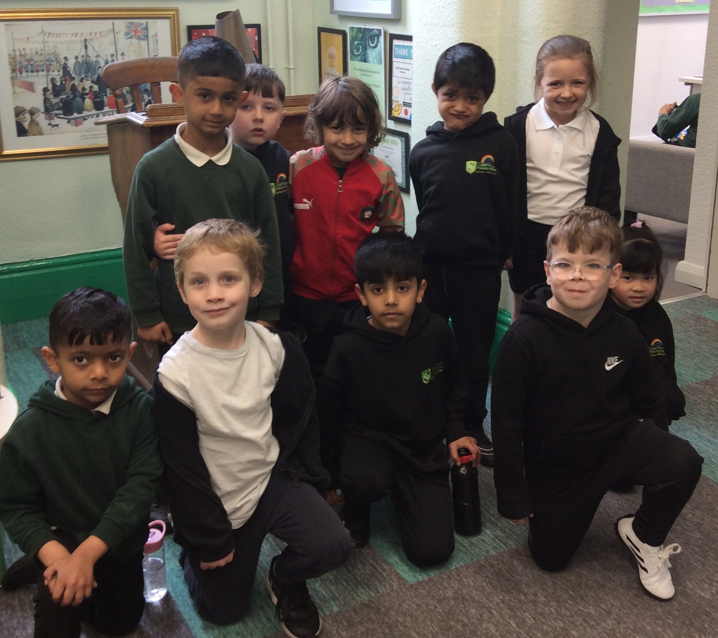
This week, ten children from Year 1 represented Cale Green at a festival of football at Cheadle Hulme School. What a great time was had by all. We had goals, man of the match (more than once) and to quote one child "It was the best day, ever!". The children took part in lots of five-aside games and played with enthusiasm and competitiveness. Thanks to CHS for organising.

