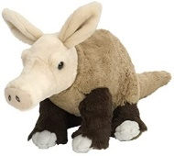
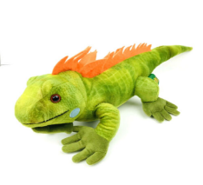
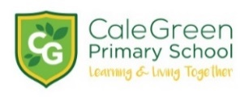Cale Green EYFS Curriculum Goals

To become a  Confident Communicator  who listens carefully in different situations and holds a conversation with friends and adults. They can tell a short story, ask relevant questions and use new vocabulary to explain ideas and feelings. | To become an  Independent Individual  who follows the Cale Green Code; aspiring, persevering and showing resilience in achieving their goals. They select resources, manage their own personal needs and know how to be fit and healthy. | To become a  Fantastic Friend  who is kind, caring and helpful, shows empathy and respect to others, works and plays co-operatively and considers the ideas and feelings of others. | To become an  Amazing Athlete  who shows strength, balance and co-ordination when playing on a large and small scale and moves confidently and safely in a variety of different ways, using a range of equipment.
To become a  Talented Tool User  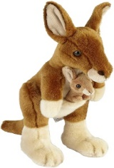  who holds a pencil effectively for writing and drawing and uses a range of tools for different purposes (for example scissors, cutlery and paintbrushes) safely and with confidence. | To become a  Brilliant Bookworm  who shows enthusiasm for reading fiction and non-fiction, and uses new vocabulary to talk about what they have read or has been read to them. They read words and simple sentences using single phonemes, digraphs and trigraphs and some simple common exception words they have learned. | To become a  Wow Writer  who correctly and independently forms letters learned alongside phonemes, digraphs and trigraphs in daily lessons. They write words and sentences which can be read by them and others, for different purposes and in different contexts. | To become a  Master of Maths  who shows a deep understanding of numbers to 10, recognises patterns within the number system, subitises, compares quantities and recalls number bonds to 5.  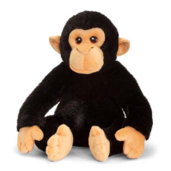
To become an  Exceptional Explorer  who shows curiosity about the world around them, understands how to read and draw a simple map and understands some similarities and differences between times, people and places. | To become a  Compassionate Citizen  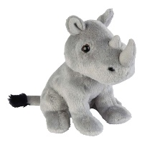  who cares for their community and the environment, knows some features of the local area and has an awareness and respect for people’s different cultures and beliefs. | To become a  Proud Performer  who performs songs, poems and dances to an audience, tells stories with expression and confidence and plays some percussion instruments correctly and with good rhythm. | To become a  Dynamic Designer  who chooses and safely uses the resources and techniques they need to make their creations, talking about what they have made, the purpose and how they have made it.

