

Monday 13th November 2023

Dear Parents / Carers,

Sports hall Athletics

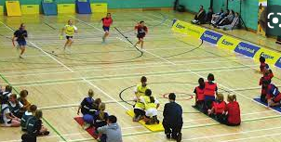

Your child has been chosen to represent school at a Sports hall Athletics event which has been organised by Stockport SHAPES Alliance.

The event takes place on Monday 20th November at Aquinas College between 9:30am and 11:30am. The children will be walking to Aquinas College on a route which has been risk assessed with Miss Falconer, Mrs Shipperlee and Mrs Beecham, who is first aid trained.

The children may wear their PE kits for the whole day on Monday. They may bring a bottle of water and a small, healthy snack with them for the visit.

If you have any queries please do not hesitate to contact school: schooladmin@calegreen.stockport.sch.uk

Yours sincerely,

Ms S Ingham

PE Subject Leader

