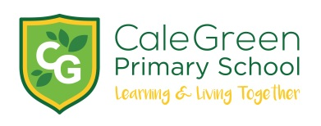

Friday 22nd September 2023

Dear Parents / Carers,

Harvest Festival

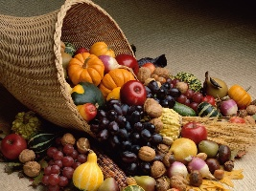

On Friday 29th September, we will be joined by the Bible Encounter Trust who will lead our Harvest celebrations. We will be collecting Harvest gifts on Thursday and Friday morning. If you could send your child in with a can or packet, as a gift we would very much appreciate it.

If you have an elderly neighbour or member of the family who would welcome a Harvest gift please email school: Schooladmin@calegreen.stockport.sch.uk The remainder of the gifts will be taken to the Chelwood Food Bank.

All families are welcome to join this Friday Family Assembly (as usual) either in person or virtually, using the same google meet code: meet.google.com/nzu-mdcc-dcz

Macmillan Coffee Morning and Cake Sale
And Pre-Loved School Uniform Sale

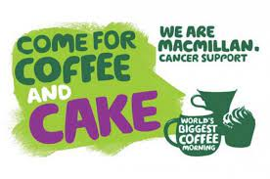

We will also be taking part in ‘The World's Biggest Coffee Morning,’ to raise money for Macmillan Cancer Support on Friday 29th September.

We would like invite you, along with your friends and family, to join us in the hall, after Family Assembly, for coffee, cake and a chat! We will also be having our Pre-Loved (freshly laundered) school uniform sale.

This fundraising event will be the ideal opportunity to get together at the start of the new school year, whilst raising money for an important cause.

We would very much welcome any donations of cakes and biscuits for the coffee morning. We respectfully ask that if cakes or cookies contain nuts that they are labelled clearly. Also, any "free from" cakes that are suitable for allergy sufferers are most welcome, so everyone can enjoy a treat.

In the morning, the children in Key Stage 1 and Key Stage 2 will be able to buy cakes from a cake sale. Children in Early Years will have their own cake sale in the Early Years’ building. Cakes will be priced at 30p per item.

Any remaining cakes will be sold at the end of the school day
in the playground, along with our pre-loved school uniform.

We hope that you will join us in supporting this worthy cause and in doing so, help us to raise as much money as possible for Macmillan. Last year, coffee mornings across the UK raised more than £27 million, and we are hoping to help contribute to raising even more this year!

Thank you for your continuing support,

Mrs McHugh, Mrs Pijoan

