The Cale Green Journal
Issue 5: December 2024

December has been a whirlwind of festive cheer, with nativities, Christmas activities, and countless learning opportunities filling our days! A heartfelt thank you to all the children, parents, and staff for your amazing support and enthusiasm throughout this busy month. Your efforts have truly made this time special and memorable.
As we approach the holiday break, I wish everyone a peaceful and restful time with loved ones. May the new year bring joy, new adventures, and continued success for our school community. Happy New Year to all!
As ever, if you would like further details about anything, please don’t hesitate to email: schooladmin@calegreen.stockport.sch.uk

Dates for your Diary:
Monday 6th January Start of Spring term
Wednesday 8th January Early Years Open Day (see below)
Monday 13th January Year 3 / 4 After School Football club
Friday 17th January Hawthorn Class Assembly
Saturday 18th January Cross-Country (Woodbank Park)
Friday 24th January Rearranged Art Gallery Visit
Monday 27th January Chill Factore event (15 Year 5 / 6)
Bikeability sessions
Friday 31st January Cedar Class Assembly

Early Years Nativity- A Special Delivery at Christmas
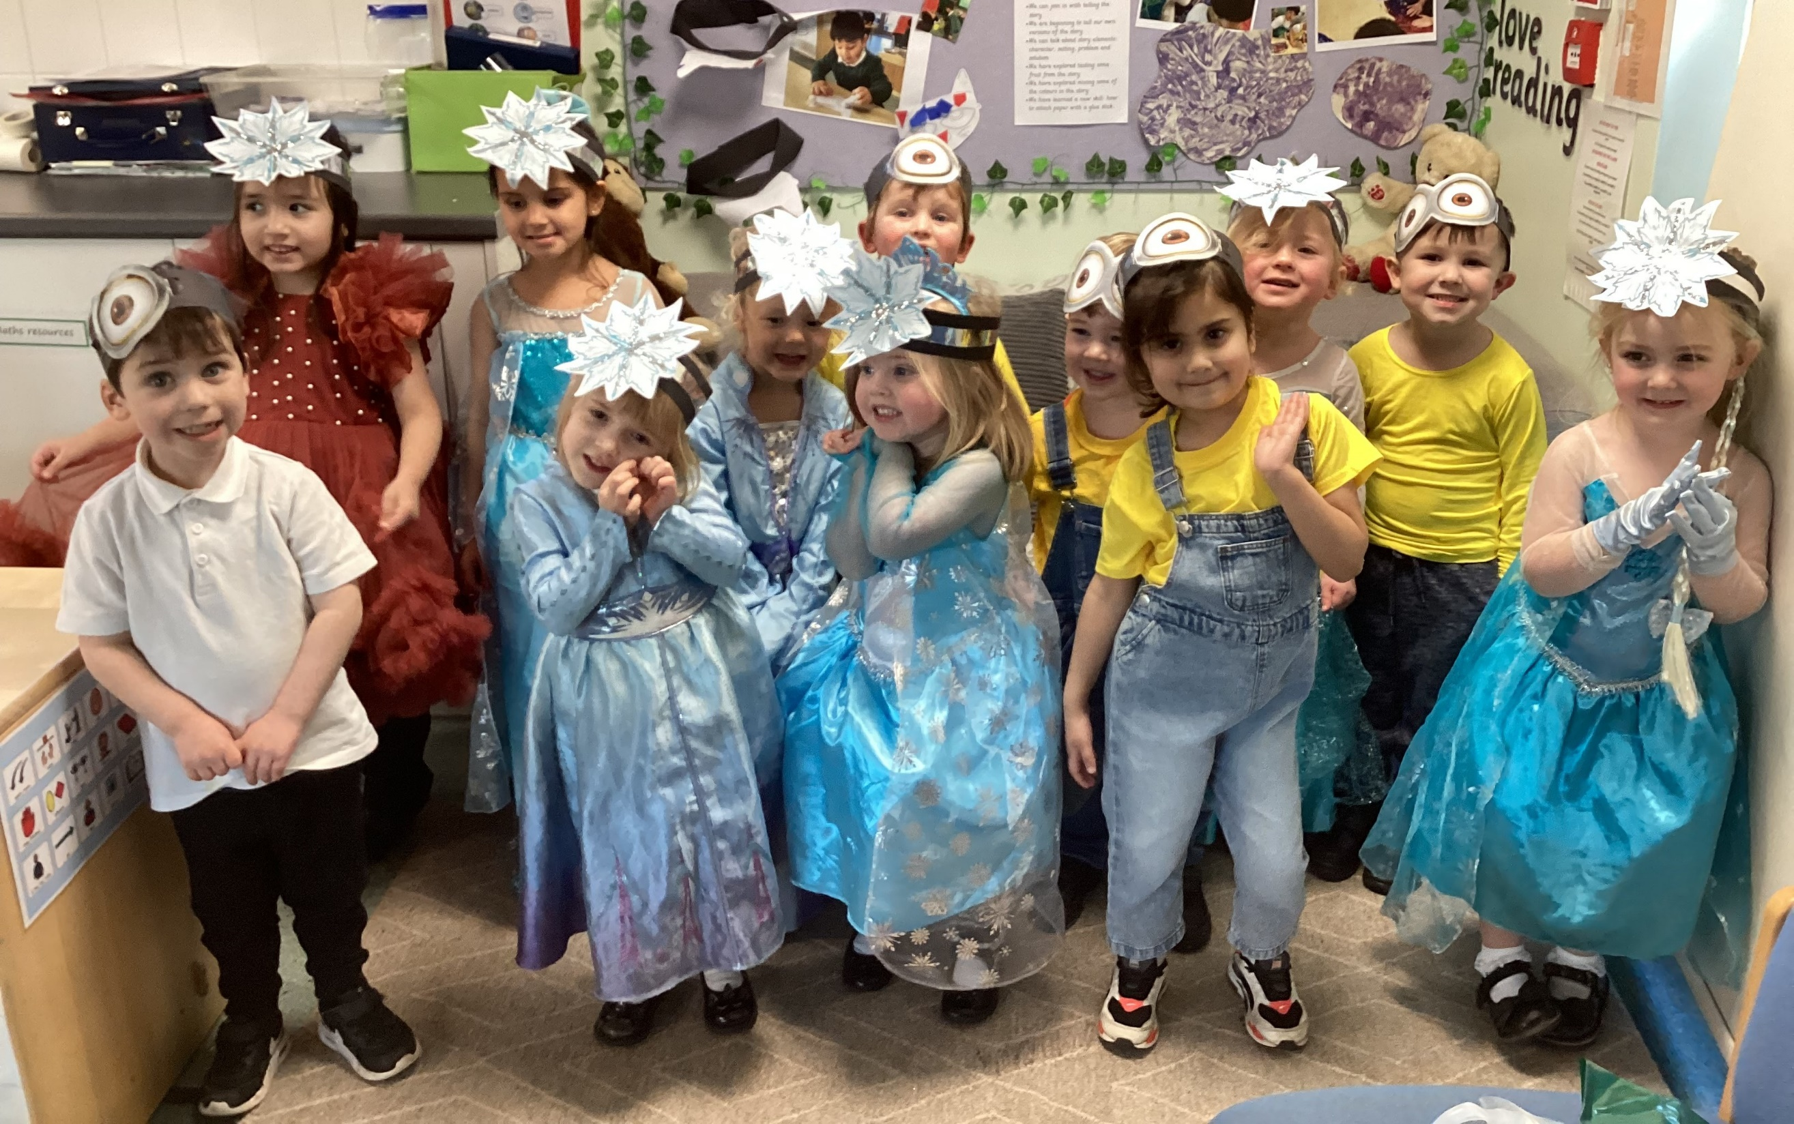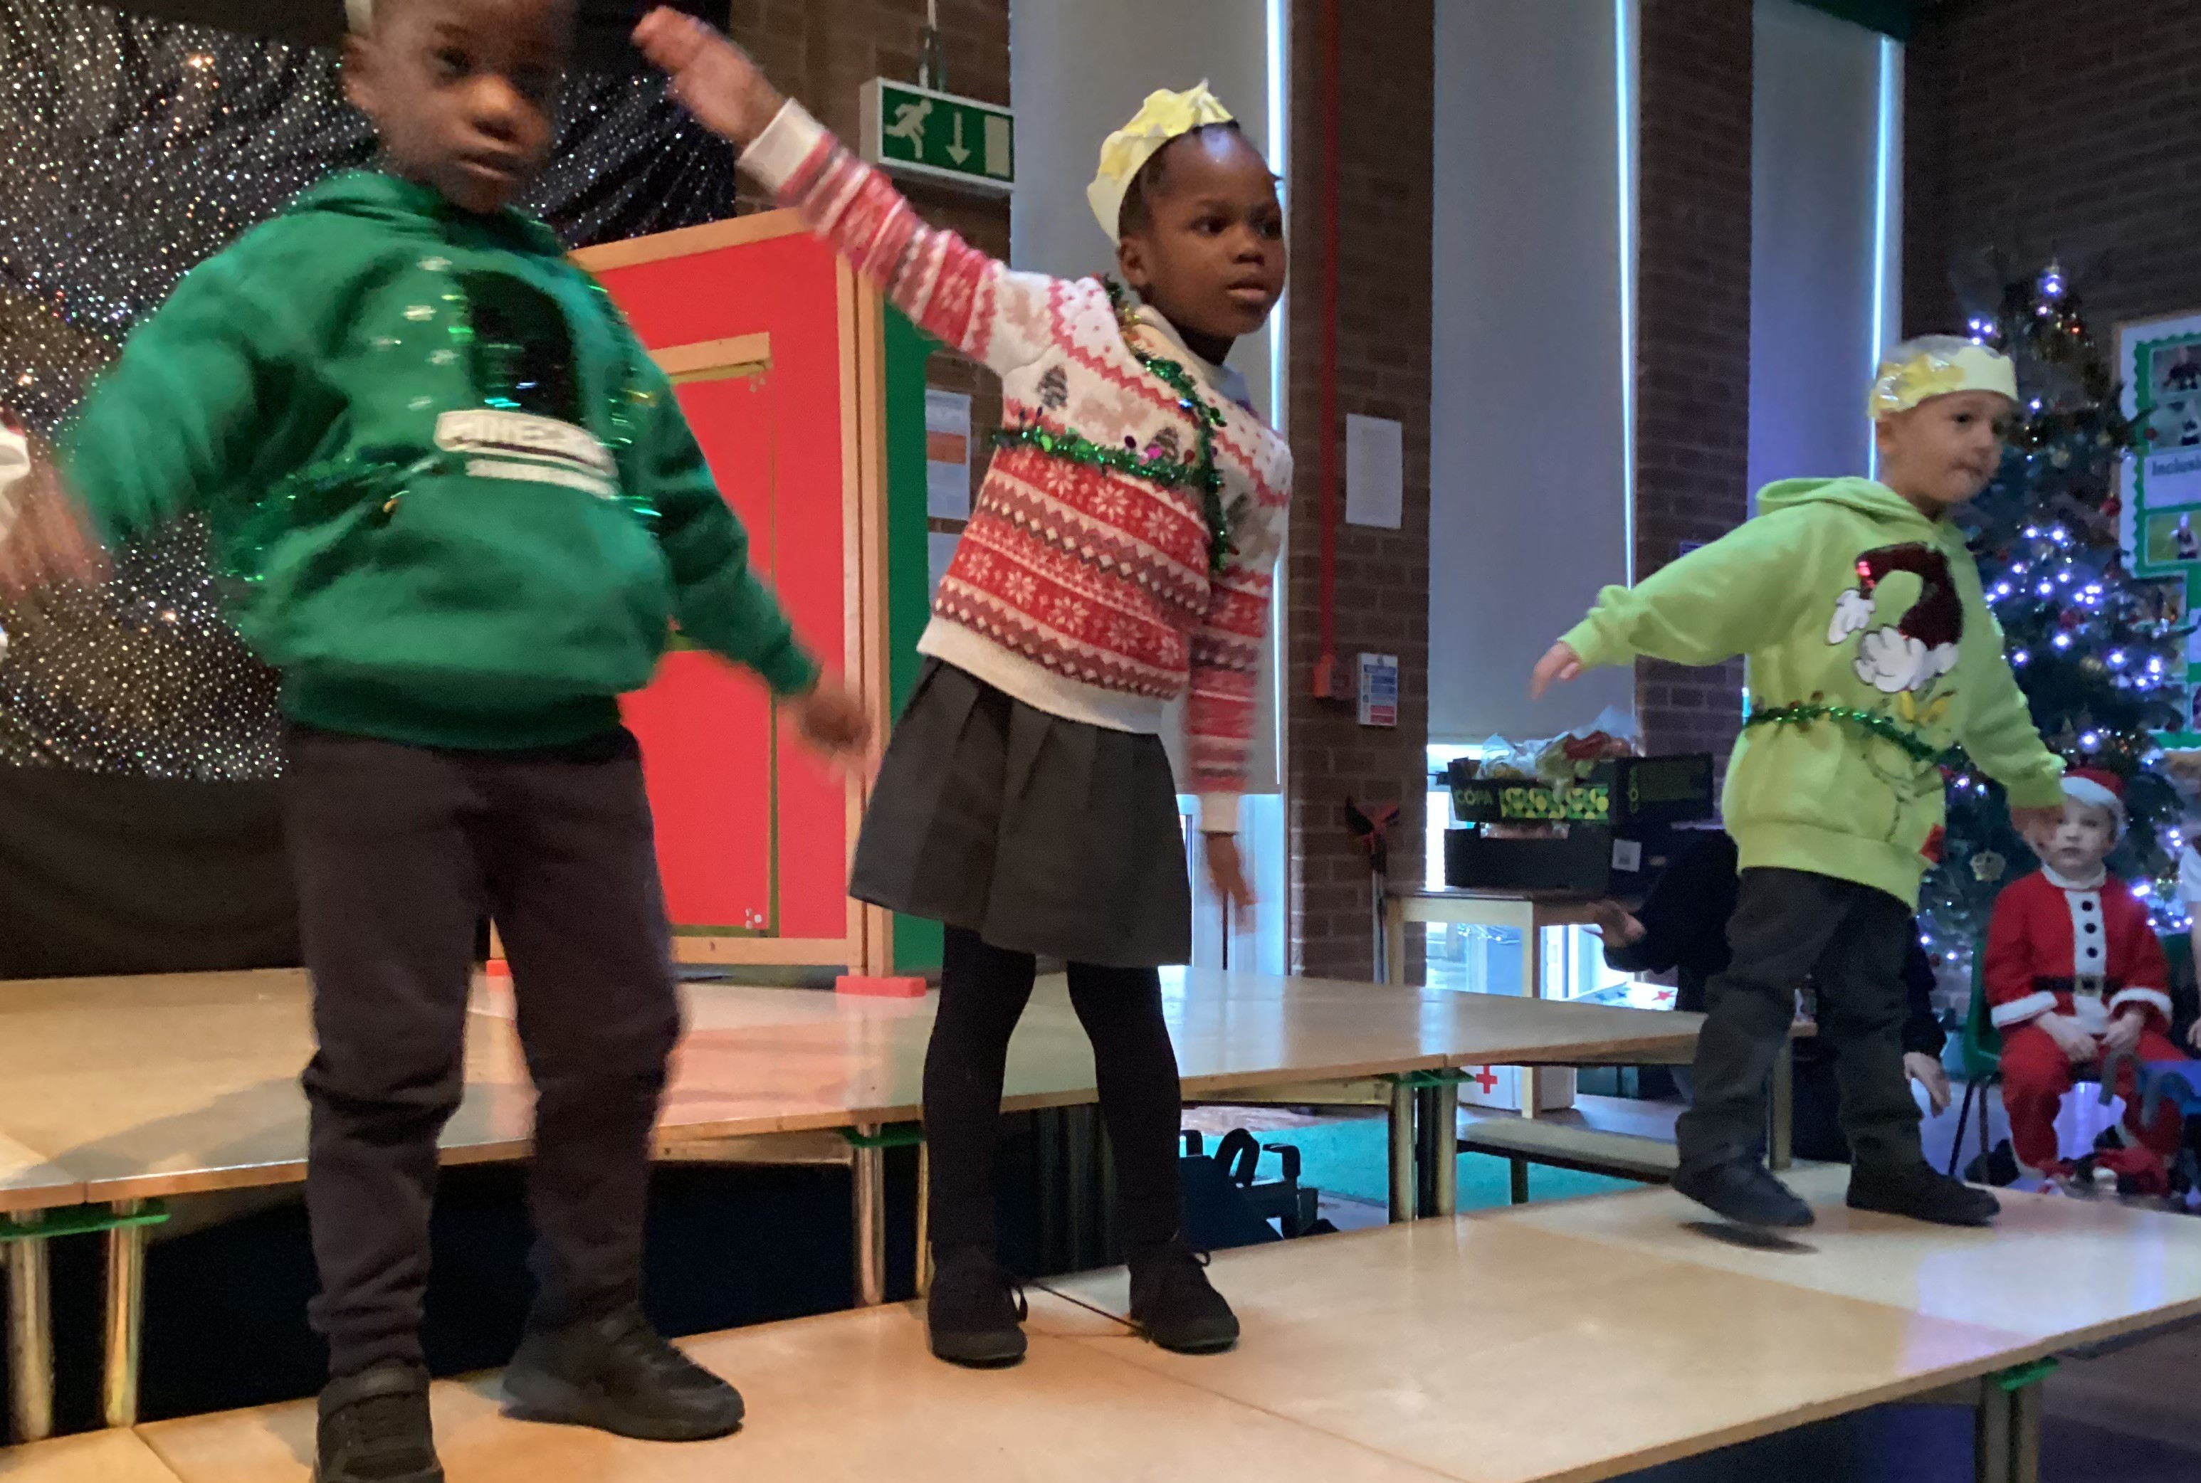
The youngest children in our school, thoroughly entertained us with their version of the Nativity, complete with Minions, a postman and some Snow Angels. It was absolutely magical from start to finish and got us all feeling incredibly festive. The children performed amazingly, singing some beautiful songs and getting us all dancing along.
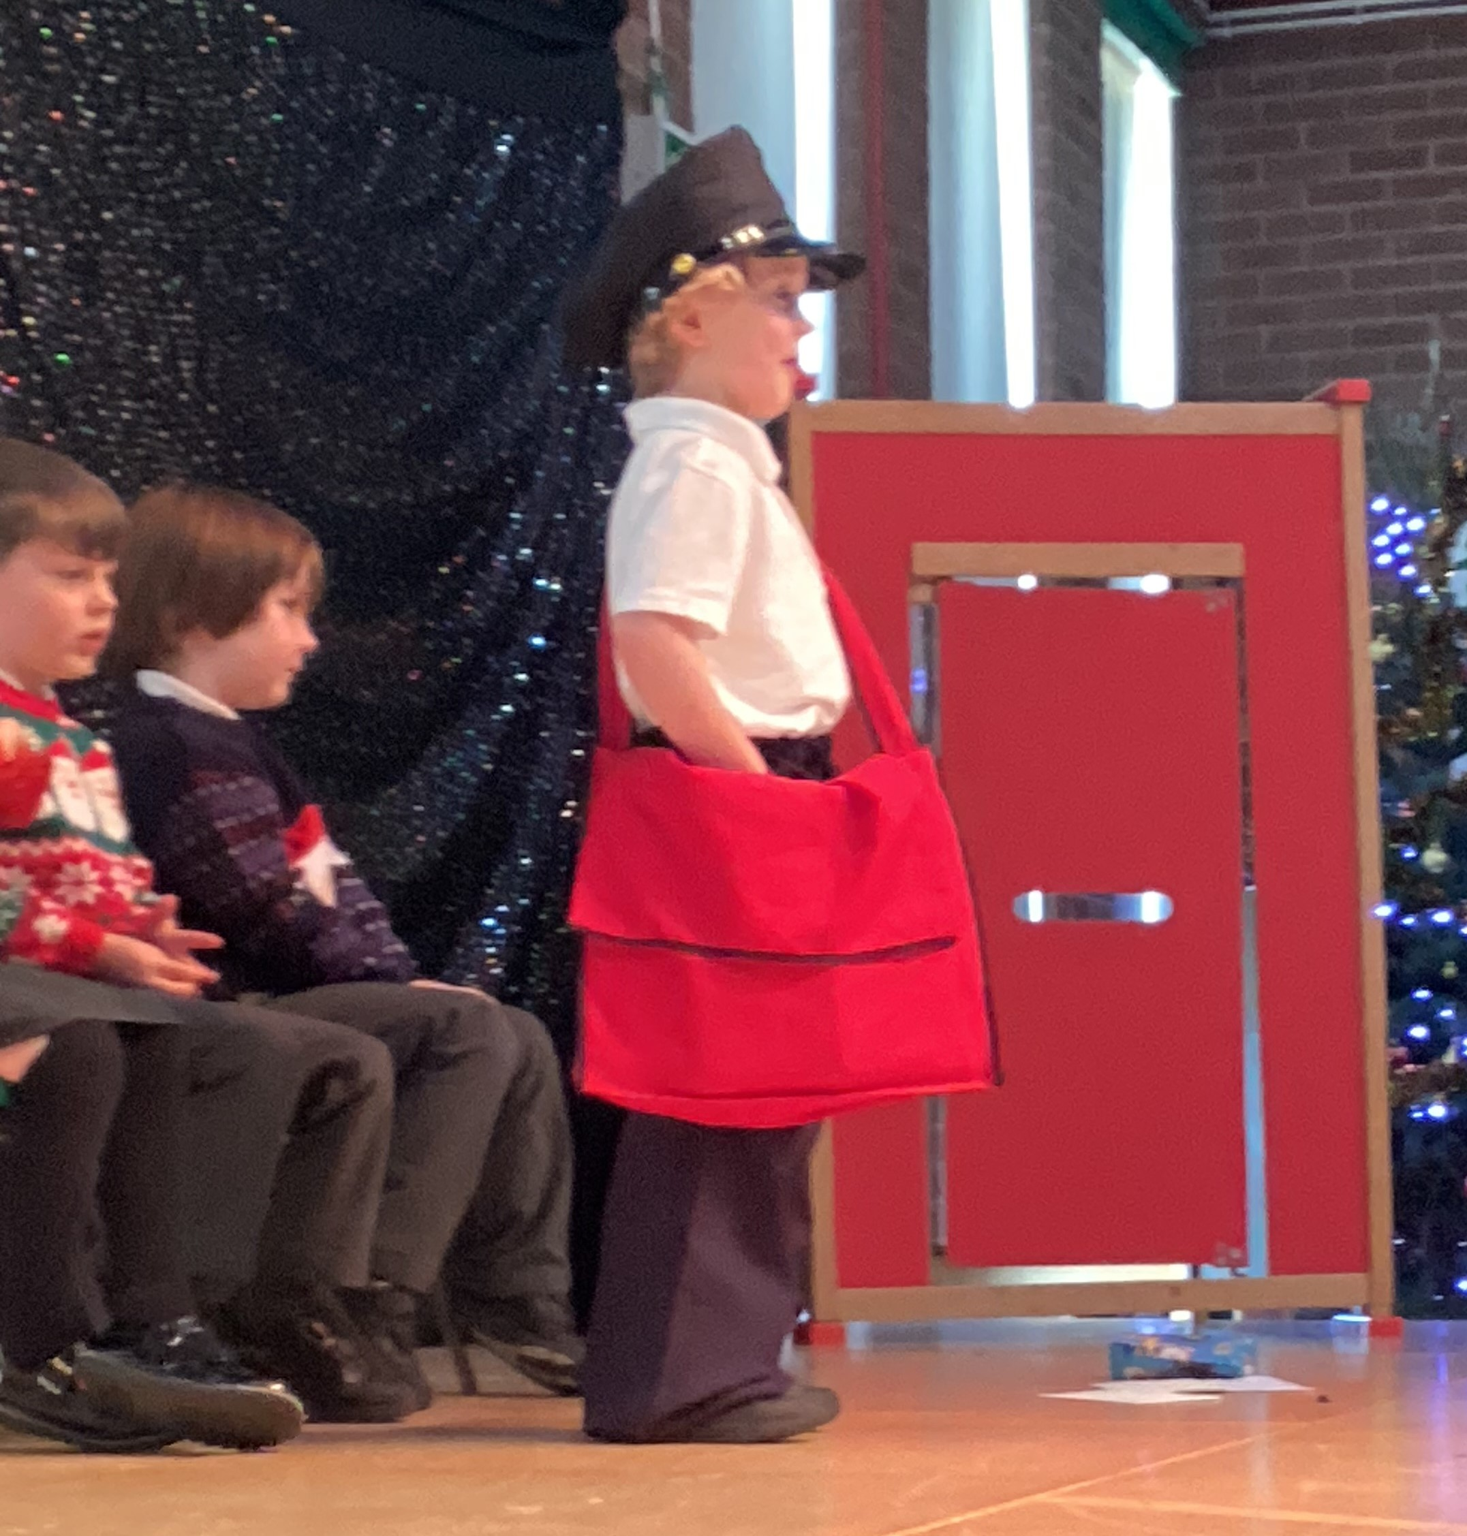

Key Stage 2 Choir- Walthew House
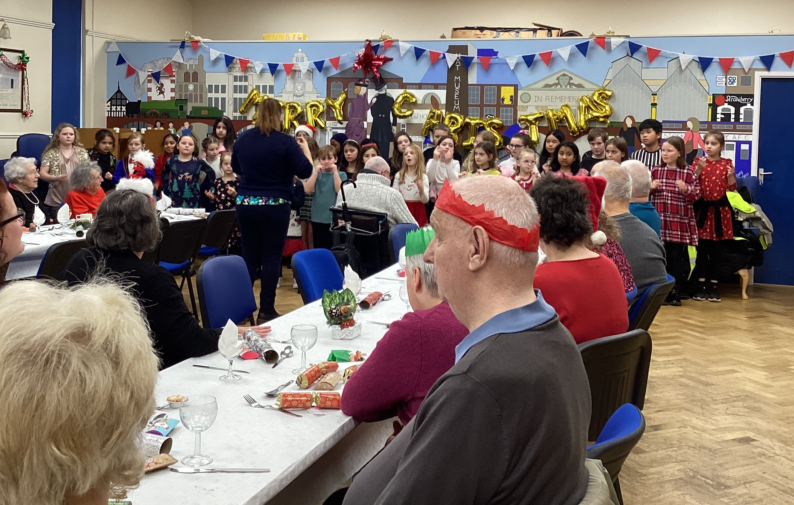
The KS2 choir sounded as beautiful as ever at Walthew House this December as they provided the lovely entertainment ahead of the guests of Walthew’s Christmas dinner. They definitely brought lots of festive cheer!

Cross-Country Races at Woodbank

All Children in Key Stage 2 are invited to run in the cross-country sessions that are held almost every month from September to February at Woodbank Park. Well done to everybody who ran in the October race (Make sure you give enough time to park if travelling by car as the car parks can become very busy!)
Match 5 Saturday 18th January 2025 10am – 12.30pm
Match 6 Saturday 1st March 2025 10am – 12pm
Presentation Day 22nd March 2025

Aladdin at Stockport Academy
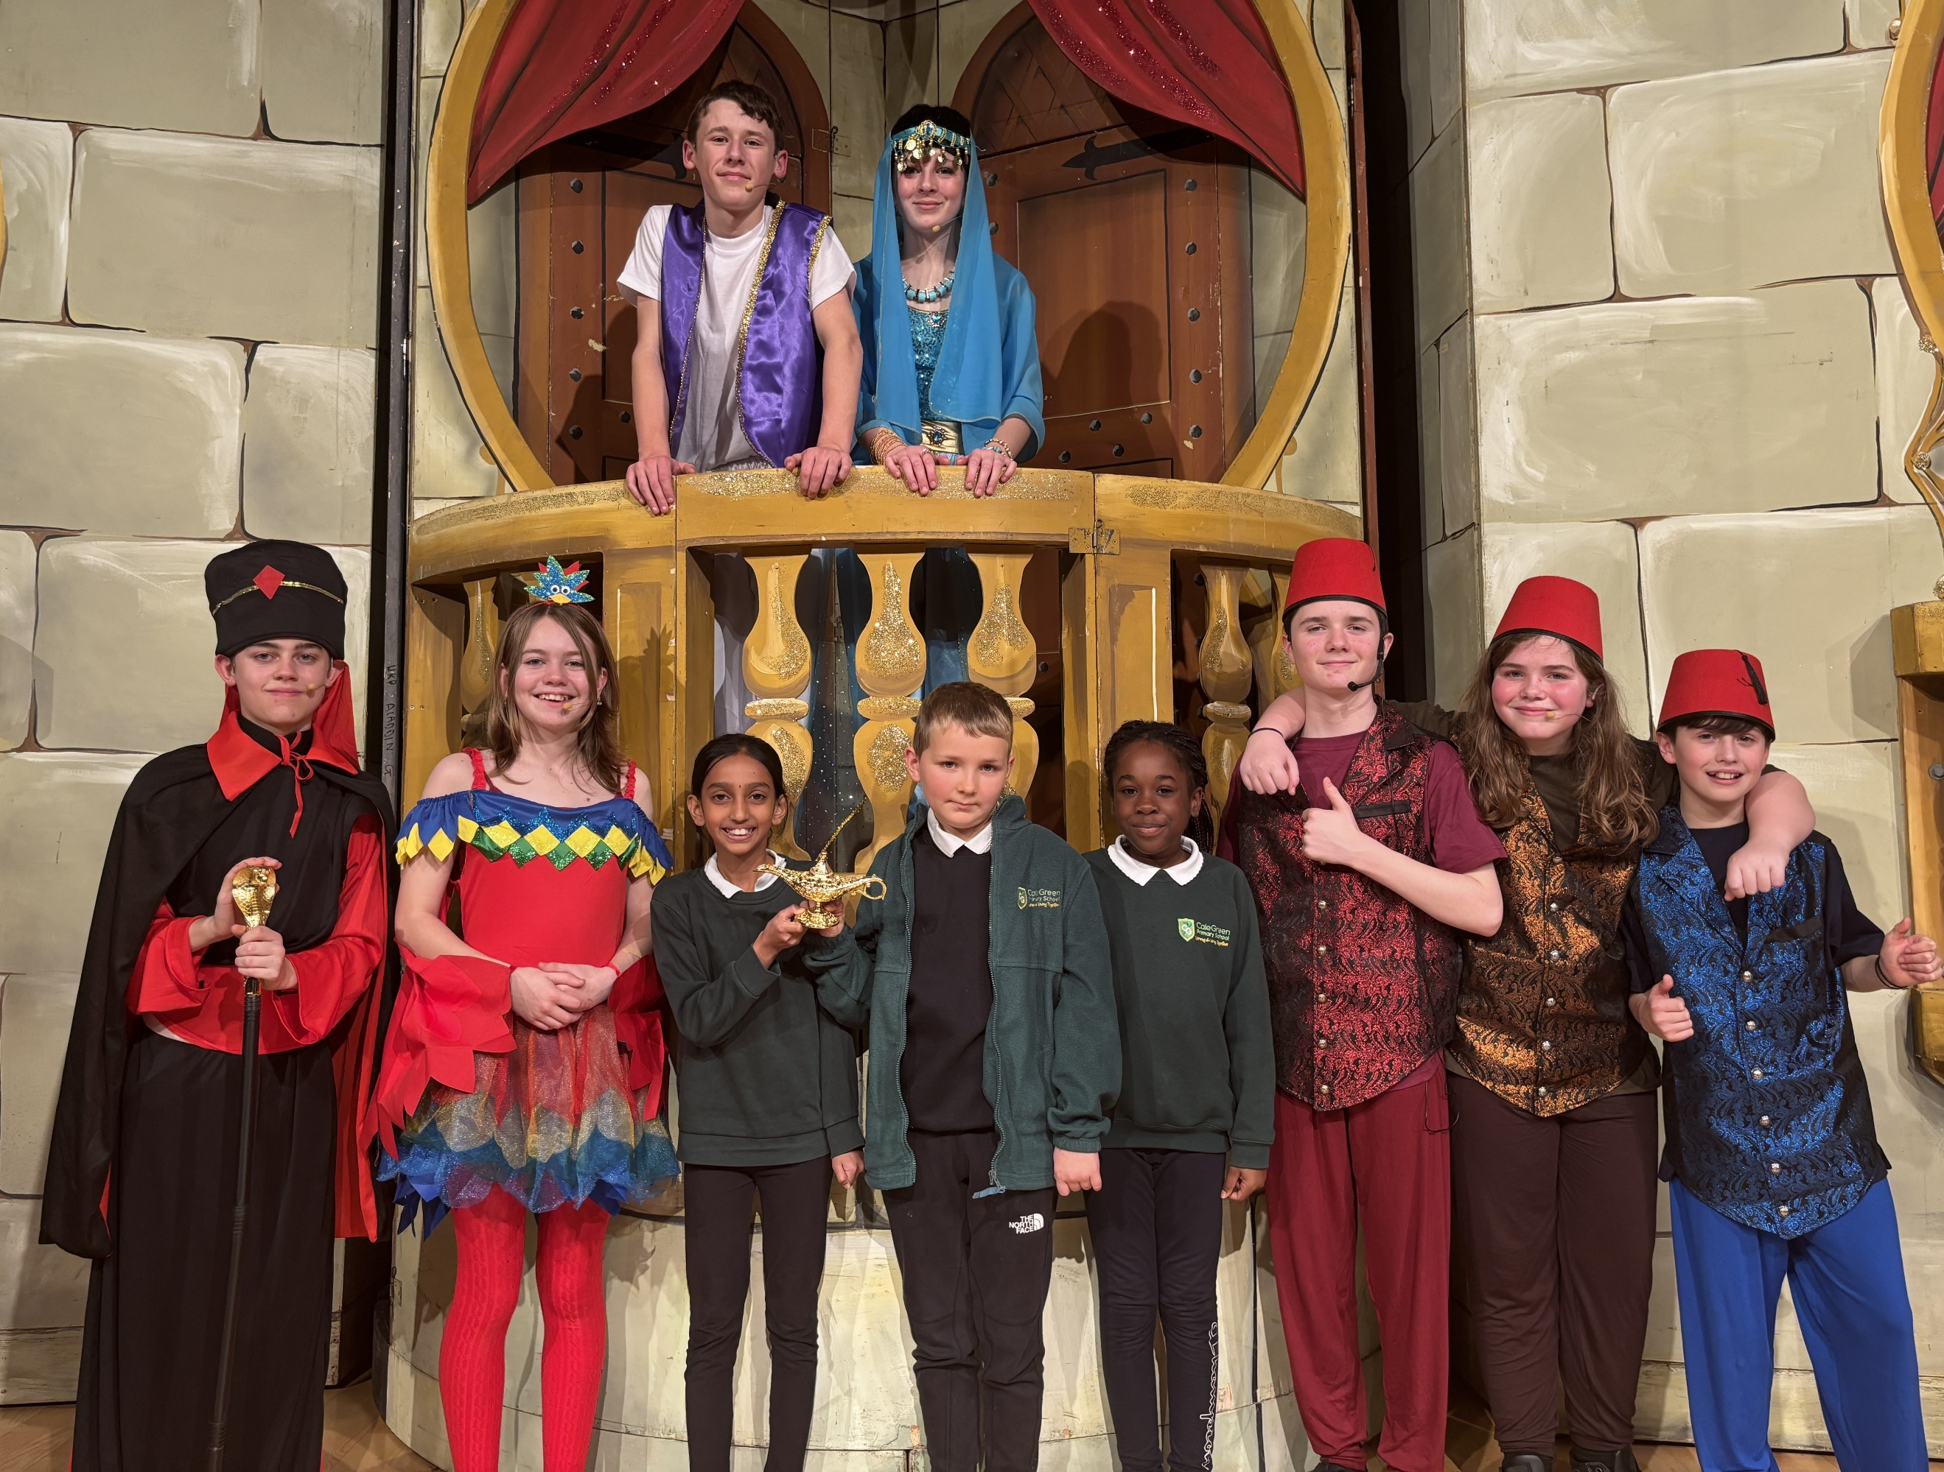
Children in Magnolia, Maple and Mulberry enjoyed a trip to Stockport Academy recently to see a performance of ‘Aladdin’. They all thought it was brilliant and it was nice to see some of our past pupils playing some of the main parts.

PE and Swimming Days 
We will always try to keep the same PE kit days for at least half a term but there will always be odd changes to the timetable that are late notice and / or unavoidable but we will always try to alert families via Instagram or email about these.
Beech and Birch will have PE on Wednesday.

Cherry, Chestnut and Cedar will have PE on Monday and Friday.

Hazel, Hawthorn and Holly will have PE on Monday and Tuesday (Holly swimming Tuesday.)

Maple, Magnolia and Mulberry will have PE on Tuesday (Magnolia swimming Tuesday) and Thursday.

Year 1 / Year 2 Football Festival
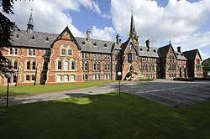
On a cold December morning, a group of 14 children from across Cedar, Chestnut and Cherry classes took part in a football festival over at Cheadle Hulme School. They joined children from 3 other primary schools from the local area taking part in lots of football related games and activities. They all represented Cale Green amazingly. Well done everyone.
Key Stage 1 Nativity
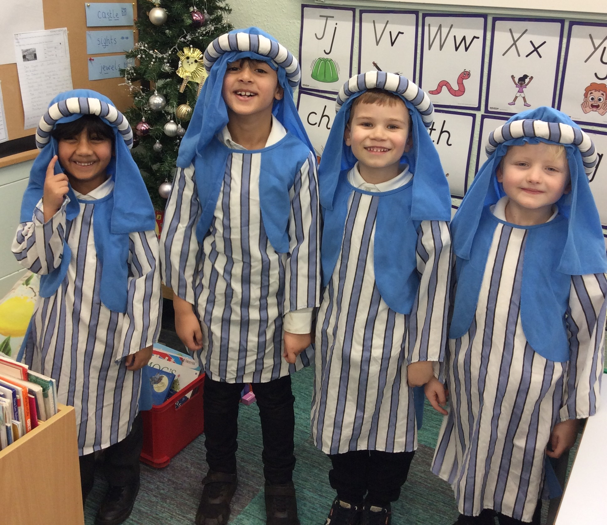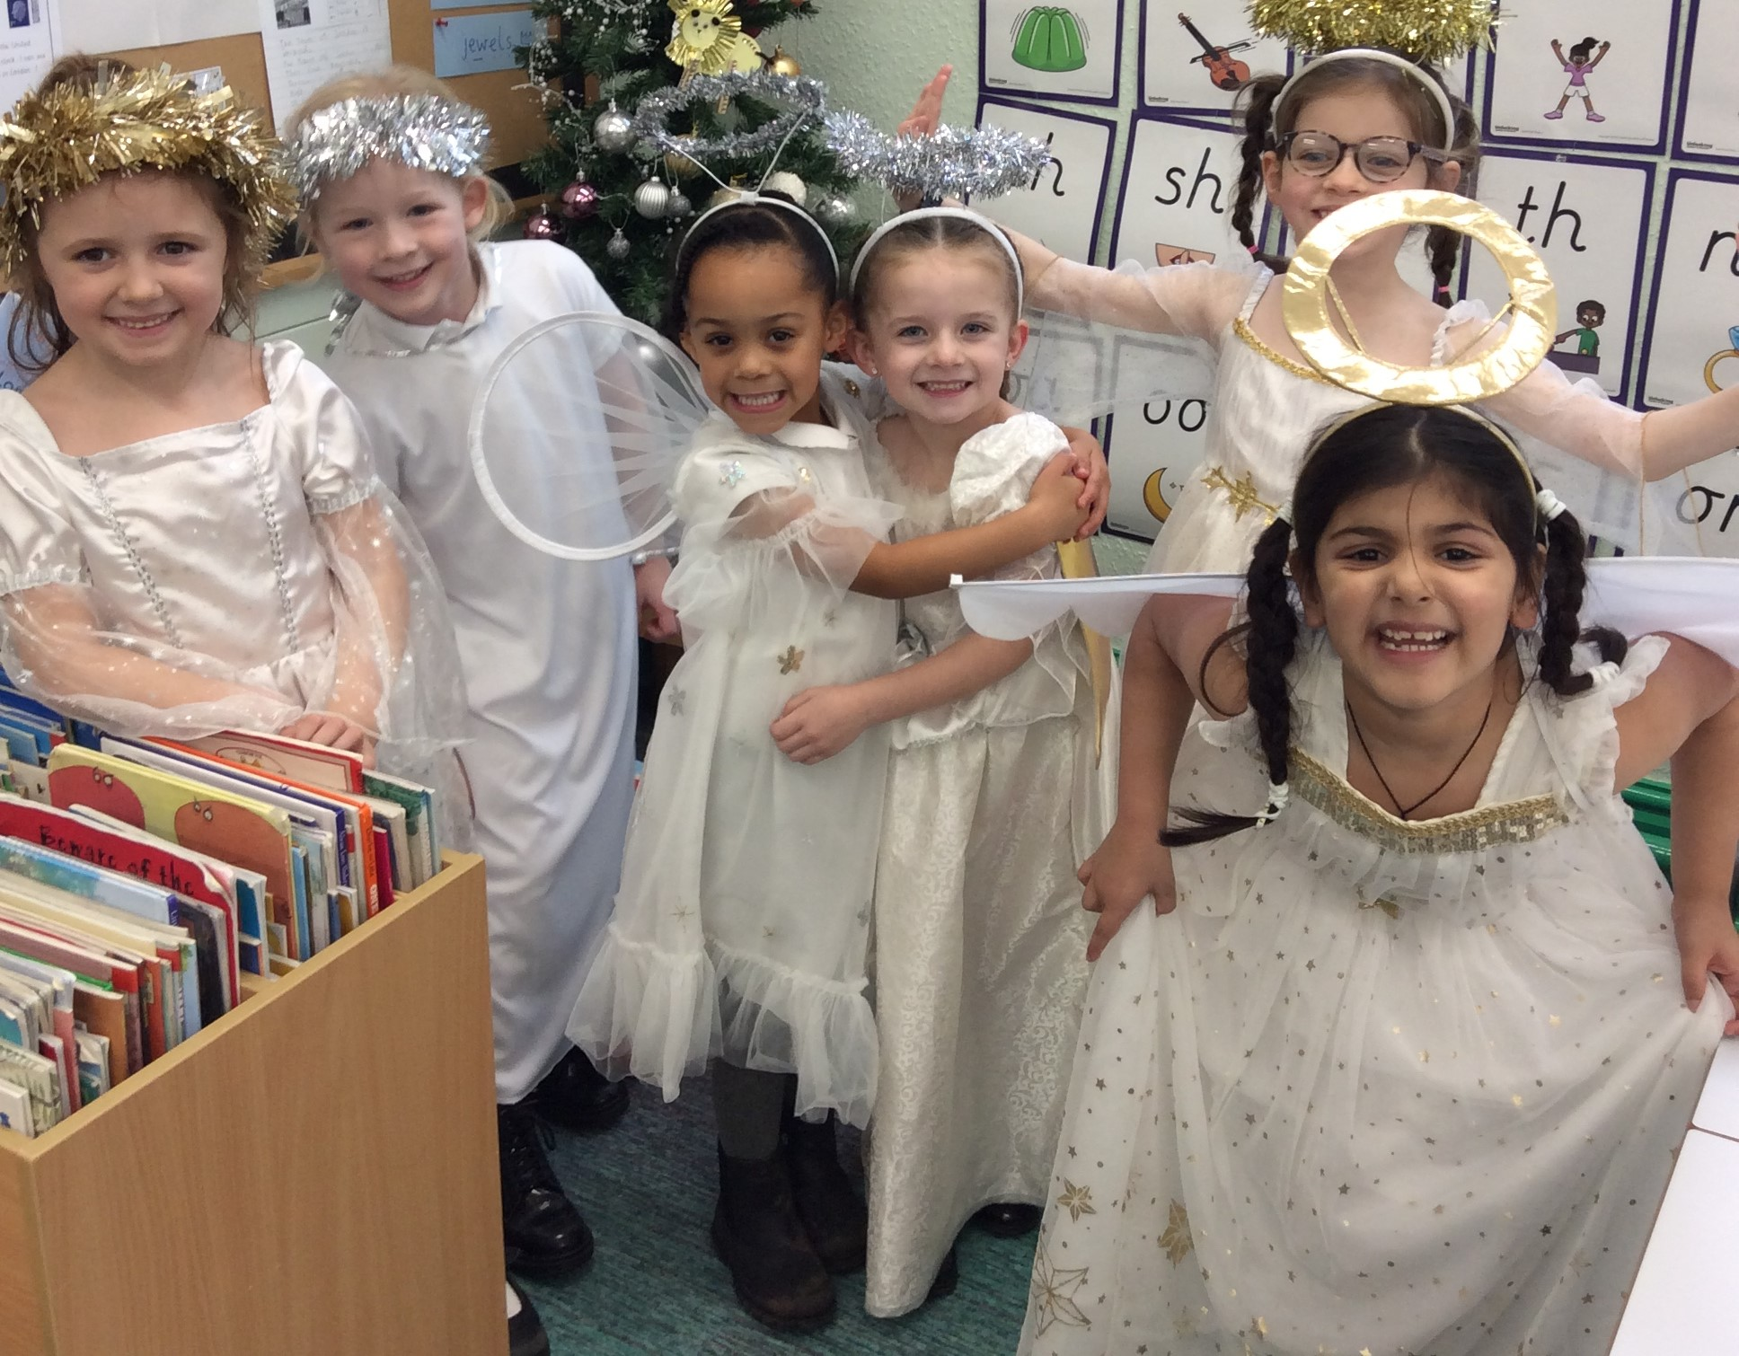
Children in Cedar, Chestnut and Cherry enjoyed taking part in their performances of ‘Simply the Nativity’ and the audiences were well entertained with some toe-tapping songs, super acting and some gorgeous dancing. Well done to everyone.

School Uniform and Pre-Loved Uniform Sale
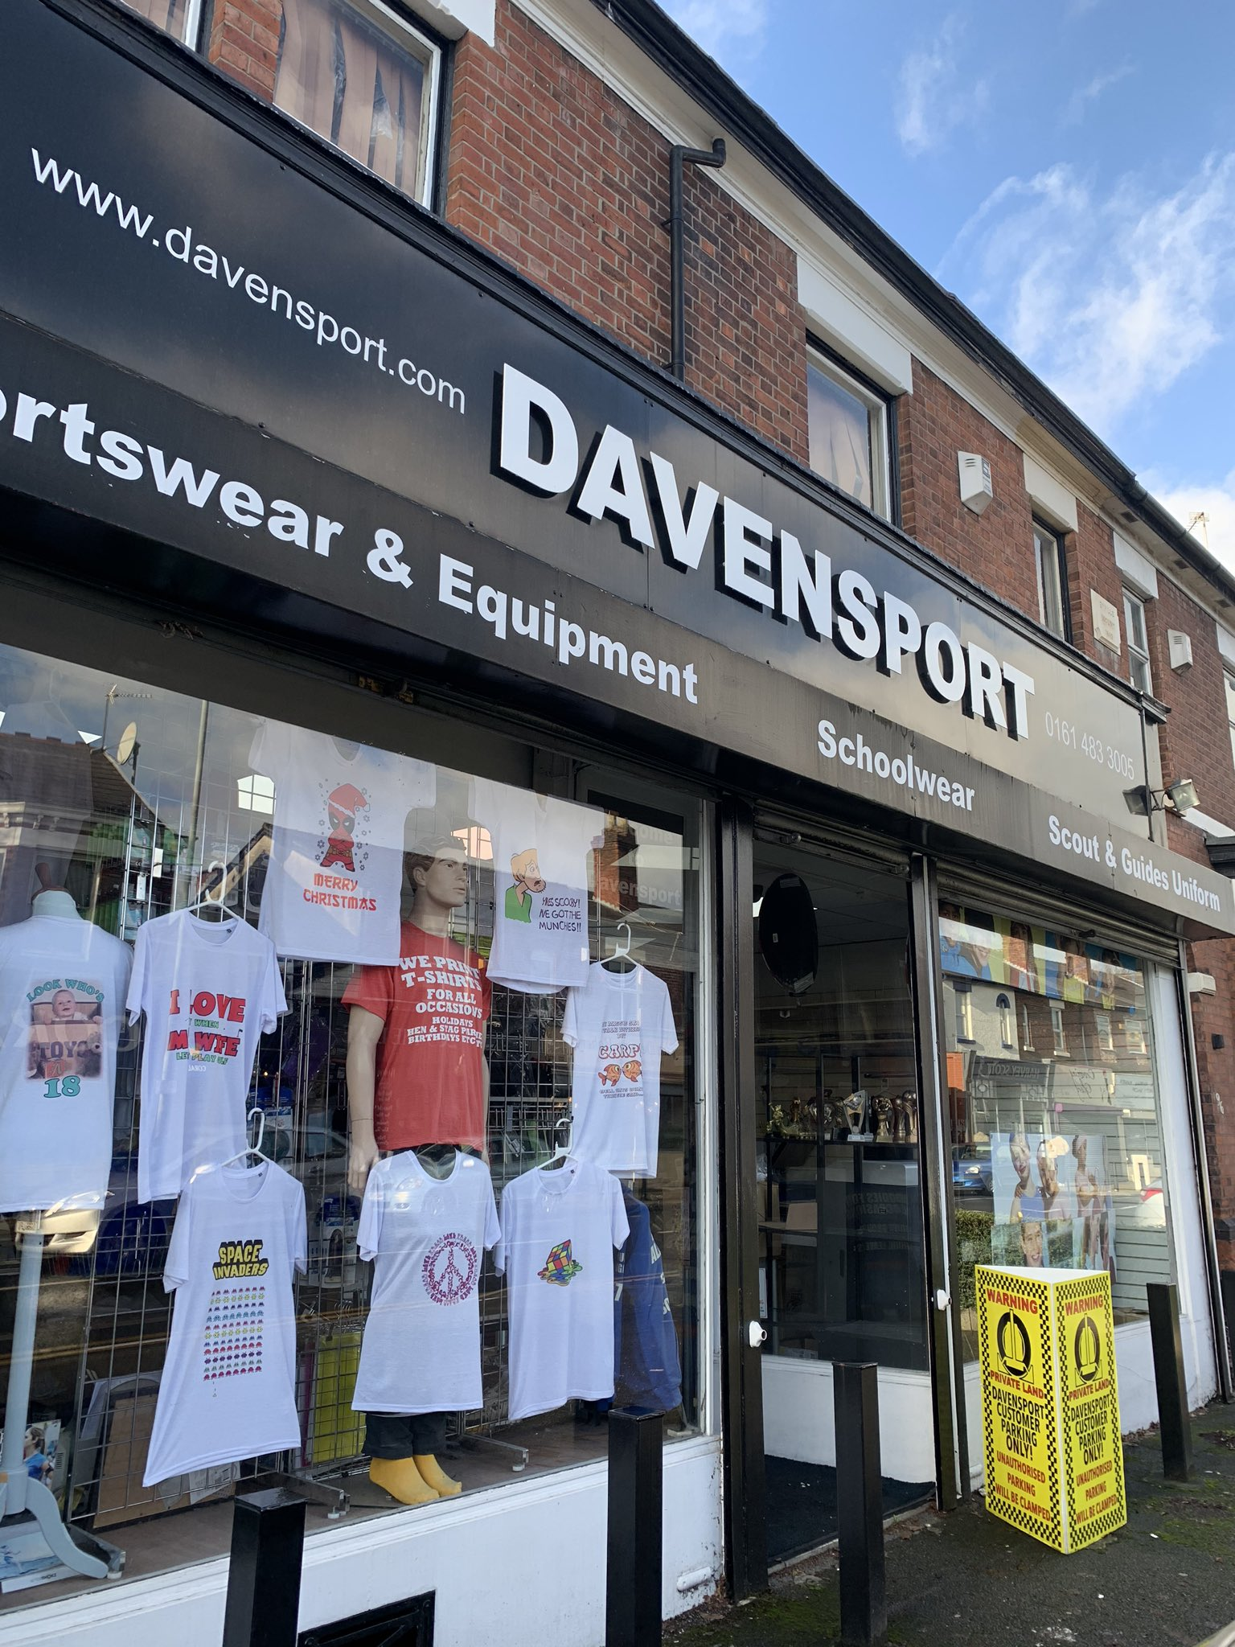
Families are able to buy uniform from Davensport which is on Bramhall Lane. They stock uniform which has the school’s logo on. You are able to go into the shop and check the sizes before buying.
A reminder that the next Pre-loved Uniform sale will be on Friday 31st January at before and after school. We have lots of uniform, shoes, coats and bags for sale. All items are 50p.

End of Theme 2 Class Visits

Advance notice of the end of theme 1 parent and carers’ class visits. These will take place in your child’s classrooms.
Early Years Monday 20th January 2.40pm – 3.10pm
Key Stage 1 Tuesday 21st January 8.50am – 9.20am
Lower Key Stage 2 Wednesday 22nd January 8.50 – 9.20
Upper Key stage 2 Thursday 23rd January 8.50 – 9.20am
Nursery Friday 24th January 8.50am – 9.20am

Writing Oscars

Congratulations to Reuben IT, William A, Georgie BB, Hesam, Leo O, Edie, Violet, Isaac C, Momina, Ellie-Mae, Momina, Zahra and Hamdiya who have all received Writing Oscars for the progress they have made with their writing during this half term.
Well done writers!

Golden Tickets
Across the half term, we have spotted or heard about children learning outside of school, thinking about others, showing kindness or supporting someone in need. Well done to Ivy B, Elie-Alex, Dylan G, Elliot C, Amarlee, Mikael, Azaan, Lillie-Sue, Grace R, Georgie BB and Hesam who were all awarded a Golden Ticket and will get to select a book from the Book Vending Machine before we finish for Christmas. Well done everyone!

Nursery and Reception Admissions
A reminder that Reception places close on 15th January 2025.
Nursery places close on 31st March 2025.

Acorn Fund

A reminder that we have lots of friends and families of Cale Green who have very kindly donated sums of money to our Acorn Fund. If your family is in need of some financial support please do contact school.

Gold Awards

Well done to Liam H, Ibrahim and Ahmad who gained their 50 Stars and gained their Gold Award. They chose their book prize and were awarded them during a Family Assembly in November. Well done Liam, Ibrahim and Ahmad!

Choir Christmas Sing-Along
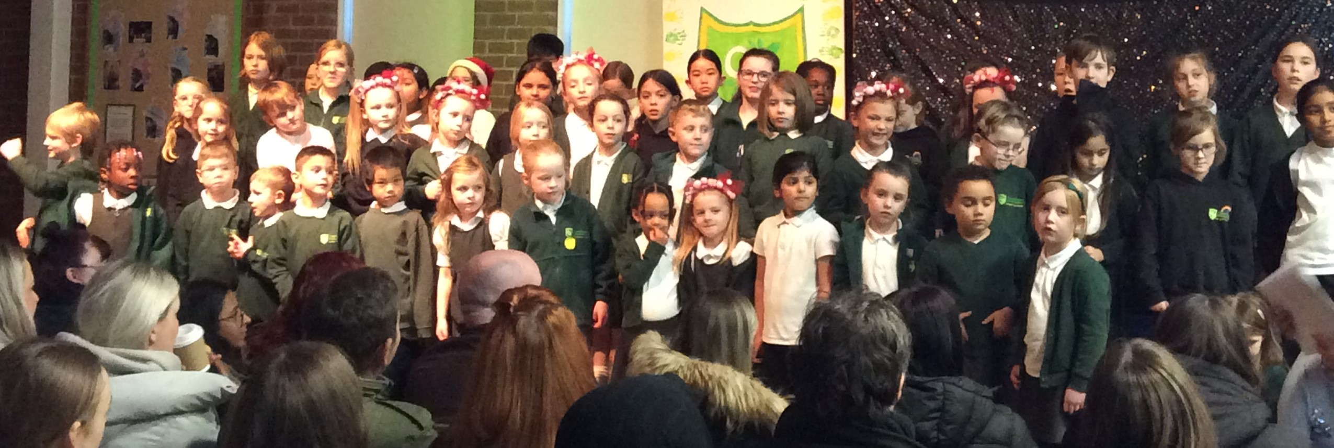
The Key Stage 1 and Key Stage 2 choirs sounded amazing in our Christmas Sing-Along- and so did all the friends and family who joined in lots of the songs.
The children’s voices absolutely rang out, definitely spreading festive cheer all around. It was an absolute delight to see everyone clapping and singing along, getting into the Christmas spirit together. The children’s smiles lit up the hall, making it such a fun and memorable occasion.

Lower Key Stage 2 Nativity
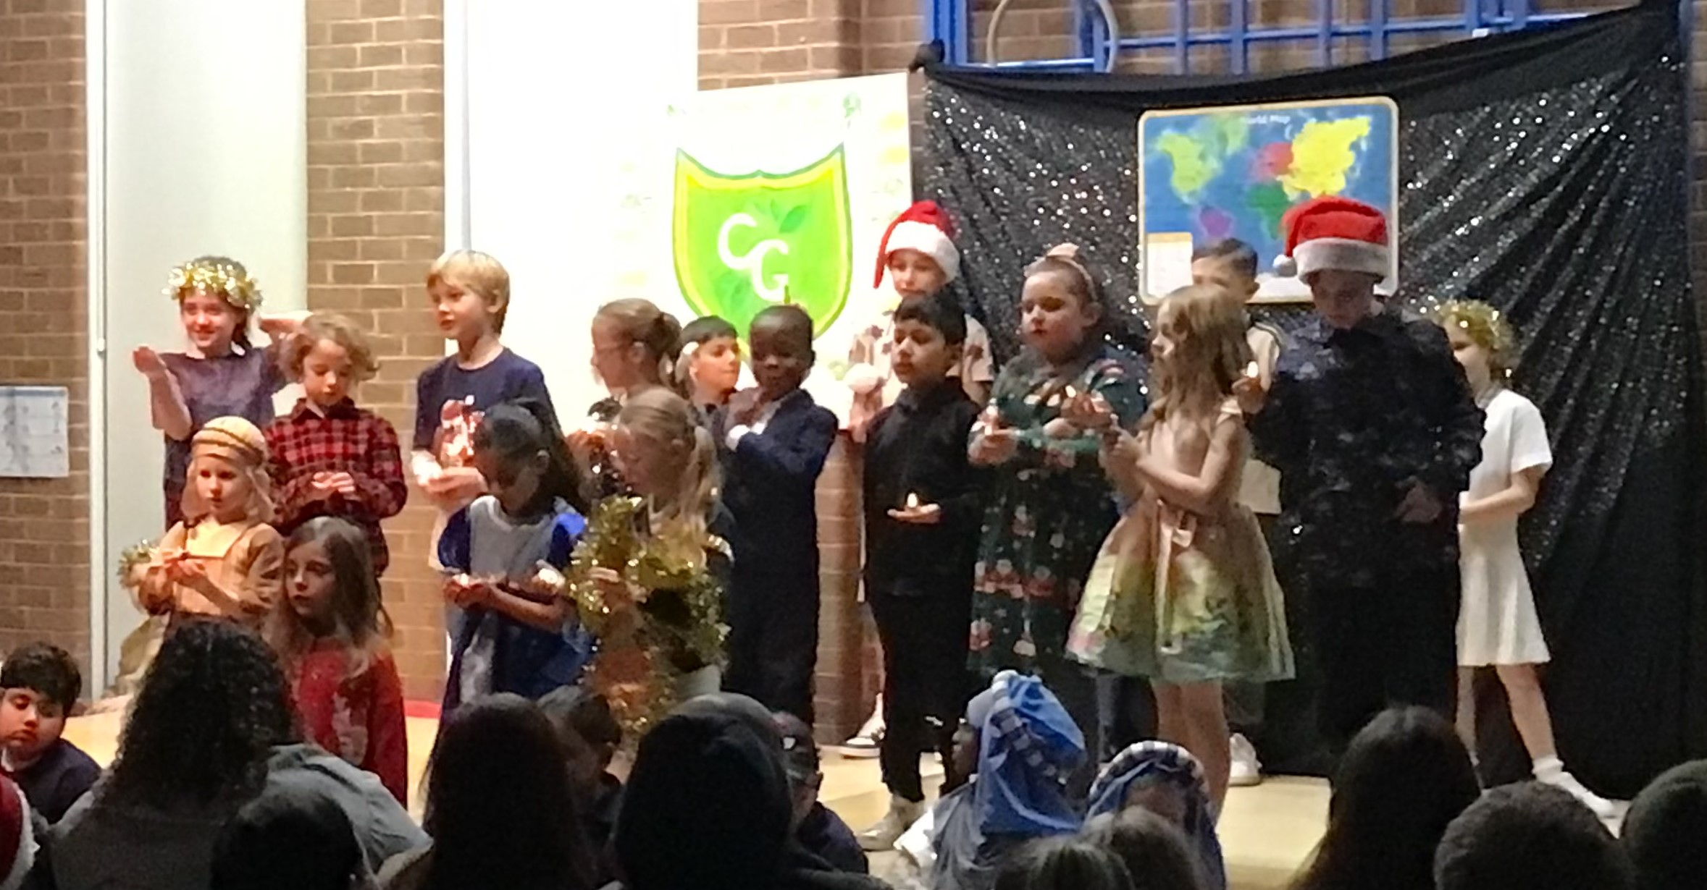
The children in Holly, Hawthorn and Hazel classes took us on a journey around the world teaching us about Christmas traditions and singing some gorgeous songs with the story of the Nativity interwoven throughout. The children performed amazingly and sung beautifully.

Early Years Open Morning

We will be hosting an Early Years Open Morning on Wednesday 8th January from 9.30am – 10.30am for families who have children who are due to start either Reception or Nursery in September 2025. Please spread the word to friends and family.
Christmas Raffle Winners

A great big ‘thank you’ to all the staff, families and Friends of Cale Green (FROcGs) who kindly donated so many Christmas gifts for our annual raffle. AND another big ‘thank you’ to everyone who bought some raffle tickets throughout December. We raised a staggering £900 to put in our school funds!

Wishing our children, their families and all the staff and governors a peaceful Christmas holiday and a very ‘Happy New Year’! Take care and we’ll see you all on
Monday 6th January 2025!

