Year 2 Geography Creative Homework:
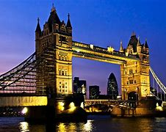
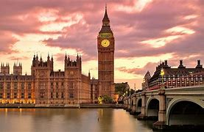
London fact file

Start date: Friday 25th October
Completion date: Friday 8th November

Geography homework explained

For this half term , please can the children create a fact file about London. Please ensure that these are well-presented as they will be put in books as a piece of work. These can be handwritten or produced digitally to be printed off.
Things to include :

Some history facts about London
Human and physical features of London
Pictures of what is in London.

Please can the fact file be created on an A4 piece of paper as I will put them in a folder in their geography books.

Be creative as you wish. I want to see lots of facts, colours, and pictures!

Kind Regards,
Miss McInnes and Mrs Leach

