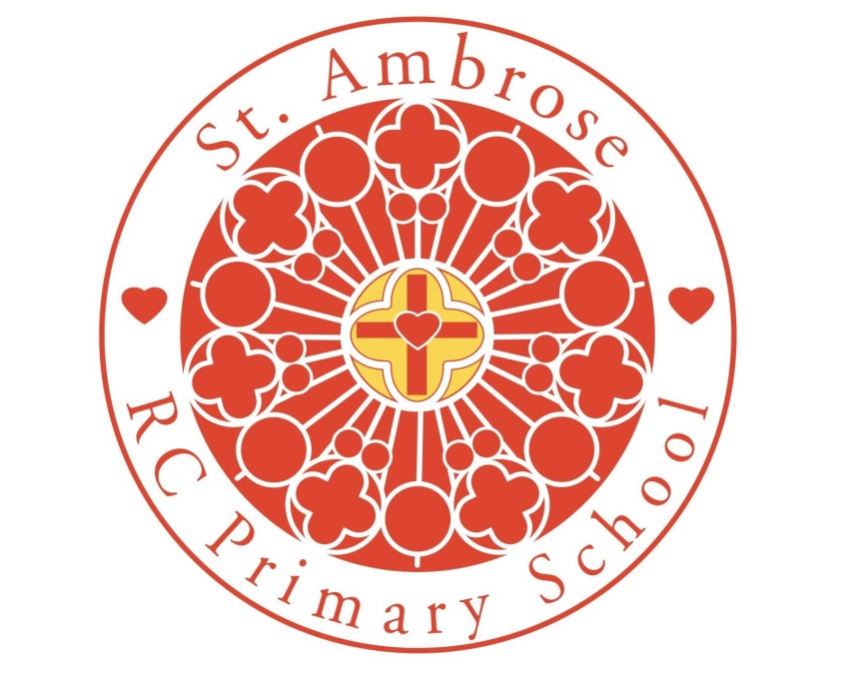

Early Years Teaching and Learning Policy 2026-27

Approved by: Headteacher |  | Date: July 2026
Last reviewed on: | July 2025
Next review due by: July 2027

In light of the school’s Mission Statement, SEND policy and Early Years Assessment Policy this policy was written.

Introduction:
Article 28: Your right to learn and to go to school
Article 31: Your right to relax and play

All children deserve the care and support they need to have the best start in life. Children learn and develop at a faster rate from birth to five years old than at any other time in their lives, so their experiences in early years have a major impact on their future life chances. A secure, safe, and happy childhood is important in its own right. Good parenting and high-quality early learning provide the foundation children need to fulfil their potential. EYFS Statutory framework 2024

Aims of the policy:

- To give each child a happy, positive and fun start to their school life in which they can establish solid foundations on which to expand and foster a deep love of learning;
- To offer each child a wide range of new and exciting experiences and give them the opportunity to consolidate, explore and test them out along with their own, individual experiences;
- To enable each child, through encouragement and high expectations, to develop, to the full, socially, physically, intellectually and emotionally.
- To offer a structure for learning and a curriculum that has a range of starting points and unlimited opportunity for development, responding to the child’s developmental needs;
- To encourage children to develop independence within a loving, secure and friendly atmosphere;
- To support children in building relationships through the development of social skills such as cooperation and sharing;
- To create a partnership with parents which supports and enhances the development of their children;
- To help each child to recognise their own strengths and achievements through experiencing success and developing the confidence to work towards personal goals.

The Curriculum:

The Nursery and Reception follow the curriculum as outlined in the Early Years Foundation Stage (EYFS) document, which is available from www.gov.uk.

This clearly defines what we teach. The EYFS framework includes seven areas of learning and development, all of which are seen as important and interconnected but three areas are seen as particularly important for igniting children’s curiosity and enthusiasm for learning, for building their capacity to learn and form relationships and thrive (DfE 2020: 1.3), they support children’s learning in all other areas, they are known as the prime areas.

The prime areas are;
• Communication and Language – Listening, Attention and Understanding and Speaking
• Physical Development – Gross motor skills and Fine motor skills
• Personal, Social and Emotional Development – Self-regulation, Managing Self and Building Relationships

The specific areas of learning develop essential skills and knowledge for children to participate successfully in society. The specific areas are;
• Literacy –Comprehension, Word reading and Writing
• Mathematics – Number and Numerical patterns
• Understanding the World – Past and Present, People, Culture and Communities and The Natural World
• Expressive Arts and Design – Creating with Materials and Being Expressive and Imaginative

Characteristics of Effective Learning:

The EYFS also includes the characteristics of effective teaching and learning. The Nursery and Reception teachers plan activities within the Nursery and Reception classrooms with these in mind. They highlight the importance of a child’s attitude to learning and their ability to play, explore and think critically about the world around them. The three characteristics are;
• Playing and Exploring – children investigate and experience things, and ‘have a go’
• Active Learning – children concentrate and keep on trying if they encounter difficulties, and enjoy achievements
• Creating and Thinking Critically – children have and develop their own ideas, make links between ideas, and develop strategies for doing things.

Effective Teaching and Learning:

Direct and carefully planned, adult led experiences for children in the form of structured adult led teaching and adult led group activities are included in planning. These are particularly important in helping children to learn specific skills and knowledge and it is often through children’s play, supported by the appropriate provision including ICT, that we see how much of this learning children have understood and taken on. Each day a timetable is followed with set routines in place. This looks quite different in the Nursery and Reception classes. Times are set aside each day when the children come together to be taught in the more traditional sense, gathered together on the carpet as a class. In these the focus is on topic work, maths, literacy, phonics, and stories. These sessions help to develop vital habits of learning: learning as a group, listening to the teacher, taking turns to answer, sitting still etc…

To achieve high quality teaching and learning, senior management will monitor and support the development of teaching and learning strategies used by staff. This ensures that a wide range of opportunities which enable the children to learn in different ways. Staff will make on-going assessments of the progress and attainment of each child and use this information to aid future planning. Regular internal and external moderation of these assessments is timetabled.

Throughout the EYFS activities are planned that give children learning experiences and opportunities that help them work towards the Early Learning Goals. Teaching and learning will take place in the indoors and outdoors provision. The children will participate in a range of activities, some independently and some adult led. It is ensured, through planning, there is a balance of adult led and child initiated activities across the day. Although much of the time is spent with children self-selecting tasks, the interaction between the adult and child is essential as the adult’s response to children builds understanding and therefore guides new learning. The adult’s role is to continually model, demonstrate and question what the child is doing. In some cases the adult will ask a child to come and complete a task or game with them; at other times they will participate in a child’s game, extending it where possible.

Play:

Play underpins the EYFS. It also underpins learning and all aspects of children’s development. Through play, children develop language skills, their emotions and creativity, social and intellectual skills. For most children their play is natural and spontaneous although some children may need extra help from adults. Play takes place indoors and outdoors and it is in these different environments that children explore and discover their immediate world. It is here they practise new ideas and skills, they take risks, show imagination and solve problems on their own or with others. The role that adults have is crucial. Adults provide time and space and appropriate resources which inspire play and the imaginations of the children. They observe play and join in when invited, watching and listening before intervening. All staff value play and provide safe but challenging environments that support and extend learning and development.

The children learn to;
- Adapt,
- Negotiate
- Communicate
- Discuss
- Investigate
- Ask questions.

Adults will take an active role in child initiated play through;
- Observing
- Modelling
- Facilitating
- Extending their play through narrating and asking questions about the play in order to develop the language and communication of the children.

The Learning Environment:

The learning environment has had considerable investment and this commitment to the development of high quality provision will continue. Displays will reflect and support the learning that takes place. The learning environment will be accessible to all children and will support a wide range of independent learning opportunities. Staff will appropriately modify teaching and learning for children with SEND, in line with our SEND policy. Staff will work closely with parents and outside agencies to ensure that the needs of the child are met.

The Early Years classroom has defined areas with clearly labelled resources to ensure children can access them easily. The classroom is set up in a way to provide children with experiences and activities in all of the seven areas of learning. The classroom has a writing area, maths area, creative area, sand area, malleable area, book corner, role play area, construction/small world area, outdoor area and two teaching areas. A variety of activities are planned for and set up in the different areas each day. The adults move to whichever area their focus for the session/day is.

Our outdoor GIFT (growing in faith together) garden was completed in October 2016, it incorporates a range of large and small scale areas and activities that promotes physical activity and challenge. There is a wide range of climbing and sliding equipment, mud kitchen, open ended role play building, games provision, den making and large scale block play, large scale water play and literacy and maths opportunities. It is comprehensively risk assessed and daily checks are completed.

Monitoring of learning environments will be conducted by senior leaders and there is opportunity for teachers and teaching assistants to be involved in monitoring the quality of provision.

Religious Education:

The children in Early Years Foundation stage cover the Come and See objectives and make clear links with the framework through Understanding of the World and Personal, Social and Emotional Development.

Home and School Links:

Parents are kept informed of what their child is learning through a variety of means, including;
- Tapestry
- Half termly Share in our learning letters
- End of year reports
- Class web page
- Parents Evening
- Informal conversations at the start and end of the day

Prior to joining our Early years, there is a home-school visit. This introduces the staff to the parent and child and enables the staff to observe the child in a familiar environment. We also invite all children to a stay and play visit to enable them to become familiar with the staff, the provision and their Year 6 buddies.

In the Autumn term, meetings are held which enables the parents to meet the staff and they are introduced to the curriculum and the routines in place.

