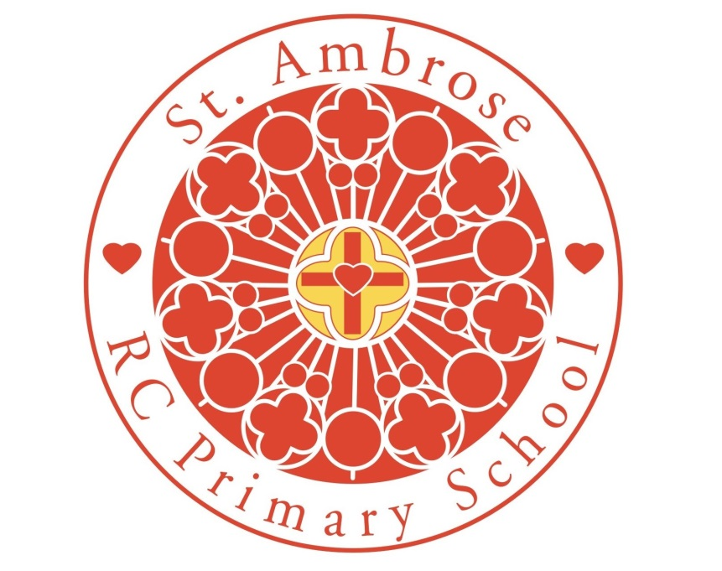

Early Years Assessment Policy 2026-2027

Approved by: Headteacher |  | Date: July 2026
Last reviewed on: | July 2025
Next review due by: | July 2027

In light of the school’s Mission Statement, Early Years Teaching and Learning Policy, SEND and Assessment policy, this policy was written.

Assessment is an essential part of the learning and development of children in the EYFS. It involves practitioners observing children to understand their level of achievement, interests and learning styles, and to then shape learning experiences for each child reflecting those observations.

Article 28: Your right to learn and to go to school

Assessment windows:

Within the first 4 weeks of the autumn half term, an initial baseline assessment is made in both Nursery and Reception using Tapestry. This runs alongside the internal tracking systems in place using SIMs. The assessments are made in the prime and specific areas of learning and for the characteristics of learning. Alongside this, Reception also complete the statutory baseline assessment.

Tapestry is used to record observations of the children, these observations are used to create on line learning journeys for each child. The evidence is used alongside class books and children’s books to support in validating judgements made during internal and external moderation.

The information is inputted on to SIMS three times a year, after baseline, in line with our pupil progress data drop. This data is analysed by the teacher and supported by the Early Years lead. This forms the basis for the pupil progress meetings, as set out in the Assessment Policy. The information is also used to support analysis of vulnerable groups.

Observations:

Observations are undertaken continually on all children and by all practitioners. There is a timetable in each class to show the roles of the practitioners each week. ‘Significant’ observations are completed by all practitioners during independent learning. This ensures children’s ability to apply taught skills are evidenced to ensure accurate judgements are made against the children. Practitioners record which areas of learning have been covered by their observations and each child has observations on all areas of learning every half term.
Parents are encouraged to contribute to the Tapestry learning journeys by logging in and adding their comments.

The judgements made use the revised Development Matters document and Tapestry.

Learning Journey Policy:

St Ambrose Primary School

EYFS: Learning Journey Policy

“Every child deserves the best possible start in life and the support that enables them to fulfil their potential. Children develop quickly in the early years and a child’s experiences between birth and age five have a major impact on their future life chances. .....Practitioners must consider the individual needs, interests, and stage of development of each child in their care, and must use this information to plan a challenging and enjoyable experience for each child in all of the areas of learning and development”. EYFS reforms Early adopter version of the Statutory Framework for the Early Years Foundation Stage: September 2020.

Aim of the learning journey

To capture a child’s journey of learning as they progress through the Early Years Foundation Stage toward the Early Learning Goal and beyond. A document which records, the uniqueness of each child’s learning and development across the seven areas of learning and the Characteristics of Effective Learning.

Organisation
- Evidence collated as follows
- On Tapestry (electronic learning journey)
Quality of observations

- Whole team approach (including parents) to recording and collating

- Chronological observations from baseline

- Recording of ‘significant’ observations

- Annotated photographs/pieces of work

Evidence to contain
- Name of observer, child’s name and date
- context (type of activity, where)
  - interactions with others
  - quotes of direct speech
  - links to learning (holistic)
  - identified next steps (as appropriate)

- Monitoring collation of evidence for each child
  - Observation list ticked when areas of learning are covered for each child. This should be completed every half term and should be visible for all staff to see.
  - evidence of indoor and outdoor learning

- Collated evidence, alongside practitioner knowledge to be used to secure 4 a year judgements on Tapestry and SIMS and for the end of reception an accurate best-fit judgment against all 17 ELGs.

- Regular moderation (in-house/inter-school) to secure accurate assessments to
- Identified next steps in learning to inform planning
- Ensure progress

