Ready Steady Write Progression Overview EYFS
A | B | C | D | E | F
Grammar: Word
Children will acquire an increased amount of grapheme-phoneme correspondences (GPC) across the reception year. It is important to encourage the application of subject skills and knowledge skills and knowledge when encoding to spell words in writing of taught GPCs. This may take place during teacher-led activities and across the provision as part of a broad and balanced EYFS provision. Phonemically plausible attempts until new graphemes have been taught. There is an emphasis in this progression document on the role of mark making and writing as forms of communication.
Children will be at different stages of development from mark making for meaning to writing sentences. Children's physical development and letter formation knowledge will also be developing at different rates, influencing their ability to write in sentences.
*Words shown below need to be in line with phonics scheme being followed by your school.
Focus on:  •Recognised spoken word can be represented in print (some children will be emergent mark makers whilst others may have some GPCs)  •Begin to represent a word with an initial sound or make phonemically plausible attempts at spelling  *Teach high frequency words: Common Exception Words; is, I, the, to, into, no, go, so | Build on previous units & focus on:  •Represent words in print segmenting using known GPCs to make phonemically plausible attempts at spelling  *Secure previous unit high frequency words and teach Common Exception Words; is, I, the, to, into, no, go, so, he, me, we, be, she, was | Build on previous unit & focus on:  •Represent words in print segmenting using growing number GPCs to make phonemically plausible attempts at spelling  *Secure previous unit high frequency words and teach Common Exception Words; is, I, the, to, into, no, go, so, he, me, we, be, she, was, my, by, her, you, they, all, are | Build on previous units & focus on:  •Represent words in print segmenting using growing number GPCs to make phonemically plausible attempts at spelling  *Secure previous unit high frequency words and teach Common Exception Words; is, I, the, to, into, no, go, so, he, me, we, be, she, was, my, by, her, you, they, all, are | Build on previous units & focus on:  •Represent words in print segmenting using growing number GPCs to make phonemically plausible attempts at spelling  *Secure previous unit high frequency words and teach Common Exception Words; is, I, the, to, into, no, go, so, he, me, we, be, she, was, my, by, her, you, they, all, are, said, have, like, some | Build on previous units & focus on:  •Represent words in print segmenting using growing number GPCs to make phonemically plausible attempts at spelling  *Secure previous unit high frequency words and teach Common Exception Words; is, I, the, to, into, no, go, so, he, me, we, be, she, was, my, by, her, you, they, all, are, said, have, like, some, come
Grammar: Sentence
Focus on:  •Orally rehearse sentences and Word Count the number of words spoken prior to writing  •Focus on a simple sentence - Subject, verb object. e.g. Dan had a dog.  •Combining words to make labels, captions, lists, phrases and short sentences (depending on developmental stage) •Teacher model use of the Sentence Accuracy Check | Build on previous units & focus on:  •Orally rehearse sentences and Word Count the number of words spoken prior to writing  •Focus on a simple sentence - Subject, verb object. e.g. I got a gem.  •Combining words to make labels, captions, lists, phrases and short sentences (depending on developmental stage) •Teacher model and support correct use of the Sentence Accuracy Check | Build on previous units & focus on:  •Orally rehearse sentences and Word Count the number of words spoken prior to writing  •Orally connect one idea or action using a range of connectives  •Re-read what they have written to check for meaning Write: Combining words to make labels, captions, lists, phrases and short sentences.  •Joining words using and, joining words and clauses using 'and'  •Teacher model, support and encourage independence in the correct use of the Sentence Accuracy Check | Build on previous units & focus on:  •Orally rehearse and recall sentence prior to writing  •Orally connect one idea or action using a range of connectives  •Write short sentences with words with known sound letter correspondences using a capital letter and full stop  •Re-read what they have written to check that it makes sense Write: Combining words to make labels, captions, lists, phrases and short sentences. •Joining words using ‘and’ joining words and clauses using 'and'  •Teacher model, support and encourage independence in the correct use of the Sentence Accuracy Check | Build on previous units & focus on:  •Orally rehearse and write: short sentences with known letter correspondences using a capital letter and full stop that can be read by themselves and others.  •Re-read what they have written to check that it makes sense Write: Combining words to make labels, captions, lists, phrases and short sentences. •Joining words using ‘and’, joining words and clauses using connectives (e.g. but, because, and).  •Teacher model, support and encourage independence in the correct use of the Sentence Accuracy Check | Build on previous units & focus on:  •Orally rehearse and write: short sentences with known letter correspondences using a capital letter and full stop that can be read by themselves and others.  •Re-read what they have written to check that it makes sense Write: Combining words to make labels, captions, lists, phrases and short sentences. •Joining words using ‘and’, joining words and clauses using connectives (e.g. but, because, and).  •Teacher model, support and encourage independence in the correct use of the Sentence Accuracy Check
Grammar: Text
Focus on:  •Listen to and talk about stories to build familiarity and understanding  •Learn new vocabulary from texts  •Support recognition of the four parts of a simple narrative - opening, build up, problem and ending  •Begin to retell familiar stories and texts in their words and / or repetition. | Build on previous units & focus on:  •Listen to and talk about stories to build familiarity and understanding  •Learn new vocabulary from texts  •Recognise four parts of a simple narrative - opening, build up, problem and ending  •Retell the story - some as exact repetition and some in own words. including: Once upon a time, So, First, Next, Finally. •Sequence sentences to form short narratives. | Build on previous units & focus on:  •Listen to and talk about stories to build familiarity and understanding  •Learn new vocabulary from texts  •Recognise four parts of a simple narrative - opening, build up, problem and ending  •Retell the story - some as exact repetition and some in own words including: Once upon a time, So, and Suddenly. •Sequence sentences to form short narratives. | Build on previous units & focus on:  •Listen to and talk about stories to build familiarity and understanding  •Learn new vocabulary from texts  •Recognise four parts of a simple narrative - opening, build up, problem and ending  •Retell the story - some as exact repetition and some in own words including: Once upon a time, So, Soon, and Suddenly. •Sequence sentences to form short narratives. | Build on previous units & focus on:  •Learn new vocabulary from texts  •Recognise four parts of a simple narrative - opening, build up, problem and ending  •Tell stories making use of recently introduced vocabulary from known stories, non-fiction and poems.  •Retell the story - some as exact repetition and some in own words including: Once upon a time, Then one night, The very next morning and Then. •Sequence sentences to form short written narratives. | Build on previous units & focus on:  •Learn new vocabulary from texts  •Recognise four parts of a simple narrative - opening, build up, problem and ending  •Tell stories making use of recently introduced vocabulary from known stories, non-fiction and poems.  •Retell the story - some as exact repetition and some in own words including: Once upon a time, Then, Suddenly and Late that night.  •Sequence sentences to form short written narratives.
Grammar: Punctuation
Focus on:  Letter formation  Separation of words and spaces | Build on previous units & focus on:  Letter formation  Separation of words with spaces  Personal pronoun - I, he | Build on previous units & focus on:  Letter formation Separation of words with spaces  Capital letters  Personal pronoun - I, she, he, Full Stops | Build on previous units & focus on:  Letter formation  Separation of words with spaces Capital letters  Personal pronoun - I, he, she  Full Stops | Build on previous units & focus on:  Letter formation  Separation of words with spaces Capital letters  Personal pronoun - I, he  Full Stops  Capital Letters for names | Build on previous units & focus on:  Letter formation  Separation of words with spaces Capital letters  Personal pronoun - I, he, she  Full Stops  Capital Letters for names
Terminology for Pupils
letter, capital letter, word, sentence, full stop, question mark

A |  | B |  | C |  | D |  | E |  | F
The Something  by Rebecca Cobb |  | Star in the Jar  by Sam Hay |  | Juniper Jupiter  by Lizzy Stewart |  | Little Red  by Bethan Woollvin |  | The Extraordinary Gardener  by Sam Boughton |  | The Storm Whale  by Benji Davies
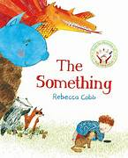 |  | 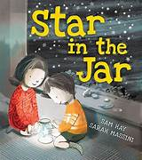 |  |  |  | 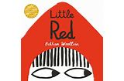 |  | 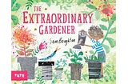 |  | 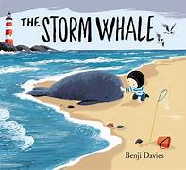
Outcome:  Encodable Losing Story Sentences | Outcome:  Encodable Animal Information Sentences | Outcome:  Encodable Finding Story Sentences | Outcome:  Encodable Poster Sentences | Outcome:  Encodable Superhero Sentences | Outcome:  Encodable Letter Sentences | Outcome:  Encodable Traditional Tale Sentences | Outcome:  Encodable Instruction Sentences | Outcome:  Encodable Instruction sentences | Outcome:  Encodable Transformation Story Sentences | Outcome:  Encodable Friendship Story Sentences | Outcome:  Encodable Whale Poem Sentences
Purpose:  To retell | Purpose:  To inform | Purpose:  To retell | Purpose:  To inform | Purpose:  To retell | Purpose:  To inform | Purpose:  To retell | Purpose:  To instruct | Purpose:  To instruct | Purpose:  To retell | Purpose:  To retell | Purpose:  To describe
n

A |  | B |  | C |  | D |  | E |  | F
Mr Gumpy’s Outing  by John Burningham | Lost  by Mariajo Ilustrajo | Moon Girl  by Thomas Docherty | Ning and the Night Spirits  by Adriena Fong | How to Hide a Lion  by Helen Stephens | Ruby’s Worry  by Tom Percival | The River  by Tom Percival | Mixed  by Arree Chung | Stuck  by Oliver Jeffers | There’s a Tiger on the Train  by Mariesa Dulak | Saving Mr Hoot  by Helen Stephens | Ready Steady Mo by Mo Farah & Kes Gray
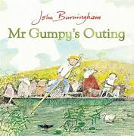 |  | 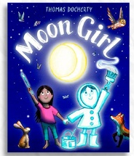 | 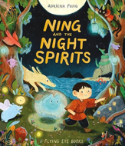 | 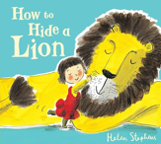 | 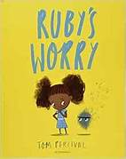 | 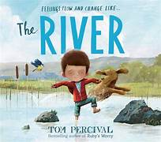 | 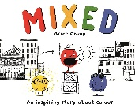 | 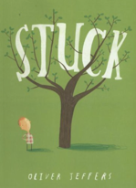 | 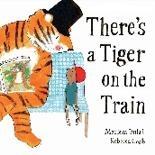 | 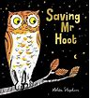 | 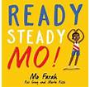
Outcome:  Encodable Journey Story Sentences | Outcome:  Encodable  Lost Instruction  Sentences | Outcome:  Encodable Night-time Story Sentences | Outcome:  Encodable  Poster Sentences | Outcome:  Encodable Instruction sentences | Outcome:  Encodable Worry Story Sentences | Outcome:  Encodable  River Story Sentences | Outcome:  Encodable Community Story  Sentences | Outcome:  Encodable  Stuck Story Sentences | Outcome:  Encodable  Diary Sentences | Outcome:  Encodable Environment Story Sentences | Outcome:  Encodable Olympic Story Sentences
Purpose:  To retell | Purpose:  To instruct | Purpose:  To retell | Purpose:  To inform | Purpose:  To instruct | Purpose:  To retell | Purpose:  To retell | Purpose:  To retell | Purpose:  To retell | Purpose:  To recount | Purpose:  To retell | Purpose:  To retell

Ready Steady Write Progression Overview Year 1
A | B | C | D | E | F
Grammar: Word
Build on previous year & focus on: Regular plural noun suffix -s or -es | Build on previous units & focus on: Reinforce plural noun suffix -s/-es Adding the suffix -er to verbs | Build on previous units & focus on: Reinforce plural noun suffix -s/-es How the prefix un- changes the meaning of verbs and adjectives Adding the suffixes -er and -est to adjectives | Build on previous units & focus on: Adding the suffixes -ing, -ed and -er to verbs Adding the suffixes -er and -est to adjectives How the prefix un- changes the meaning of verbs and adjectives | Build on previous units & focus on: Reinforce plural noun suffix -s/-es Adding the suffixes -er and -est to adjectives Adding the suffixes -ing and -ed to verbs Reinforce how the prefix un- changes the meaning of verbs and adjectives | Build on previous units & focus on: Reinforce plural noun suffix -s/-es Adding the suffixes -ing and -ed to verbs Adding the suffixes -er and -est to adjectives
Grammar: Sentence
Build on previous year & focus on: Combining words to make sentences Joining words and clauses using ‘and’ | Build on previous units & focus on: Combining words to make sentences Joining words and clauses using ‘and’ | Build on previous units & focus on: Combining words to make sentences Joining words and clauses using ‘and’ | Build on previous units & focus on: Combining words to make sentences Joining words and clauses using ‘and’ | Build on previous units & focus on: Combining words to make sentences Joining words and clauses using ‘and’ | Build on previous units & focus on: Combining words to make sentences Joining words and clauses using ‘and’
Grammar: Text
Build on previous year & focus on: Sequencing sentences to form short narratives | Build on previous year & focus on: Sequencing sentences to form short narratives | Build on previous year & focus on: Sequencing sentences to form short narratives | Build on previous year & focus on: Sequencing sentences to form short narratives | Build on previous year & focus on: Sequencing sentences to form short narratives | Build on previous year & focus on: Sequencing sentences to form short narratives
Grammar: Punctuation
Build on previous year & focus on: Separation of words with spaces Capital letters Full Stops | Build on previous year & focus on: Separation of words with spaces Capital letters Full Stops | Build on previous year & focus on: Separation of words with spaces Capital letters Full Stops Question mark Exclamation mark | Build on previous year & focus on: Separation of words with spaces Capital letters Full Stops Question mark Exclamation mark Capital Letters for names and personal pronoun - I | Build on previous year & focus on: Separation of words with spaces Capital letters Full Stops Question mark Exclamation mark Capital Letters for names and personal pronoun - I | Build on previous year & focus on: Separation of words with spaces Capital letters Full Stops Question mark Exclamation mark
Terminology for Pupils
letter, capital letter, word, sentence, plural, singular, full stop, question mark, exclamation mark, punctuation

A |  | B |  | C |  | D |  | E |  | F
Old Bear  by Jane Hissey |  | Rapunzel  by Bethan Woollvin |  | Hermelin  by Mini Grey |  | Where the Wild Things Are by Maurice Sendak |  | The Secret of Black Rock by Joe Todd-Stanton |  | The Last Wolf  by Mini Grey
 |  |  |  | 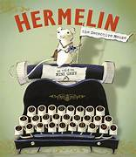 |  | 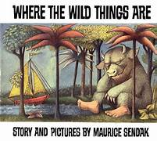 |  | 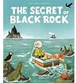 |  | 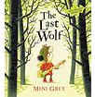
Outcome:  Encodable Finding Story Sentences | Outcome:  Encodable Message Sentences | Outcome:  Encodable Traditional Tale Sentences | Outcome:  Encodable Instruction Sentences | Outcome:  Encodable Detective Sentences | Outcome:  Encodable Letter Sentences | Outcome:  Encodable Return Story Sentences | Outcome:  Encodable Information Sentences | Outcome:  Encodable Return Story Sentences | Outcome:  Encodable Diary Sentences | Outcome:  Encodable Hunting Story Sentences | Outcome:  Encodable Recipe Sentences
Purpose:  To retell | Purpose:  To inform | Purpose:  To retell | Purpose:  To instruct | Purpose:  To retell | Purpose:  To inform | Purpose:  To retell | Purpose:  To inform | Purpose:  To retell | Purpose:  To recount | Purpose:  To retell | Purpose:  To instruct
A |  | B |  | C |  | D |  | E |  | F
The Girl at the Front of the Class  by Onjali Q. Rauf | King Lion by Emma Yarlett | Snow White and the Seven Bears  by Michael Rosen | The Queen Next Door  by Marcela Ferreira | Cloud Boy by Greg Stobbs | Whirly Twirly Me by Manjeet Mann | The 3 Little Wolves and the Big Bad Pig  by Eugene Trivizas | Pip  by Jess Rose | There’s a Tiger in the Garden by Lizzy Stewart | How to Find a Yeti by Matt Hunt | Last Tree in the City  by Peter Carnavas | Splash  by Claire Cashmore
 |  | 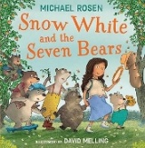 | 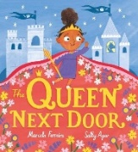 |  | 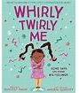 | 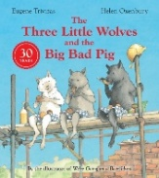 | 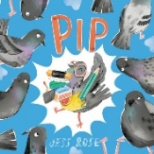 | 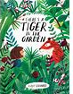 |  | 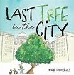 | 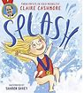
Outcome:  Encodable  Friendship Story Sentences | Outcome:  Encodable Instruction Sentences | Outcome:  Fairy Tale Sentences | Outcome: Encodable  Invitation Sentences | Outcome:  Encodable Imagination Story Sentences | Outcome:  Encodable Diary Sentences | Outcome:  Encodable Instruction Sentences | Outcome:  Encodable Invention Story Sentences | Outcome:  Encodable Search Story Sentences | Outcome:  Encodable Diary Sentences | Outcome:  Encodable Environment Story Sentences | Outcome:  Encodable Olympic Story Sentences
Purpose:  To retell | Purpose:  To instruct | Purpose:  To retell | Purpose:  To inform | Purpose:  To retell | Purpose:  To recount | Purpose:  To instruct | Purpose:  To retell | Purpose:  To retell | Purpose:  To recount | Purpose:  To retell | Purpose:  To retell

Ready Steady Write Progression Overview Year 2
A | B | C | D | E | F
Grammar: Word
Build on previous units & focus on: Use of the Suffixes –er & –est in adjectives Learn how to use -ly in Standard English to turn adjectives into adverbs Develop understanding of regular plural noun suffixes -s or -es | Build on previous units & focus on: Use of the suffix –ly to turn adjectives into adverbs  Form adjectives using suffixes -ful and -less | Build on previous units & focus on: Formation of adjectives using suffixes e.g. –ful, –less Use of the suffix –ly to turn adjectives into adverbs | Build on previous units & focus on: Use of the Suffixes –er & –est in adjectives Use of the suffix –ly to turn adjectives into adverbs | Build on previous units & focus on: Formation of nouns using suffixes e.g. –ness, –er Formation of adjectives using suffixes e.g. –ful, –less Use of the suffix –ly to turn adjectives into adverbs | Build on previous units & focus on: Formation of nouns by compounding Use of the Suffixes –er & –est in adjectives Use of the suffix –ly to turn adjectives into adverbs
Grammar: Sentence
Build on previous year & focus on: Subordination (using when, if, that, because)  Co-ordination (or, and, but)  Expanded Noun Phrases for description and specification  Learn that the grammatical patterns in a sentence indicate its function as a question or command | Build on previous units & focus on: Co-ordination (or, and, but, so) Sentence indicates its function as an exclamation or a question Expanded Noun Phrases for description and specification | Build on previous units & focus on: Subordination (using when, if, that, because) Co-ordination (or, and, but) Expanded noun phrases for description and specification How the grammatical patterns in a sentence indicates its function as a question and command | Build on previous units & focus on:  Learn that the grammatical patterns in sentence indicates its function as a question and an exclamation  Expanded Noun Phrases for description and specification | Build on previous units & focus on: Expanded noun phrases for description and specification Subordination (using when, if, that, because) Co-ordination (or, and, but) How the grammatical patterns in a sentence indicates its function as question and a statement. | Build on previous units & focus on: Subordination (using when, if, that, because)  Co-ordination (or, and, but)  Sentence indicates its function as an exclamation.  Expanded Noun Phrases for description and specification
Grammar: Text
Build on previous year & focus on: Correct choice and consistent use of past and present tense throughout writing | Build on previous units & focus on: Correct choice and consistent use of past and present tense throughout writing | Build on previous units & focus on: Correct choice and consistent use of past and present tense throughout writing | Build on previous units & focus on: Correct choice and consistent use of past and present tense throughout writing including progressive forms of verbs | Build on previous units & focus on: Correct choice and consistent use of past and present tense throughout writing | Build on previous units & focus on: Correct choice and consistent use of past and present tense throughout writing
Grammar: Punctuation
Build on previous units & focus on: Use of capital letters, full stops and question marks to demarcate sentences Use apostrophes to mark singular possession in nouns | Build on previous year & focus on: Use of capital letters, full stops, question marks and exclamation marks to demarcate sentences Apostrophes to mark where letters are missing in spelling (contractions) Apostrophes to mark singular possession in nouns Commas to separate items in a list | Build on previous units & focus on: Use of capital letters, full stops and question marks to demarcate sentences Commas to separate items in a list Apostrophes to mark where letters are missing in spelling (contractions) | Build on previous units & focus on: Use of capital letters, full stops, question marks and exclamation marks to demarcate sentences Apostrophes to mark singular possession in nouns | Build on previous units & focus on: Use of capital letters, full stops, question marks and exclamation marks to demarcate sentences Apostrophes to mark where letters are missing in spellings Commas to separate items in a list | Build on previous units & focus on: Use of capital letters, full stops and question marks to demarcate sentences Apostrophes to mark singular possession in nouns Commas to separate items in a list
Terminology for Pupils
noun, noun phrase, statement, question, exclamation, command, compound, suffix, adjective, adverb, verb, tense (past present) apostrophe, comma

A |  | B |  | C |  | D |  | E |  | F
A River  by Marc Martin |  | The Night Gardener  by The Fan Brothers |  | The Bog Baby  by Jeanne Willis |  | Grandad’s Island  by Benji Davies |  | The King Who Banned the Dark  by Emily Haworth-Booth |  | Rosie Revere, Engineer  by Andrea Beaty
 |  | 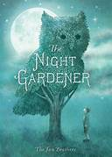 |  | 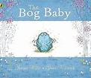 |  | 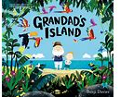 |  | 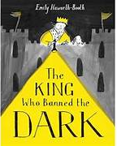 |  | 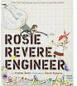
Outcome:  Circular Narrative | Outcome:  Letter | Outcome:  Setting Narrative | Outcome:  Diary | Outcome:  Finding Narrative | Outcome:  Instructions | Outcome:  Return Narrative | Outcome:  Information Text | Outcome:  Persuasive Letter | Outcome:  Banning Narrative | Outcome:  Invention Narrative | Outcome:  Explanation Text
Purpose:  To narrate | Purpose:  To inform | Purpose:  To narrate | Purpose:  To recount | Purpose:  To narrate | Purpose:  To instruct | Purpose:  To narrate | Purpose:  To inform | Purpose:  To persuade | Purpose:  To narrate | Purpose:  To narrate | Purpose:  To explain
A |  | B |  | C |  | D |  | E |  | F
Leo and the Octopus  by Isabelle Marinov | The Search for Carmella  by Chloe Savage | Noah’s New Home  by Zeshan Akhter | The Misadventures of Frederick  by Ben Manley | Lizzy and the Cloud  by The Fan Brothers | Cyril the Lonely Cloud  by Tim Hopgood | Flower Block  by Lanisha Butterfield | Grandad’s Camper by Harry Woodgate | Jack and the Baked Beanstalk  by Colin Stimpson | Jack and the Baked Beanstalk  by Colin Stimpson | Tidy  by Emily Gravett | Sportopedia  by Adam Skinner
 |  |  | 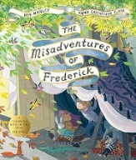 | 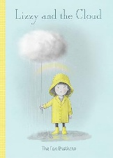 | 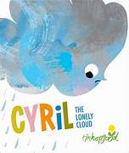 |  |  | 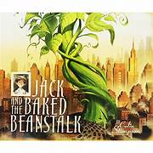 |  | 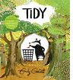 | 
Outcome:  Friendship Narrative | Outcome: Underwater Explorer’s Log | Outcome:  Overcoming Fear Narrative | Outcome:  Persuasive Letter | Outcome:  Caring for a Cloud Guide | Outcome:  Belonging Narrative | Outcome:  Diary | Outcome:  Memory Narrative | Outcome:  Persuasive Letter | Outcome:  Twisted Tale | Outcome:  Environment Narrative | Outcome:  Olympics Sports Guide
Purpose:  To narrate | Purpose:  To recount | Purpose:  To narrate | Purpose:  To inform | Purpose:  To instruct | Purpose:  To narrate | Purpose:  To recount | Purpose:  To narrate | Purpose:  To persuade | Purpose:  To narrate | Purpose:  To narrate | Purpose:  To inform/ instruct

Ready Steady Write Progression Overview Year 3
A | B | C | D | E | F
Grammar: Word
Build on previous year & focus on: Formation of nouns using a range of prefixes e.g. auto- super- anti-  Use of the forms 'a' or 'an' | Build on previous units & focus on: Formation of nouns using a range of prefixes e.g. auto- super- anti- un- -dis -mis -im -in Use of the forms ‘a’ or ‘an’ when next word starts with a consonant or a vowel Adverbs ending in -ly | Build on previous units & focus on: Use of the forms ‘a’ or ‘an’ when next word starts with a consonant or a vowel | Build on previous units & focus on: Use of the forms ‘a’ or ‘an’ when next word starts with a consonant or a vowel Word families based on common words showing how words are related in form and meaning | Build on previous units & focus on: Use of the forms ‘a’ or ‘an’ when next word starts with a consonant or a vowel Word families based on common words showing how words are related in form and meaning | Build on previous units & focus on: Formation of nouns using a range of prefixes e.g. auto- super- anti- (mis-, in-, dis-, un-) Use of the forms ‘a’ or ‘an’ when next word starts with a consonant or a vowel Word families based on common words showing how words are related in form and meaning
Grammar: Sentence
Build on previous year & focus on: Expressing time, place and cause using conjunctions e.g. (when, before, after, while, so, because, if, although) Learn how to use subordination (reinforce from Y2) Expressing time, place and cause using adverbs e.g. then, there, soon, after Expressing time, place and cause using prepositions e.g. before, during, after, in Use expanded noun phrases for description and specification | Build on previous units & focus on: Expressing time, place and cause using prepositions, e.g. before, after, during, in Use a wider range of conjunctions, e.g. when, if, because, although | Build on previous units & focus on: Noun phrases expanded by the addition of modifying adjectives, nouns and prepositions  Fronted adverbials  Developing the range of sentences with more than one clause by using a wider range of conjunctions including when, if, because, although, before, after, while, so’ | Build on previous units & focus on: Expressing time, place and cause using prepositions e.g. before, after, during, in, because, of  Expressing time, place and cause using adverbs e.g. then, next, soon, therefore  Use a wider range of conjunctions, e.g. when, if, because, although | Build on previous units & focus on: Expressing time, place and cause using adverbs e.g. (then, next, soon, therefore) Expressing time, place and cause using prepositions e.g. (before, after, during, in, because of) | Build on previous units & focus on: Expressing time, place and cause using adverbs e.g. then, next, soon, therefore  Expressing time, place and cause using prepositions e.g. before, after, during, in, because of
Grammar: Text
Build on previous year & focus on: Introduction to paragraphs as a way to group related material | Build on previous units & focus on: Present perfect form of verbs in contrast to the simple past | Build on previous units & focus on: Introduction to paragraphs as a way to group related material Present perfect form of verbs in contrast to the simple past | Build on previous units & focus on: Present perfect form of verbs in contrast to the simple past | Build on previous units & focus on: Headings and sub-headings to aid presentation | Build on previous units & focus on: Present perfect form of verbs Introduction to paragraphs as a way to group related material Headings and sub-headings to aid presentation
Grammar: Punctuation
Reinforce from Year 2: Use of capital letters, full stops, question marks and exclamation marks to demarcate sentences Apostrophes to mark where letters are missing in spelling and to mark singular possession in nouns Use commas to separate items in a list | Reinforce from Year 2: Commas to separate items in a list Apostrophes to mark singular possession in nouns Inverted commas to punctuate direct speech | Build on previous units & focus on: Apostrophes to mark singular possession in nouns Learn how to use commas to separate items in a list | Build on previous units & focus on: Inverted commas to punctuate direct speech | Build on previous units & focus on: Inverted commas to punctuate direct speech | Build on previous units & focus on: Inverted commas to punctuate direct speech
Terminology for Pupils
preposition, conjunction, word family, prefix, clause, subordinate clause, direct speech, consonant, consonant letter vowel, vowel letter, inverted commas

A |  | B |  | C |  | D |  | E |  | F
The Iron Man by Ted Hughes (Chris Mould edition) |  | Fox  by Margaret Wild |  | The Rhythm of the Rain  by Grahame Baker-Smith |  | Pip & Egg  by Alex Latimer | It Fell from the Sky by The Fan Brothers | Marcy and the Riddle of the Sphinx by Joe Todd-Stanton |  | Into the Forest  by Anthony Browne | The Secret Elephant  by Ellan Rankin
 |  |  |  | 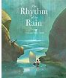 |  | 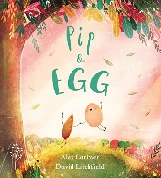 |  |  |  | 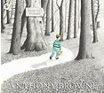 | 
Outcome:  Approaching Threat Narrative | Outcome:  Trap Explanation | Outcome:  Fable Narrative | Outcome:  Information Report | Outcome:  Setting Narrative | Outcome:  Encodable Information Leaflet | Outcome:  Transformation Narrative | Outcome:  Complaint Letter | Outcome:  Quest Narrative | Outcome:  Non-Chronological Report | Outcome:  Lost Narrative | Outcome:  Diary
Purpose:  To narrate | Purpose:  To explain | Purpose:  To narrate | Purpose:  To inform | Purpose:  To narrate | Purpose:  To inform | Purpose:  To narrate | Purpose:  To persuade | Purpose:  To narrate | Purpose:  To inform | Purpose:  To narrate | Purpose:  To recount
A |  | B |  | C |  | D |  | E |  | F
Ocean Meets Sky  by The Fan Brothers | The Search for the Giant Arctic Jellyfish  by Chloe Savage | The Grumpy Ghost Upstairs  by Mamiko Shiotani | Hortense and the Shadow  by Natalia and Lauren O’Hara | Starbird  by Sharon King-Chai | The Worry Tiger  by Chloe Savage | Wisp  by Zana Fraillon | A Stage Full of Shakespeare Stories by Angela McAllister | The Forgettery  by Rachel Ip | The Search for Our Cosmic Neighbours  by Chloe Savage | Dear Earth  by Isabella Otter | Usain Bolt  by Maria Sanchez-Vegara
 |  | 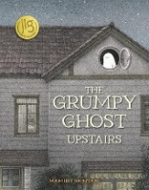 | 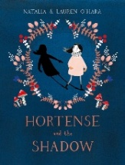 |  |  |  | 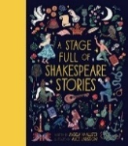 | 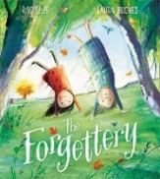 |  | 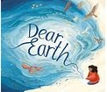 | 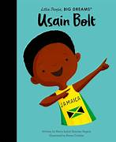
Outcome:  Dream Adventure Narrative | Outcome:  Captain’s Daily Log | Outcome:  Ghost Narrative | Outcome:  Diary | Outcome:  Captivity Narrative | Outcome:  Calmness Guide | Outcome:  Promise Narrative | Outcome:  Potion Recipe | Outcome:  Finding Memories Narrative | Outcome:  Exploration Narrative | Outcome:  Environment Letter | Outcome:  Olympian Recount
Purpose:  To narrate | Purpose:  To recount | Purpose:  To narrate | Purpose:  To recount | Purpose:  To narrate | Purpose:  To inform | Purpose:  To narrate | Purpose:  To instruct | Purpose:  To narrate | Purpose:  To narrate | Purpose:  To describe | Purpose:  To inform
Ready Steady Write Progression Overview Year 4
A | B | C | D | E | F
Grammar: Word
Build on previous units & focus on: Develop understanding of standard English forms for verb inflections (we were instead of we was) | Build on previous year & focus on: Grammatical difference between plural and possessive -s Develop understanding of standard English forms for verb inflections (we were instead of we was) | Build on previous units & focus on: Grammatical difference between plural and possessive -s | Build on previous units & focus on: Grammatical difference between plural and possessive -s Develop understanding of standard English forms for verb inflections (we were instead of we was) | Build on previous units & focus on: Develop understanding of standard English forms for verb inflections (we were instead of we was) Grammatical difference between plural and possessive -s | Build on previous units & focus on: Verb inflections (we were instead of we was)
Grammar: Sentence
Build on previous units & focus on: Noun phrases expanded by the addition of modifying adjectives, nouns and prepositions Fronted adverbials | Build on previous year & focus on: Noun phrases expanded by the addition of modifying adjectives, nouns and preposition phrases Expressing time and place and cause using prepositions [for example, before, after, during, in, because of] (Recap from Y3) Fronted adverbials | Build on previous units & focus on: Noun phrases expanded by the addition of modifying adjectives, nouns and prepositions Fronted adverbials | Build on previous units & focus on: Noun phrases expanded by the addition of modifying adjectives, nouns and prepositions Fronted adverbials | Build on previous units & focus on: Fronted adverbials | Build on previous units & focus on: Fronted adverbials
Grammar: Text
Build on previous units & focus on: Nouns or pronouns to aid cohesion and avoid repetition Develop understanding using the present perfect forms of verbs (reinforcement from Y3) | Build on previous year & focus on: Appropriate choice of pronoun or noun within and across sentences to aid cohesion and avoid repetition | Build on previous units & focus on: Nouns or pronouns to aid cohesion and avoid repetition Paragraphs to organise ideas around a theme, with headings and subheadings | Build on previous units & focus on: use adverbials and conjunctions for cohesion | Build on previous units & focus on: Nouns or pronouns to aid cohesion and avoid repetition | Build on previous units & focus on: Nouns or pronouns to aid cohesion and avoid repetition Paragraphs to organise ideas around a theme
Grammar: Punctuation
Build on previous units & focus on: Inverted commas and other punctuation to indicate direct speech Use commas after fronted adverbials | Build on previous year & focus on: Apostrophes for possession (plural nouns) Use commas after fronted adverbials | Build on previous units & focus on: Apostrophes for possession (plural nouns)  Use commas after fronted adverbials | Build on previous units & focus on: Inverted commas and other punctuation to indicate direct speech Apostrophes for possession (plural nouns) Use commas after fronted adverbials | Build on previous units & focus on: Inverted commas and other punctuation to indicate direct speech Apostrophes for possession (plural nouns) Use commas after fronted adverbials | Build on previous units & focus on: Inverted commas and other punctuation to indicate direct speech Use commas after fronted adverbials
Terminology for Pupils
determiner, pronoun, possessive pronoun, adverbial
A |  | B |  | C |  | D |  | E |  | F
The Whale  by Ethan and Vita Murrow |  | Leaf  by Sandra Dieckmann |  | Arthur and the Golden Rope by Joe Todd-Stanton |  | The Lost Happy Endings  by Carol Ann Duffy |  | The Journey  by Francesca Sanna |  | Manfish  by Jennifer Berne
 |  |  |  |  |  | 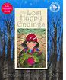 |  | 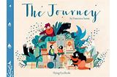 |  | 
Outcome:  Setting Narrative | Outcome:  Newspaper Report | Outcome:  Outsider Narrative | Outcome:  Diary | Outcome:  Myth Narrative | Outcome:  Information Guide | Outcome:  Twisted Narrative | Outcome:  Persuasive Letter | Outcome:  Refugee Narrative | Outcome:  Diary | Outcome:  Invention Narrative | Outcome:  Biography
Purpose:  To narrate | Purpose:  To report | Purpose:  To narrate | Purpose:  To inform | Purpose:  To narrate | Purpose:  To inform | Purpose:  To narrate | Purpose:  To persuade | Purpose:  To narrate | Purpose:  To recount | Purpose:  To narrate | Purpose:  To inform
A |  | B |  | C |  | D |  | E |  | F
Leon and the Place Between  by Angela McAllister | Leon and the Place Between  by Angela McAllister | Nen and the Lonely Fisherman  by Ian Eagleton | The Barnabus Project  by The Fan Brothers | The Boy Who Grew Flowers  by Jennifer Wojtowicz | The Invisible  by Tom Percival | The Great Kapok Tree  by Lynne Cherry | A Stage Full of Shakespeare Stories by Angela McAllister | Our Tower  by Joseph Coelho | Flotsam  by David Wiesner | The Secret Sky Garden  by Linda Sarah | The Corinthian Girl  by Christina Balit
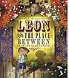 |  | 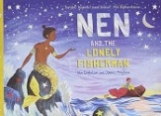 | 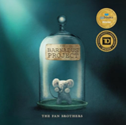 | 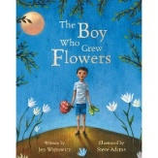 | 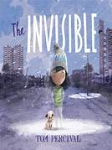 | 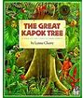 |  | 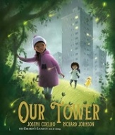 |  | 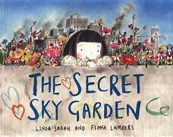 | 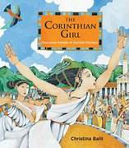
Outcome:  Portal Narrative | Outcome:  Persuasive Magic Show Report | Outcome:  Folklore Narrative | Outcome:  First Person Escape Plan | Outcome:  Diary | Outcome:  Becoming Visible Narrative | Outcome:  Persuasive Letter | Outcome:  Summoning Narrative | Outcome:  Environmental Change Narrative | Outcome:  Secret Sea Creature Guide | Outcome:  Transformation Narrative | Outcome:  Success Narrative
Purpose:  To narrate | Purpose:  To persuade | Purpose:  To narrate | Purpose:  To explain | Purpose:  To recount | Purpose:  To narrate | Purpose:  To persuade | Purpose:  To narrate | Purpose:  To narrate | Purpose:  To explain | Purpose:  To narrate | Purpose:  To narrate

Ready Steady Write Progression Overview Year 5
A | B | C | D | E | F
Grammar: Word
Build on previous year & focus on: Develop an understanding of the use of verb prefixes | Build on previous units & focus on: The difference between vocabulary of informal speech and vocabulary appropriate to formal speech and writing – formal tone Use verb prefixes (un-, de-, re-, over-, dis-, mis-) | Build on previous units & focus on: The difference between vocabulary of informal speech and vocabulary appropriate to formal speech and writing – formal tone Develop understanding and use of verb prefixes Converting nouns or adjectives into verbs using suffixes | Build on previous units & focus on: Develop understanding and use of verb prefixes | Build on previous units & focus on: Verb prefixes mis, over and de Converting nouns or adjectives into verbs using suffixes | Build on previous units & focus on: Converting nouns or adjectives into verbs using suffixes
Grammar: Sentence
Build on previous year & focus on: Indicate degrees of possibility using modal verbs Expanded noun phrases to convey complicated information concisely Develop understanding of relative clauses | Build on previous units & focus on: Indicate degrees of possibility using modal verbs Expanded noun phrases to convey complicated information concisely Use fronted adverbials | Build on previous units & focus on: Relative clauses beginning with who, which, where, when, whose, that or an omitted relative pronoun | Build on previous units & focus on: Indicate degrees of possibility using modal verbs and adverbs | Build on previous units & focus on: Indicate degrees of possibility using adverbs and modal verbs Relative clauses beginning with who, which, where, when, whose, that or an omitted relative pronoun | Build on previous units & focus on: Develop understanding and use of relative clauses beginning with who, which, where, when, whose, that, or an omitted relative pronoun Develop understanding of expanded noun phrases to convey complicated information concisely Indicate degrees of possibility using modal verbs
Grammar: Text
Build on previous year & focus on: Use of a range of sentence types for impact and cohesion | Build on previous units & focus on: Develop understanding in using devices to build cohesion within a paragraph | Build on previous units & focus on: Develop understanding in using devices to build cohesion within a paragraph | Build on previous units & focus on: Develop understanding in using devices to build cohesion within a paragraph | Build on previous units & focus on: Develop understanding in using devices to build cohesion within a paragraph | Build on previous units & focus on: Develop understanding in using devices to build cohesion within a paragraph
Grammar: Punctuation
Build on previous year & focus on: Indicate parenthesis using dashes and brackets Commas after fronted adverbials (reinforce from Y4) Inverted commas to indicate direct speech (reinforce from Y4) | Build on previous units & focus on: Commas, brackets and dashes for parenthesis Use commas after fronted adverbials | Build on previous units & focus on: Commas, brackets and dashes for parenthesis Use commas after fronted adverbials | Build on previous units & focus on: Commas for parenthesis | Build on previous units & focus on: Indicate parenthesis using brackets Commas for clarity | Build on previous units & focus on: Use commas for clarity and to avoid ambiguity Use of a comma after the reporting clause and use of end punctuation within inverted commas (Y4) Indicate parenthesis using brackets
Terminology for Pupils
modal verb, relative pronoun, relative clause, parenthesis, bracket, dash, cohesion, ambiguity

A |  | B |  | C |  | D |  | E |  | F
Curiosity  by Markus Motum |  | FArTHER  by Grahame Baker-Smith |  | The Hound of the Baskervilles by Sir Arthur Conan Doyle (graphic novel edition by Daniel Ferran) |  | The Promise  by Nicola Davies |  | The Lost Book of Adventure  by Teddy Keen |  | King Kong  by Anthony Browne
 |  | 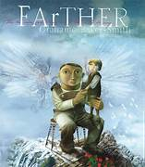 |  | 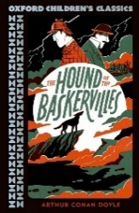 |  | 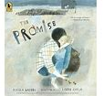 |  | 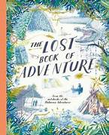 |  | 
Outcome:  Space Journey Narrative | Outcome:  Formal Mission Report | Outcome:  Setting Narrative | Outcome:  Letter | Outcome:  Cliffhanger Narrative | Outcome:  Formal Report | Outcome:  Character Narrative | Outcome:  Bargain Letter | Outcome:  Survival Narrative | Outcome:  Survival Guide | Outcome:  Dilemma Narrative | Outcome:  Balanced Argument
Purpose:  To narrate | Purpose:  To report | Purpose:  To narrate | Purpose:  To recount | Purpose:  To narrate | Purpose:  To report | Purpose:  To narrate | Purpose:  To persuade | Purpose:  To narrate | Purpose:  To explain | Purpose:  To narrate | Purpose:  To discuss
A |  | B |  | C |  | D |  | E |  | F
The Midnight Fair by Gideon Sterer | I Go Quiet  by David Ouimet | The Lost Thing by Shaun Tan | The New Girl  by Nicola Davies | Milo Imagines the World by Matt de la Peña | A Shelter for Sadness  by Anne Booth | Wild is the Wind by Grahame Baker-Smith | A Stage Full of Shakespeare Stories by Angela McAllister | Henry’s Freedom Box  by Ellen Levine | Henry’s Freedom Box  by Ellen Levine | Greta and the Giants  by Zoë Tucker | Wilma Rudolph by Maria Sanchez-Vegara
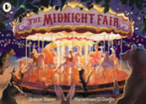 | 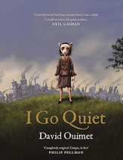 |  | 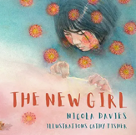 |  | 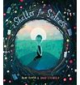 | 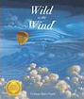 |  |  |  | 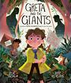 | 
Outcome:  Trespass Narrative | Outcome:  Diary | Outcome:  Return Narrative | Outcome:  Letter | Outcome:  Diary | Outcome:  Embracing Emotions Narrative | Outcome:  Journey Narrative | Outcome:  Persuasive Letter | Outcome:  Diary Entry | Outcome:  Biography | Outcome:  Restoring the Environment Narrative | Outcome:  Gratitude Speech
Purpose:  To narrate | Purpose:  To recount | Purpose:  To narrate | Purpose:  To recount | Purpose:  To recount | Purpose:  To narrate | Purpose:  To narrate | Purpose:  To persuade | Purpose:  To recount | Purpose:  To recount | Purpose:  To narrate | Purpose:  To inform

Ready Steady Write Progression Overview Year 6
A | B | C | D | E | F
Grammar: Word
Build on previous year & focus on: Understand how words are related by meaning as synonyms and antonyms The difference between vocabulary of informal speech and vocabulary appropriate to formal speech and writing – formal and informal vocabulary choices | Build on previous units & focus on: Understand how words are related by meaning as synonyms and antonyms Converting nouns into verbs using suffixes (reinforce from Y5) The difference between vocabulary of informal speech and vocabulary appropriate to formal speech and writing - informality of direct quote contrasting with formality of vocabulary choices | Build on previous units & focus on: Understand how words are related by meaning as synonyms and antonyms The difference between vocabulary of informal speech and vocabulary appropriate to formal speech and writing | Build on previous units & focus on: Develop understanding of how words are related by meaning as synonyms and antonyms The difference between vocabulary of informal speech and vocabulary appropriate to formal speech and writing | Build on previous units & focus on: Develop understanding of how words are related by meaning as synonyms and antonyms The difference between vocabulary of informal speech and vocabulary appropriate to formal speech and writing | Build on previous units & focus on: Understand how words are related by meaning as synonyms and antonyms The difference between vocabulary of informal speech and vocabulary appropriate to formal speech and writing – formal tone
Grammar: Sentence
Build on previous year & focus on:  The difference between structures typical of informal speech and structures appropriate to formal - use of question tags in informal speech  Develop understanding of the passive to affect the presentation of information in a sentence | Build on previous units & focus on: The difference between structures typical of informal speech and structures appropriate to formal Using expanded noun phrases to convey complicated information concisely | Build on previous units & focus on: The difference between structures typical of informal speech and structures appropriate to formal Using expanded noun phrases to convey complicated information concisely Use the subjunctive forms in some very formal writing and speech | Build on previous units & focus on: Using expanded noun phrases to convey complicated information concisely Understand the difference between structures typical of informal speech and structures appropriate to formal  Develop understanding of the passive to affect the presentation of information in a sentence Use the subjunctive forms in some very formal writing and speech | Build on previous units & focus on: Using expanded noun phrases to convey complicated information concisely Understand the difference between structures typical of informal speech and structures appropriate to formal  Develop understanding of the passive to affect the presentation of information in a sentence | Build on previous units & focus on:  The difference between structures typical of informal speech and structures appropriate to formal speech in writing  Use of the subjunctive form in some very formal speech and writing
Grammar: Text
Build on previous year & focus on: using a wider range of cohesive devices - adverbials | Build on previous units & focus on: Use headings, sub-headings, columns and captions to structure information | Build on previous units & focus on: Use headings and sub-headings to structure information | Build on previous units & focus on: Using cohesive devices, e.g. synonyms Accurate tense choices throughout the writing | Build on previous units & focus on: Using headings and sub-headings to organise information | Build on previous units & focus on: Linking ideas within and across paragraphs using a wider range of cohesive devices
Grammar: Punctuation
Build on previous year & focus on: Semi-colons within detailed lists Indicate grammatical features using the semi-colon to mark the boundary between independent clauses Dashes and commas to indicate parenthesis | Build on previous units & focus on: Use hyphens to join words and avoid ambiguity Use range of punctuation taught at KS2 (Speech punctuation) Use the semi-colon as the boundary between independent clauses | Build on previous units & focus on: Use dashes, colons and semi-colons to mark the boundary between independent clauses Use colons to introduce a list | Build on previous units & focus on: Use semi-colons, colons and dashes to mark the boundary between independent clauses  Use hyphens to avoid ambiguity  Use colons to introduce a list  Use semi-colons within lists | Build on previous units & focus on: Use semi-colons, and dashes to mark the boundary between independent clauses Use commas to clarify meaning and avoid ambiguity | Build on previous units & focus on: Use semi-colons, colons and dashes to mark the boundary between independent clauses Use hyphens to avoid ambiguity
Terminology for Pupils
subject, object, active, passive, synonym, antonym, ellipsis, hyphen, colon, semi-colon, bullet points

A |  | B |  | C |  | D |  |  | E |  | F
Rose Blanche  by Ian McEwan |  | A Story Like the Wind  by Gill Lewis |  | On the Origin of Species  by Sabina Radeva |  | The Ways of the Wolf  by Smriti Prasadam-Halls |  |  | Shackleton’s Journey  by William Grill |  | Paradise Sands  by Levi Pinfold
 |  | 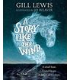 |  | 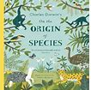 |  | 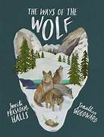 |  |  |  |  | 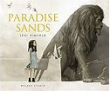
Outcome:  Diary | Outcome:  Bravery Award Speech | Outcome:  Flashback Narrative | Outcome:  Newspaper Report | Outcome:  Discovery Narrative | Outcome:  Explanation Text | Outcome:  Documentary Narrative | Outcome:  Balanced Argument | Outcome: Hunted Narrative | Outcome:  Endurance Narrative | Outcome:  Biography | Outcome:  First-Person Narrative | Outcome:  Warning Letter
Purpose:  To recount | Purpose:  To recount & inform | Purpose:  To narrate | Purpose:  To report | Purpose:  To narrate | Purpose:  To explain | Purpose:  To narrate | Purpose:  To discuss | Purpose:  To narrate | Purpose:  To narrate | Purpose:  To recount | Purpose:  To narrate | Purpose:  To warn

A |  | B |  | C |  | D |  |  | E |  | F
One Day  by Michael Rosen |  | The Lost Book of Undersea Adventure  by Teddy Keen | Rescuing Titanic  by Flora Delargy | The Station Cat  by Stephen Hogtun | Night Shift  by Debi Gliori | Rise Up  by Amanda Li | A Stage Full of Shakespea-re Stories  by Angela McAllister | The Ice Bear by Jackie Morris | The Invisible Story  by Jaime Gamboa | The Mysteries of Harris Burdick  by Chris Van Allsburg | Varmints  by Helen Ward | Stories for Boys Who Dare to be Different 2  by Ben Brooks  Good Night Stories for Rebel Girls 2  by Elena Favilli and Francesca Cavallo
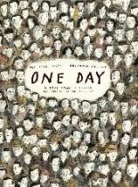 | 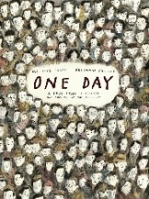 | 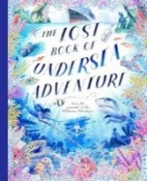 | 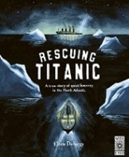 | 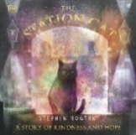 |  |  | 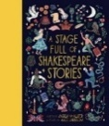 |  | 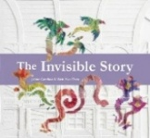 | 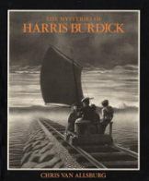 |  |   
Outcome:  Diary | Outcome:  Letter | Outcome:  Underwater Adventure Narrative | Outcome:  Survivor’s Letter Home | Outcome:  Restoring Happiness Narrative | Outcome:  Journal | Outcome:  Newspaper Report | Outcome  Diary | Outcome: Myth Narrative | Outcome:  First-Person Narrative | Outcome:  Private Investigator Report | Outcome:  Environmental Change Narrative | Outcome:  Daily Blog
Purpose:  To recount | Purpose:  To describe | Purpose:  To narrate | Purpose:  To inform | Purpose:  To narrate | Purpose:  To recount | Purpose:  To report | Purpose:  To recount | Purpose:  To narrate | Purpose:  To narrate | Purpose:  To report | Purpose:  To narrate | Purpose:  To inform

