

A Parents’ Guide to Supporting Children’s Spelling

Dear Parents,
Many of you have been asking us how you can support your child at home with spelling, so we have devised this booklet. If you have any questions, please do not hesitate to ask your child’s teacher.

Learning to spell is a highly complex business! Some children learn to spell effortlessly – most get there in the end, but too many can find the process of learning to spell arduous, painstaking and sadly boring.
The Friday spelling test may be great for those who can already spell, but for others it makes for a scary Friday morning. Children can get most spellings right on the day, but some then forget them when coming to use them in future work.

For this reason, it is necessary to have an approach that meets the needs of all children and allows them, to develop their skills at an appropriate rate, in order that they can happily spell common words accurately and develop a range of strategies to tackle words that are more complex with confidence.

Studies have shown that sending home a list of words to learn in preparation for a weekly test is not the most effective way for most children to learn and some children (although they may have performed well), have forgotten these words just a few hours after the test.
Spelling must be made fun, enjoyable and interesting. Children only really become good at spelling by practising repeatedly and this is best done in fun and interesting ways.

There are distinct stages through which children progress in spelling and these will be outlined in this guide. Before finding out about these, please take time to read about how children learn to spell.
The range of sections will help you understand how your child learns best and how to choose the most appropriate activities to help them. It is important to say however, that all children are different and progress at different rates and some will not display the characteristics described in the key stage descriptions in this document. If you are unsure at which stage your child is at, please ask the class teacher who will be happy to advise on appropriate words and activities.

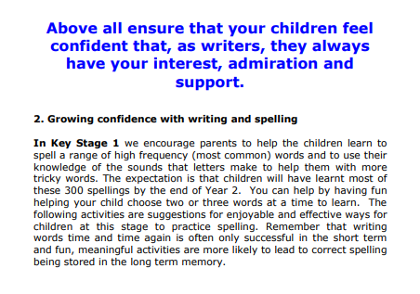

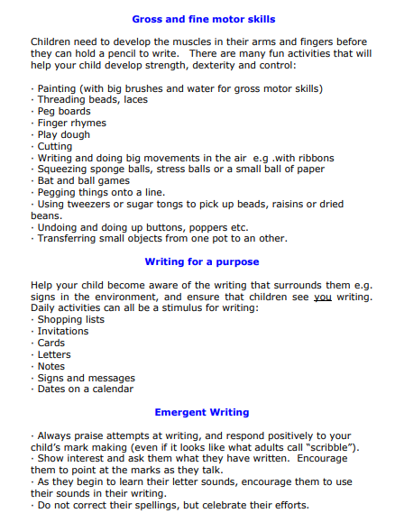

3. Developing accuracy and a range of strategies for spelling

In Key Stage 2, children will be set a spelling pattern; this means that children need to learn the rules for this pattern and be confident in spelling a range of words with said pattern. Please don’t just encourage children to learn the examples set as these won’t necessarily be the words they are tested on.
Children will also be expected to learn a range of statutory spellings, these are a mixture of words pupils frequently use in their writing and those which they often misspell.
Teachers check that the children are then using these correct spellings in their own writing. At this stage, it is appropriate for teachers to point out when certain words are spelt incorrectly, but more importantly, that children recognise for themselves when they have made an error and know a range of strategies for correcting inaccuracies.
By this stage, children will have a range of spelling strategies that they will have been taught, to draw on. Children will use the strategy which best suits their learning style and works best for them.
Supporting children who find spelling particularly difficult
In a few cases, children have particular difficulties with reading and spelling. Your child’s teacher will have discussed with you if your child has these difficulties and it is most likely that there will be an intervention in place; which identifies specific, tailored activities that will best help your child learn to spell. If you feel that your child has difficulties with spelling, then please discuss this with your child’s class teacher. You can help by supporting your child with these specific activities rather than the general ones listed below.

Glossary
Consonant – any letter of the alphabet which is not a vowel.
Digraph – Two letters which together make one unit of sound, e.g. sh. th, ee, oa.
Grapheme – The written representation of letters which represent the sounds.
Homophone – a word which sounds the same as another word but is spelt differently and has a different meaning, e.g. hear and here
Phonetics – system of spelling words by representing sounds with syllables
Phoneme – the smallest unit of sound in a word, e.g. c/a/t, sh/o/p, t/ea/ch/er.
Prefix – small addition to a word made by joining on one or more letters at the beginning, e.g. pre, anti
Plural – a plural word refers to more than one thing, e.g. books
Segmenting – means hearing the individual phonemes within a word – for instance the word „crash‟ consists of four phonemes: „c-r-a-sh‟. In order to spell this word, a child must segment it into its component phonemes and choose a grapheme to represent each phoneme.
Singular – the name referring to one thing or a group of things, e.g. man, book, flock Split digraph – two letters, which work as a pair, split, to represent one sound, e.g. a-e as in cake, or i-e as in kite
Suffix – a letter or group of letters added to the end of a word to change the way you use it, e.g. coward – cowardly
Syllable – a combination of one or more vowels and consonants which can make one short word or part of a longer word, e.g. won-der-ful
Trigraph – three letters which together make one sound but cannot be separated into smaller phonemes, e.g. igh as in light, ear as in fear and tch as in watch
Vowel – there are 5 vowels in the alphabet - aeiou

