

Britannia Community Primary School

Online Safety Newsletter: October 2019
Netflix

Does your child watch Netflix? You can add a PIN to your account so a 4-digit PIN must be entered to either play any TV show or movie above a selected maturity level (on all profiles) or to play a specific TV series or movie (on all profiles).

Alternatively, you can create up to 5 personalised profiles in your Netflix account for each member of the household. You can then choose a maturity level for each profile to control the TV shows and movies they can view.

For younger children, you could create a child profile which only includes content appropriate for children.

Find out more here:
https://help.netflix.com/en/node/264
Nintendo Switch

Nintendo Switch (and the newer Switch Lite which launched last month) offers lots of fun and age appropriate games to play and by setting up appropriate controls, it can offer a safe and fun environment to play games.

What is Nintendo Switch Online?

This is a paid service that allows the user to play online by linking to other Switch consoles. Nintendo’s guidance states ‘this service should not be used by account users who are under 13 years old’. Due to its online nature, children could be playing games with people they don’t know which has risks such as being exposed to inappropriate language. If you do choose to purchase this service for your child then set up the appropriate controls detailed below.

Parental Controls App
There is a Nintendo Switch Parental Controls app available which is free to download to your phone (or other smart device) which you can then link to your child’s Nintendo Switch in order to monitor what they are playing. You can also set some restrictions on the Nintendo Switch. You can use the app to:
- see what video games your child has been playing
- how long your child has been playing for and set time limits
- set which games can be played based on their PEGI age rating
- turn off voice chat
- restrict spending in the Nintendo eShop


Further information
For further information and guidance, visit the following links:

- https://www.nintendo.co.uk/Nintendo-Switch/Nintendo-Switch-Parental-Controls/Nintendo-Switch-Parental-Controls-1183145.html
- https://www.commonsensemedia.org/blog/parental-controls-nintendo-switch
Users of this guide do so at their own discretion. No liability is entered into. Current as of the date released 1.10.19.

Digital Wellbeing

We all need to be aware of how being online can affect us and look after our digital wellbeing. Childnet have further information about what digital wellbeing is as well as how you can support your child’s digital wellbeing tailored to their age:
The BBC Own It app has launched!

The BBC Own it app is now available to download. It includes its own keyboard and lots of content to help your child develop healthy online behaviours. The app monitors how your child interacts with their friends and family and uses artificial intelligence to try and see how your child is feeling.


The keyboard analyses your child’s activity to recommend content that might be helpful or may intervene when a child is typing something to check that they are happy to share that information. Here are some examples:
https://www.childnet.com/parents-and-carers/hot-topics/digital-wellbeing
- If your child is typing their phone number, the app will prompt the child to ‘think safe’ before sharing it.
- If they are typing something that could be deemed as unkind, they will be asked if they really want to say that.
Guided Access
with iPhone, iPad and iPod touch

Turn on Guided Access when you let your child use your device. Guided Access limits access to one app. This can be set up in Settings. To find out how to set this up, follow these instructions:

https://support.apple.com/en-gb/HT202612

- If the child types a nice message then they are reminded that they are doing great!

The app also includes lots of content from BBC Own it, videos, quizzes, gifs and memes.

More information is available here:
https://www.bbc.com/ownit/take-control/own-it-app
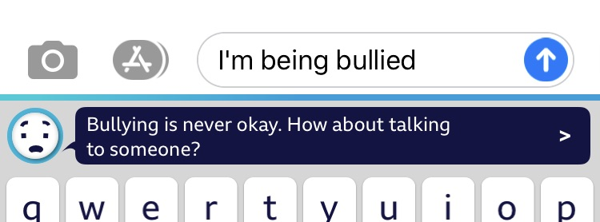


Screen time

Are you worried your child has too much screen time? Internet Matters have produced these great guides which include the benefits and challenges of screen use as well as top tips for managing your child’s screen time based on their age.

Available here:
https://www.internetmatters.org/issues/screen-time/
82 % of 5 – 7 year olds go online for around 9½ hrs a week
Source: Ofcom children and parents media use and attitudes 2018

