Outwood Primary School - FS2 Homework – Spring Term 2
Social Justice and Equality: Is it Fair?
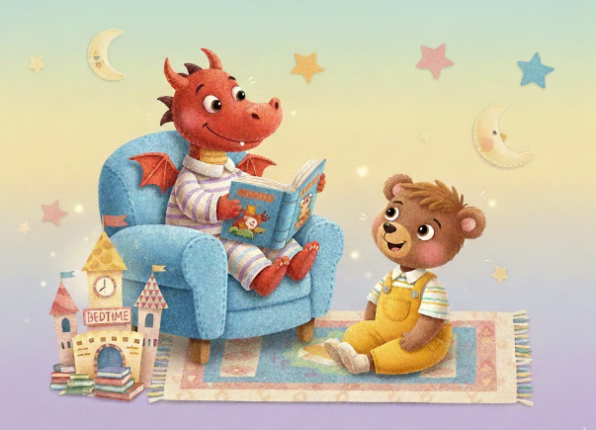
Please read everynight to support your child as a developing reader and storyteller.
Cover as many areas as you can to collect the chillies
Writing chillies | Reading chillies |  | Maths chilies
  Write your first name. Use a capital letter for the beginning.  Can you also write your surname accurately too? | Can you read all of set 1 and special friends sounds yet? Challenge yourself to see what sounds you can recognise very quickly. |  | What 2D & 3D shapes can you find at home? Look in cupboards at tins and boxes. Can you sort them into heavy and light? Find the heaviest/lightest.
Can you write the letters of the alphabet? Can you write the capital letters to match? Use the sheet to remind you if needed. | What ‘red words’ can you read speedily? Keep practising. Try to get speedier each time you read them. Then – try to write them using the correct spellings. |  | How far can you accurately count to? Can you wirte the numbers?  Can you count in 10’s, 5’s, 2’s? Can you wirte those number patterns?
    Draw a picture of your favourite story character. Why do you select them? Write a caption/sentence about it. | Read your book to an adult every day. Can you talk about the characters and link the story to other stories you have read? |  | Can you find doubles? 1-7?  Can you add 2 groups of things and find the total?
EAD Music  Interactive early years music. Body percussion – everybody do this just like me. Can you do all for when singing if your happy and you know it? (break the lesson into approximately 5 minute sessions)  https://www.youtube.com/watch?v=BlxEmKC3yyM | EAD Art  Look at you favourite toy. What colours can you see? How tall is it? What parts are bigger than others?  Carefully observe your toy and beging to draw it using a pencil first. Once you are happy – colour it using paints or pencil colours. |  | UW History  Find out about the roles and occupations your parents and grandparents have. How are they similar / different? Have they changed over time? Has technology changed their job? What tools do they use?

Red words: read. Write (copy). Spell
Week 1 | Week 2 | Week 3 | Week 4 | Week 5
The/the I me of my, to | No/no, said, you, your, my,  (revise all so far) | He/he, are, go, so, are  (revise all so far) | We/we, be, she, her, want, like, (revise all so far) | I’ve, some, there, paint,  (revise all so far)

