
OUTWOOD PRIMARY SCHOOL
Year 4 Homework- Spring term
TOPIC: ‘What was the impact of the Roman Empire on Britain?’

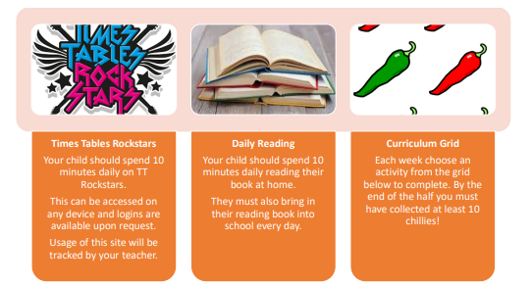

Walk through your local area, what sounds can you hear? Describe the sound, is it high or low pitched? Loud or quiet? | Create a fact file about Hadrian’s Wall. | Write 10 questions you would ask a Julius Caesar.
Draw a picture of a Roman soldier and label their clothing/ weapons. | Write your own instructions on how to look after a pet. | Create your own Ancient Roman historical narrative story.
Challenge your friend to a battle on TTR. | Can you find examples of vertebrates and invertebrates? | Create a poster for the number 3,999- how many different ways can you represent the number.
Create a timeline on how the Romans invaded Europe. | Practise your 3, 4 and 6 times tables. What patterns do you notice? | Create your own shopping list in Spanish for things that you need to buy,

