Year 4 Spring Newsletter
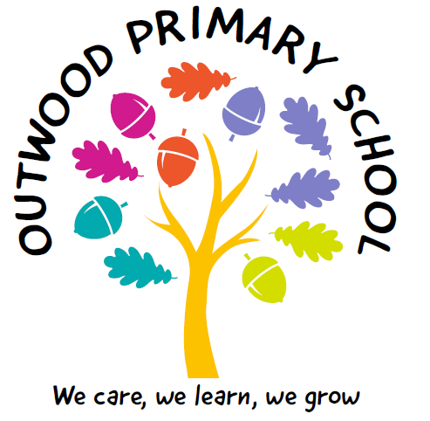
In your classroom this year will be:

Mrs Kaushal– Class Teacher Mon-Wed
Mrs Mahmood- Class Teacher Thu-Fri
Miss Dwan- LSA
Mrs Spilman – LSA
Miss M’laine-LSA

General Reminders:
Homework
The children will have a variety of options for homework linked to their current topic. They will also have weekly homework linked to Maths and English.

TTRockstars
TTRockstars is recomended to be played for at least 10 minutes everyday. The children will have a Multiplication Tables Check in June 2026 (for more information please see ‘Meet the Teacher’ powerpoint or visit https://www.gov.uk/government/publications/multiplication-tables-check-information-for-parents)

Reading
Children should read at home each day and bring their reading book and record into school every day.

Snacks and Waterbottles
We also have a healthy eating tuck shop where the children can purchase items for 20p each morning break time.
Please send a reusable, labelled water bottle with your child to school everyday. It is really important to stay hydrated when learning.

This will be a very exciting term!
In RE we will learn about why some people think life is a journey and what significant experiences mark this. In computing we will be looking at programming and data logging. In Music we will continue to learn how to play the JFlute. In Spanish we will be looking at vocabulary and pharses we may use in a supermarket.
The children will have Gymnastics on Wednesday and Lacrosse on Thursday.
We are really looking forward to this term!
If you have any queries, please do not hesitate to contact us via dojo. We are available during school hours and will do our best to answer them that day. If the dojos are sent after 4:30pm we may not reply until the following morning
Many thanks,
Mrs Kaushal & Mrs Mahmood
Welcome Back!
We hope you all had a lovely Christmas and New Year!
The children have a fabulous topic all about The Roman Empire this term. They will learn about why the Romans wanted to invade Britain, why roads were so important to Roman Britain and the impact the Romans had on the way people lived.
In Maths we will cover multiplication and division, decimals, length and perimeter, fractions and fractions greater than one. The children will have opportunities to undertake in-depth investigations to deepen their learning.
In Science, we will learn aout sound and living things and their habitats. We will be grouping and classifying plants and animals and exploring their habitats. We will also study particles in the state of matter.
We have an exciting art topic that explores Roman mosaics. The children will learn the skills of mosaicking to make their own mosaic. We will be looking at the artist Sonia King, In DT the children will design, make and evaluate their own Roman drawstring purse.

This term our topic will be ‘What was the impact of the Roman Empire on Britain?’

