 

**OUTWOOD PRIMARY SCHOOL**

**Year 4 Homework- Autumn term**

TOPIC: Europe Past and Present- Are we still part of Europe?

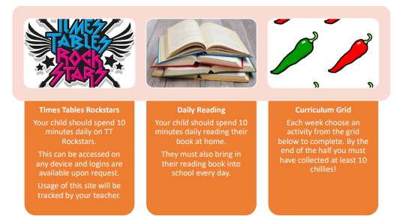

|  |  |  |
| --- | --- | --- |
| Can you find examples of mains-powered and battery-powered appliances in your house? | Identify and locate Ancient Greek landmarks on a map and explain why they are famous. | Write a diary entry from someone living in Ancient Sparta. |
| Create your own maths games using addition, subtraction, multiplication and division. | Create your own kenning poem. | Create your own Ancient Greek historical narrative story. |
| Research and design your own Greek inspired pot.  Think about the colour of the pot and the patterns. | Can you find examples of conductors and insulators in your house? | Create a place value poster for a four -digit number. |
| Create a fact file about a mythical creature. | Practise your 2, 5 and 10 times tables. What patterns do you notice? | Create your own script for a podcast. |