Through Drawing Club the children will focus on one book per week and explore character, setting and develop their understanding of story structure. They will use their imagination to draw and mark make, applying their phonics in the form of secret codes and passwords.

The children might also: Make shopping lists, write cards to their friends, label their pictures …

Books and animations that will be used to spark interest and prompt writing

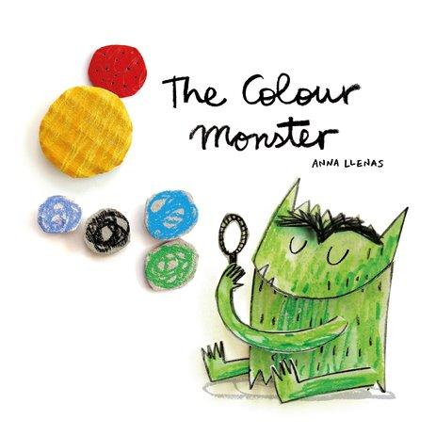 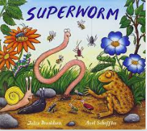 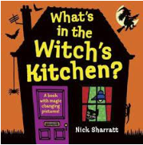

**Communication and Language**

* Listens to stories with increasing attention and recall
* Listens to others one to one or in small groups, when conversation interests them.
* Joins in with repeated refrains and anticipates key events and phrases in rhymes and stories
* Focusing attention – still listen or do, but can shift own attention.
* Is able to follow directions – baking, PE activities, obstacle course, classroom routines
* Role play area – using language to imagine and recreate roles and experiences.

.

**Mathematics**

The children will begin matching, sorting and comparing, exploring number; subitising smaller numbers and developing strong conceptual images of numbers, understanding the composition.

As the term progresses the children will explore number; subitising smaller numbers and developing strong conceptual images of numbers.

They will investigate measure and patterns

**Understanding the World**

Explore the natural world around them.

Understand the effect of changing seasons on the natural world around them. Talk about members of their immediate family and community. Name and describe people who are familiar to them.

Can talk about some of the things they have observed such as plants, animals, natural and found objects.

***This is me***

|  |  |
| --- | --- |
|  | **Owl class**  **Autumn Term 2025**  **Mrs Donaldson,**  **Ms Hodgson**  **and**  **Mrs Chastney** |
|  | |

**Phonics -** Owl class begins with a focus on phonics and mark making.

* Beginning phase 2 phonics
* Emergent writing
* Blending and segmenting games
* Rhyming games
* Beginning to write our names correctly
* Using phonics taught in Drawing Club sessions

**Expressive Arts and Design**

Portraits using collage, paint and loose parts

Junk modelling – experimenting joining and combining materials

Creating puppets and storytelling props

Drawing self-portraits and pictures of their family

Create artwork linked to key texts

Designing role play costumes

Responding to music and creating their own

**Physical Development**

Our focus is on fine and gross motor skills throughout this term including duster disco, climbing, playdough and Squiggle While You Wiggle activities. In PE the children will focus on building strength in their legs, hand eye coordination and will be practising negotiating space when playing racing and chasing games.

**PSHE Me and my relationships**

The children will talk about what makes them special, important people in their lives and develop their understanding of their feelings. There will also be a focus on making friends and learning about our classmates through games and circle time. Class rules to create a happy classroom.

**RE Being special: where do we belong?**

Through this unit the children will talk about people who care for them, how do we know how people are feeling, and belonging to special groups.