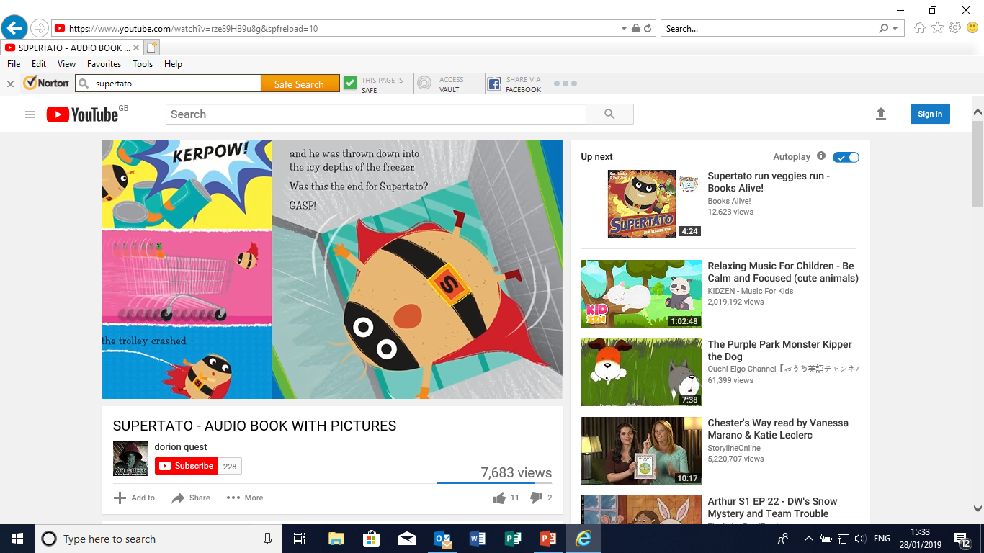
WB: 4.1.21 I D W- CL-
To make a prediction for next part of the story “Supertato”.

