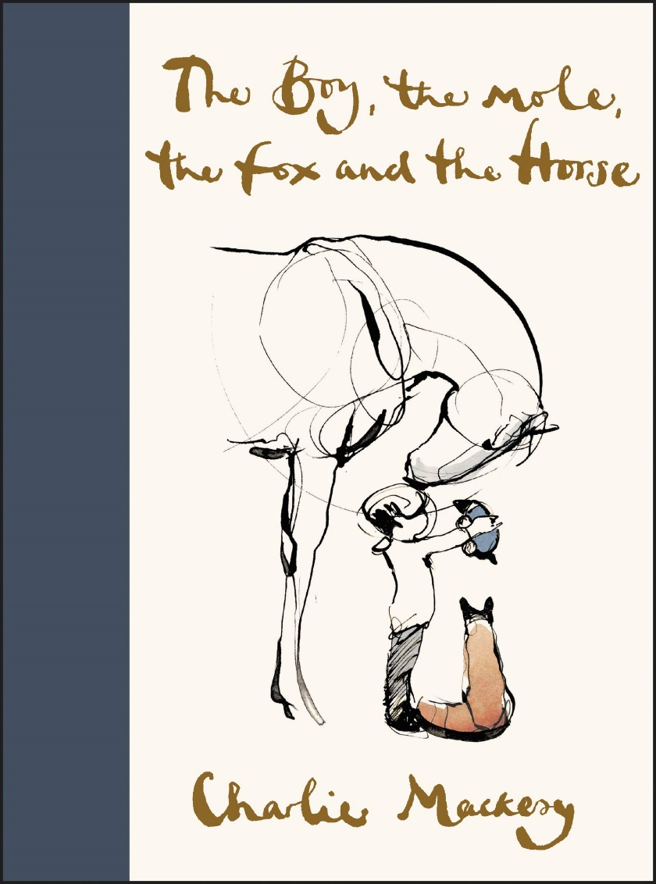
LO: I can write a prediction about a story from looking at the front cover
- Think about the picture and title; what characters might be in the story?
- Where might the story be set? When might the story have been set? What might the story be about?

