Autumn Term
Place Value (and negative numbers)
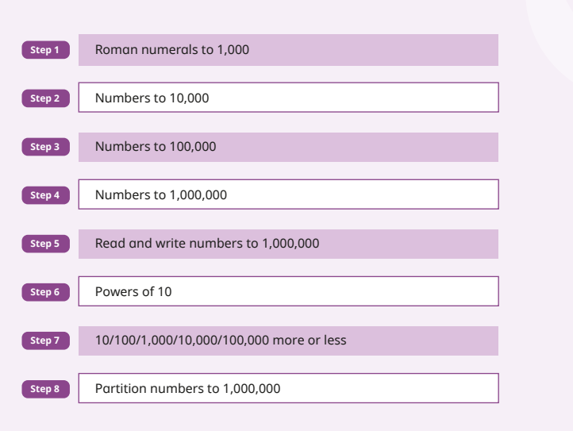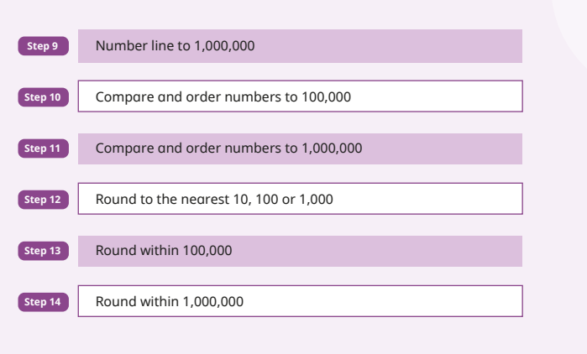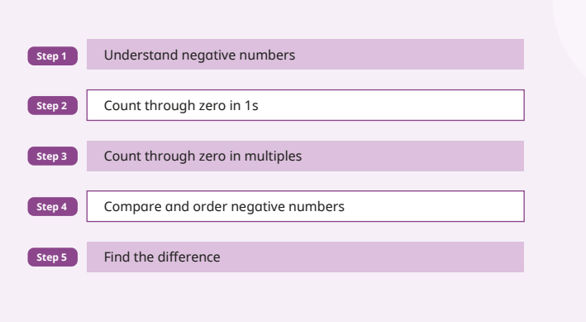
Try to condense some steps if chn able:
Romans numerals can be done as a daily routine
Steps 2-4 can be condensed to 2 days
Step 10 and 11

Weakness:
Rounding
Following number clues
Numberlines

Remember: more resources on WR Infinity for extra practice and in google drive in Gareth M for word problems and reasoning
Addition and Subtraction
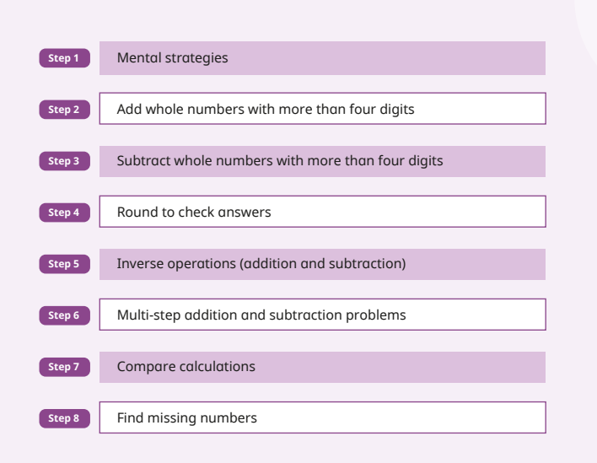
Weaknesses:
subtraction across zeros – showed up in y6 2025 and 2026 so Y5 need to ensure coverage
word problems
Remember to do missing digit problems in column
Ensure true understanding of equals sign
3567 = ??? - 1000

Multiplication and Division
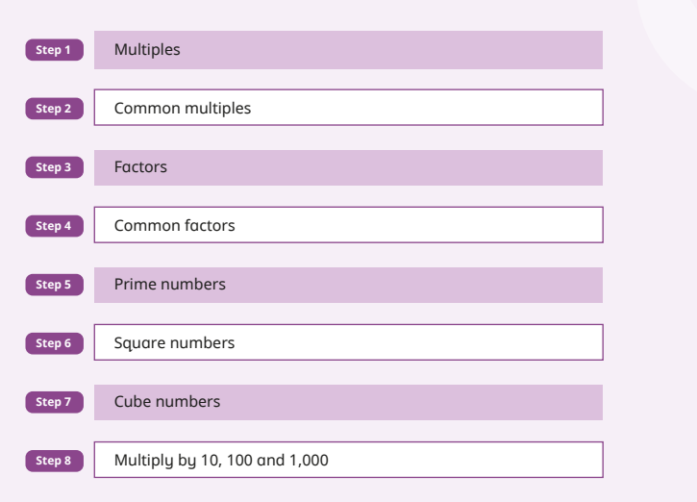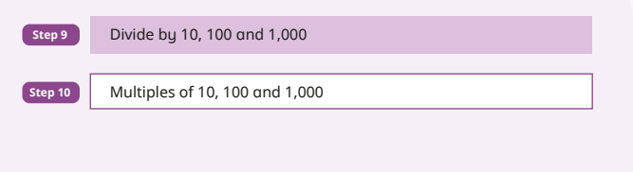
Important that chn know they will be using common multiples and factors for their fractions calculations from now on so very important!

Step 8 through 10 really important and also helps with measure. Can use counters on a place value chart and slide them or use PV sliders.

Fractions A
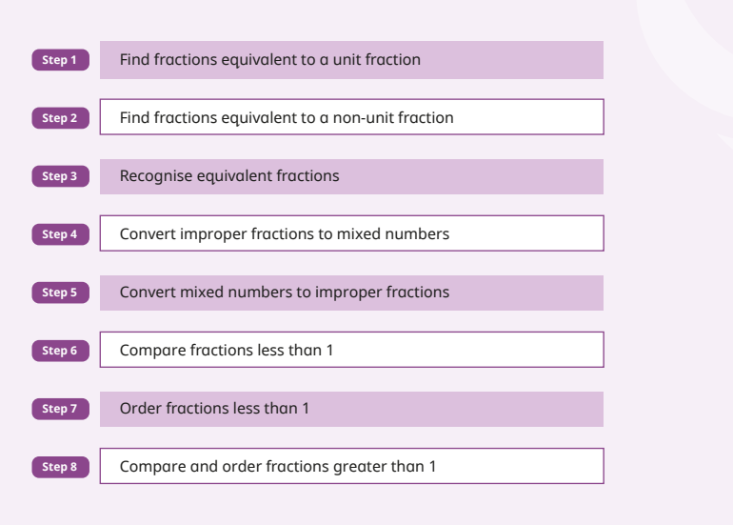
Weaker areas of incoming Y5 :
Fractions on a numberline
Weakness Y5:
Comparing using reasoning e.g. thinking about 5/6 and 7/8 and thinking both missing 1 part but 8ths smaller than sixths so 7/8 must be larger fraction. Remembering what whole looks like as a fraction 5/5 7/7

Mixed number calculations

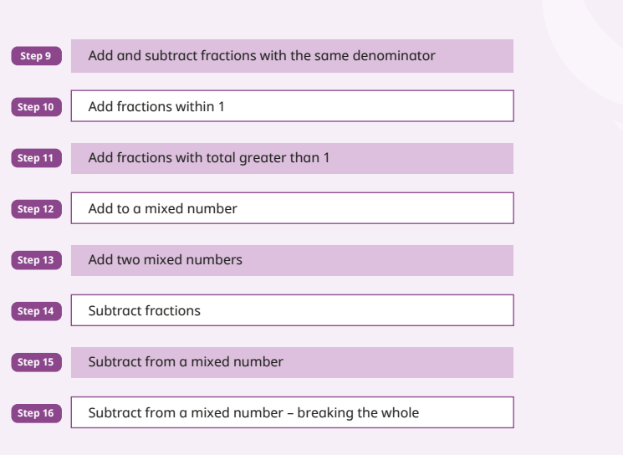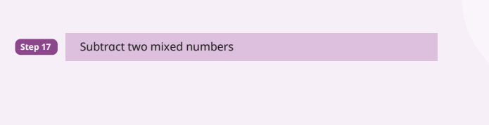

Spring Term
Multiplication and Division B
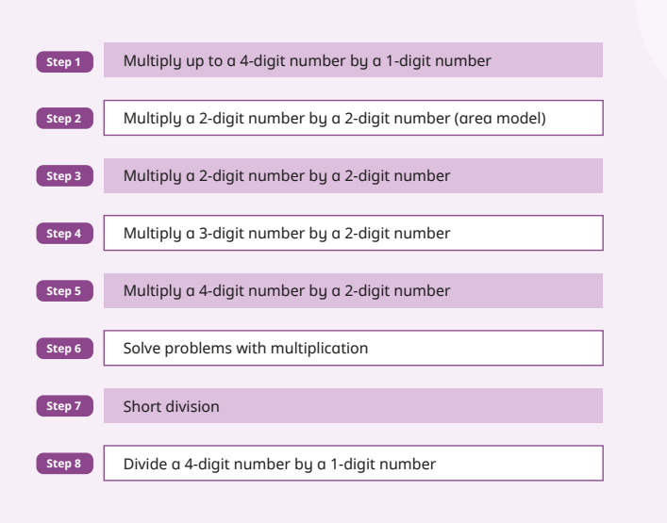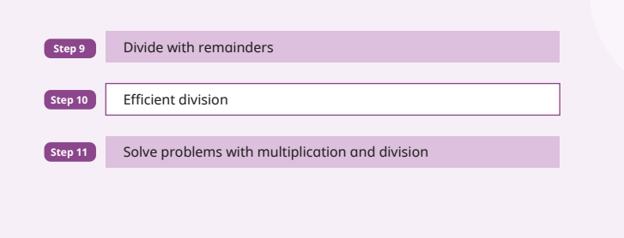

Remember goal is long multiplication method (column) as it is efficient. Remembering the zero is important!
I’d skip area model.

Mult and division word problems - likely need more added in, especially two step such as a jacket costs £52. Eight jackets and 3 skirts cost £653. How much is 1 skirt?

Mental maths: Multiplying 3 numbers and thinking about which to do first e.g. 2 x 7 x 5 =makes sense to do 2 x 5 to get 10 then x 7.

Vocab: factor x factor = product
Fractions B
This unit takes longer than 7 days as some steps need a couple of days.

Ensure children can use a bar model to solve problems that involve finding the whole e.g. if he eats 1/3 and has 30 left, what did he start with?
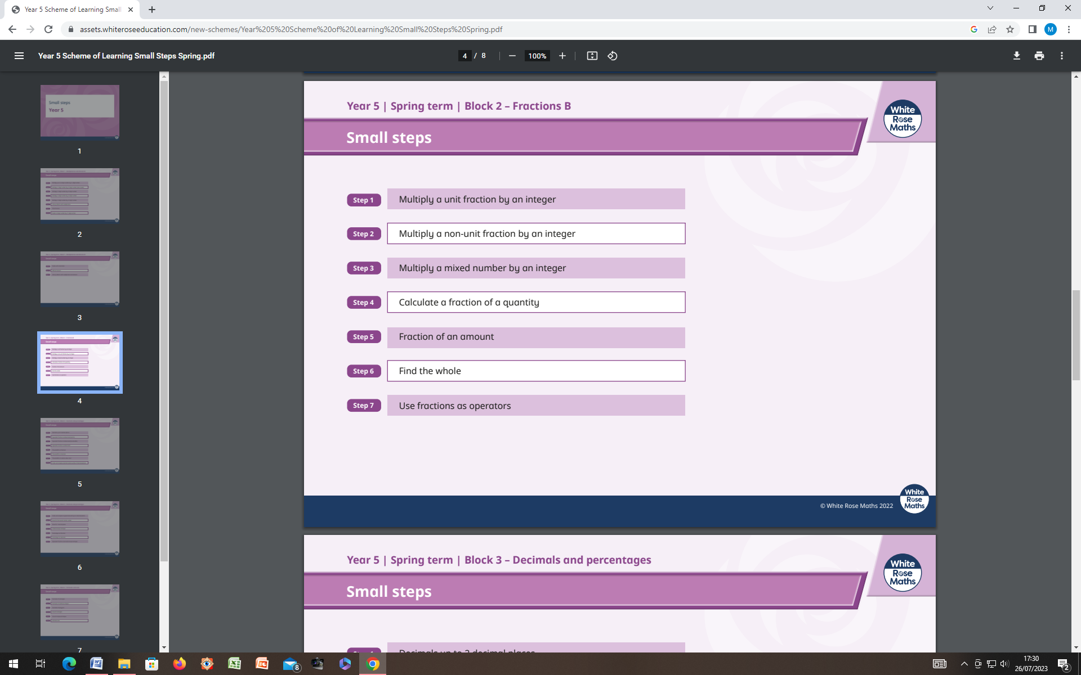

Decimals and Percentages
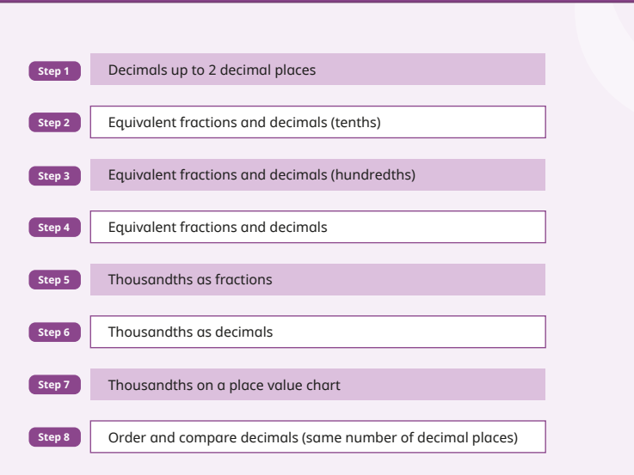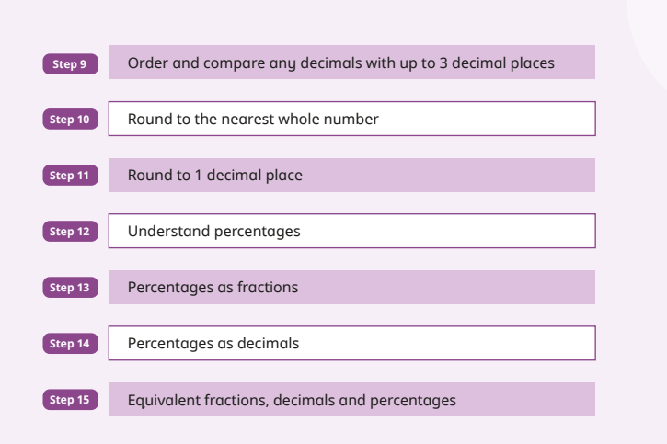
Weaknesses:
Multi step word problems that ask things like what % is left, what fraction is left? (not how many left)

Has been a weakness for 2 years. Please ensure you add extra questions.

Perimeter and Area
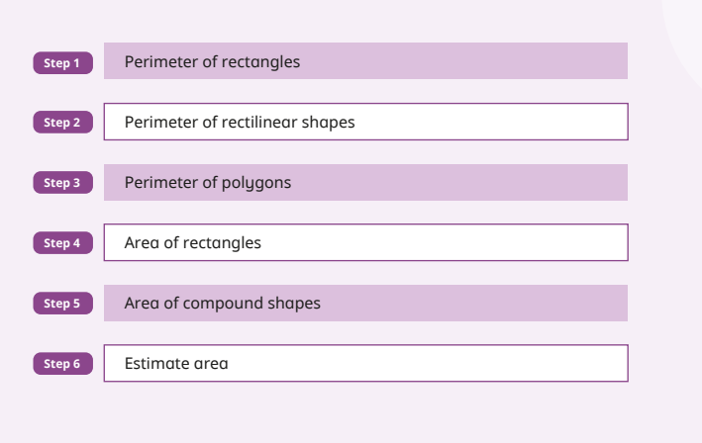
Weaknesses:
Finding missing dimension and when given perimeter of square and rectangle that are the same, find dimension of square
Problem solving and reasoning

Summer Term
Decimal Calculation
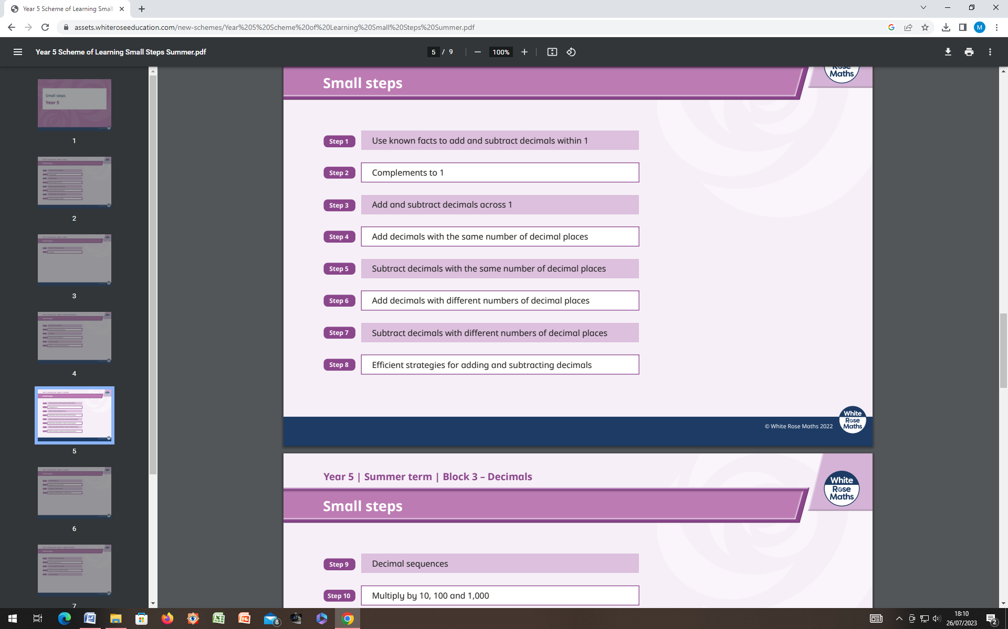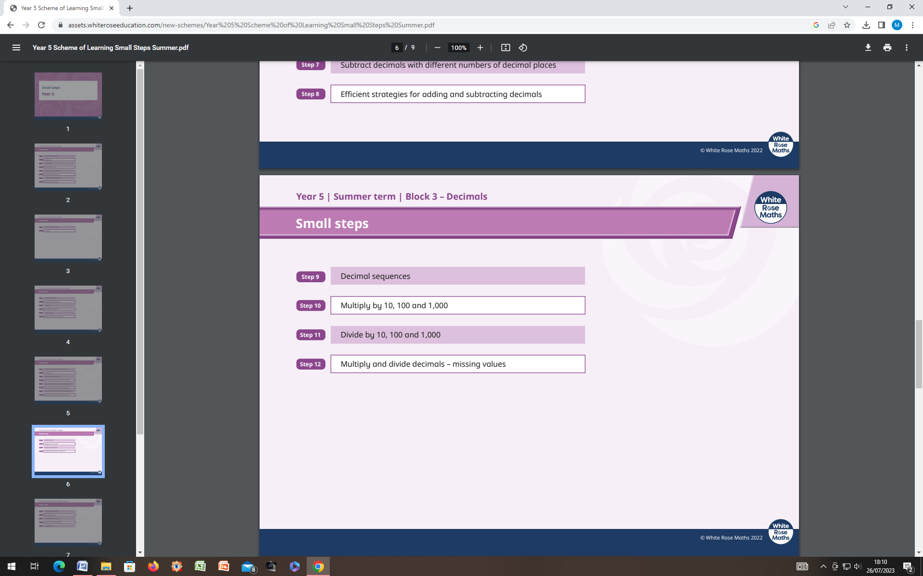
Weakness
Decimal pyramid
Need to be more secure of x ÷ 10, 100 etc with missing boxes

Ensure cover calculation with different number of decimal places e.g.
3.4 – 1.23

Weakness
Shape names and properties – add into starters/ use Infinity/ Y4 Primary quiz to review.

Parallel and perpendicular

Calculating angles on a straight line (was better this past year)

Drawing accurately from a straight line using a protractor

Note: Cylinder – 3 faces, (one is curved) and 2 curved edges

Shape
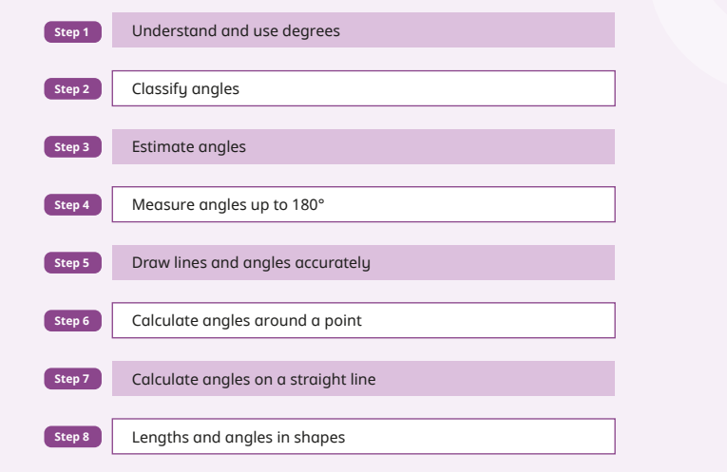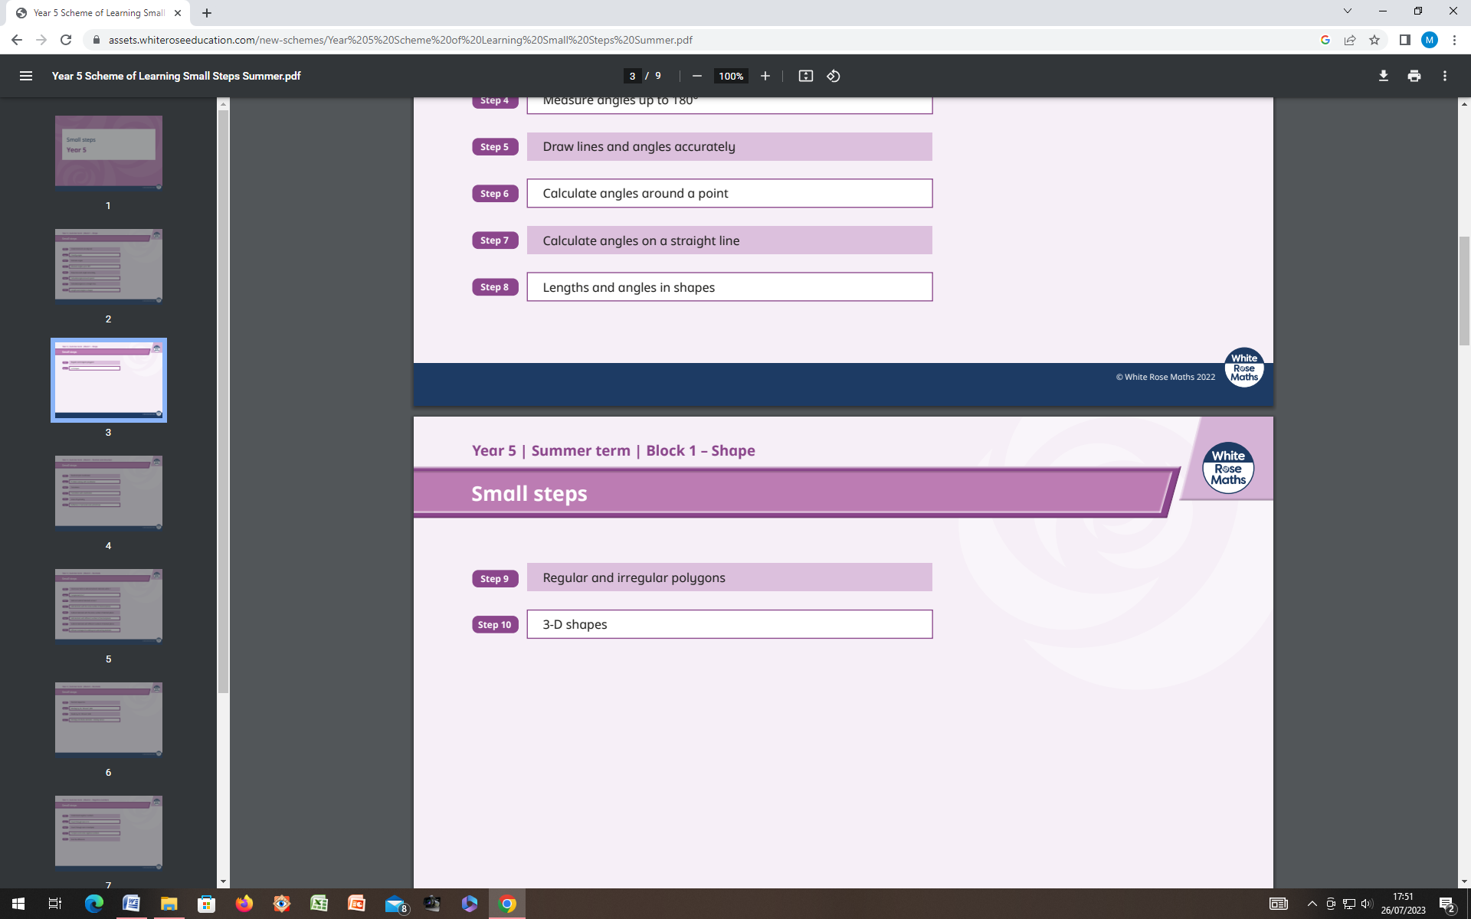

Position and Direction
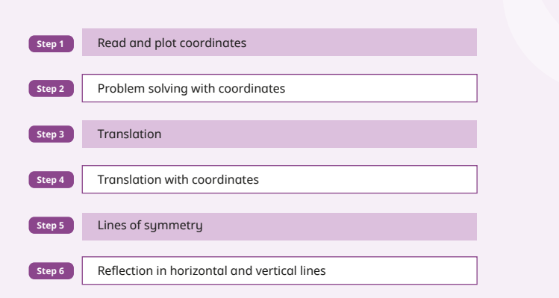
Weakness of incoming Y5 as well as last year’s Y5:
Translations
Missing coordinates

Measure
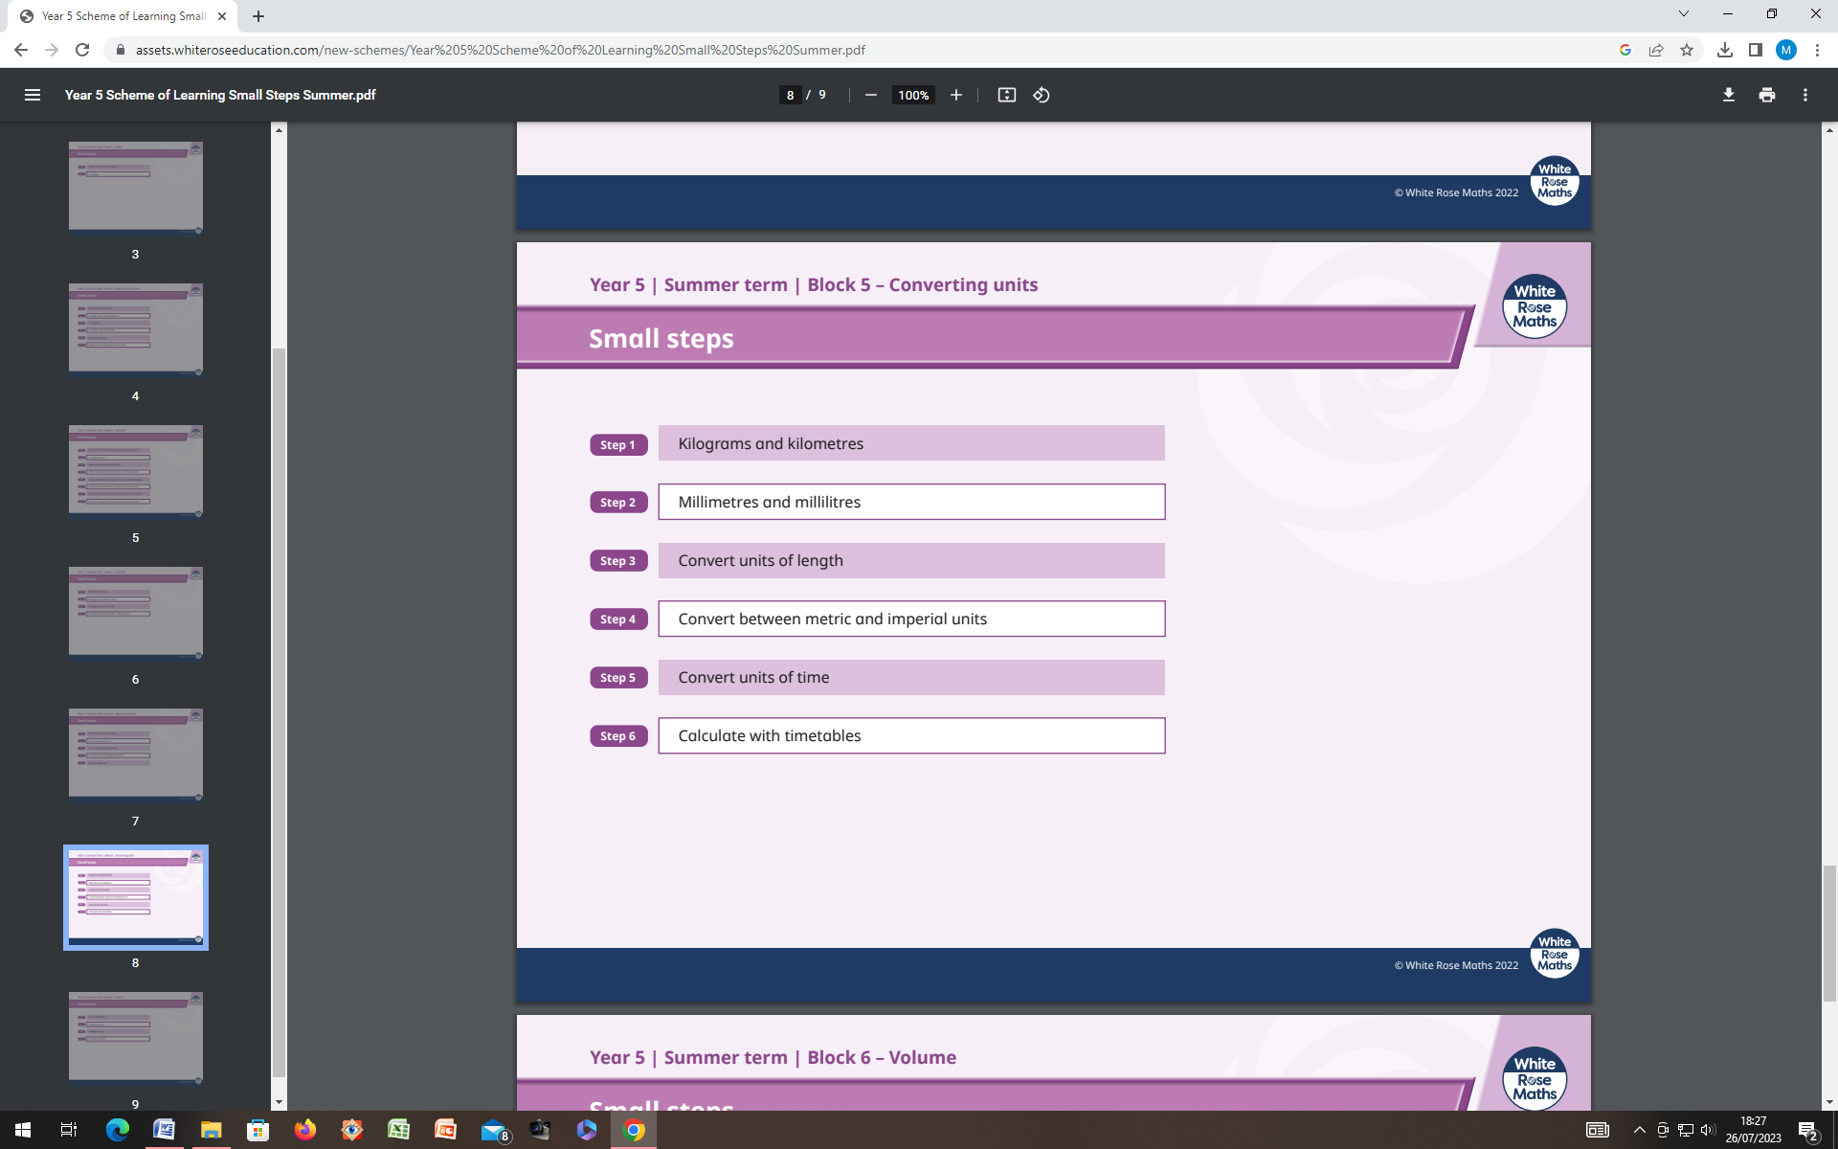
Weakness:
Measurement conversions and adding mixed measures continues to be a weakness

Bus timetables: what is the latest bus … to get to …. By ..
Volume
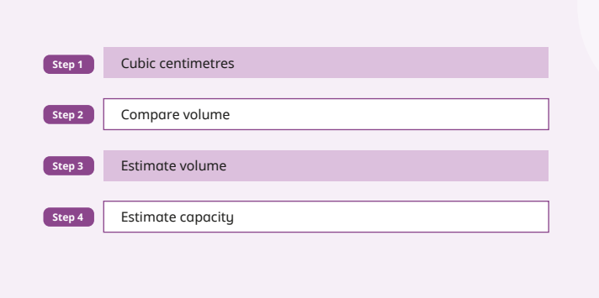

Statistics
Weakness
Interpreting info in a table
