A lot of multiplication teaching and review will take place in the additional sessions on the timetable. Autumn test needs rejigging as it contains negative numbers , perimeter and decimals. (CHECK NEW NTS ASSESSMENTS DUE OUT IN AUTUMN)
Autumn Term
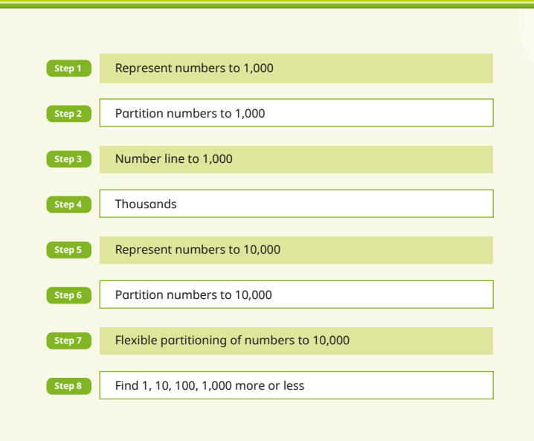
Place Value
Look at qu from RTP 4NPV-3 assessment in google drive (Ready to Progress assessments) for context of measure PV questions

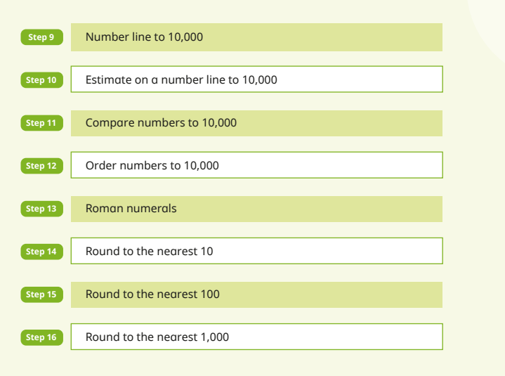
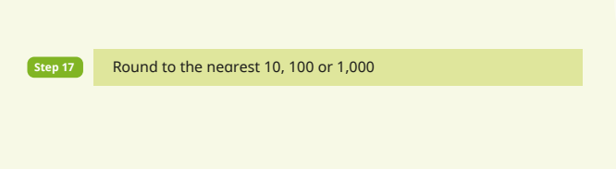
Addition and Subtraction
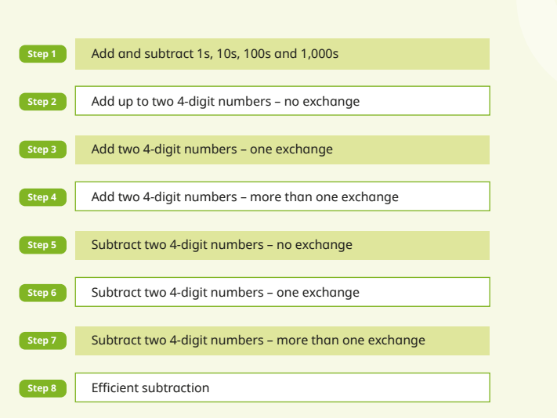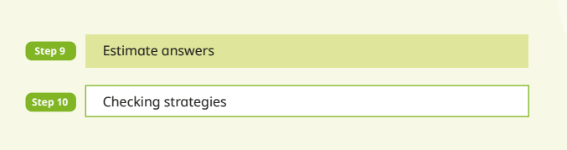

Multiplication and Division A
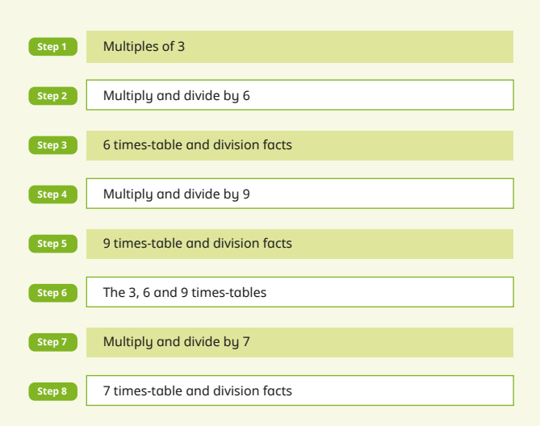
As there are 2 timetabled multiplication units per week that focus on slow targeted teaching, this unit does not need to be followed exactly.
Multiples of 3 should have been covered by now in y3. Use judgement during this unit and know that facts will be covered in depth in extra sessions too.
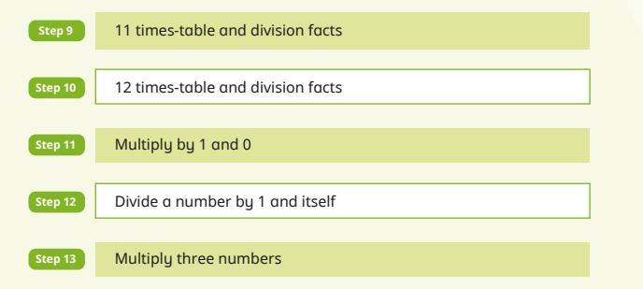
We will move away from WR planning for this as it makes sense to teach the area model A = l x w to follow on from arrays and multiplication.
However, chn got confused on white rose test by qu that showed squares of different sizes and knowing that the more space is covered, the larger the area, not just the highest number of (smaller) squares – two years in a row. PLEASE EXPLAIN THIS DURING UNIT: AREA IS THE AMOUNT OF FLAT SPACE COVERED SO IF UNIT IS BIGGER AND MORE SPACE COVERED EVEN WHEN LESS SQUARES, AREA IS MORE
Area
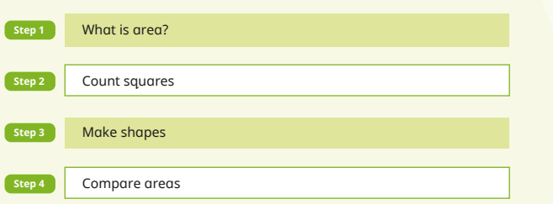

Spring Term
Multiplication and Division B
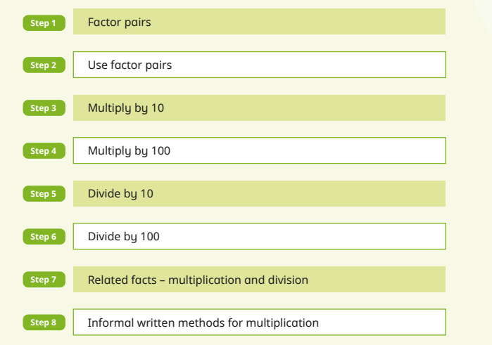

Main focus is x 10 x100 etc

In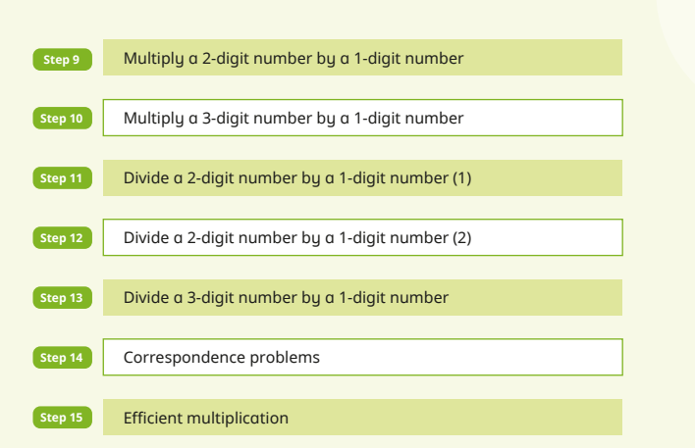
Use formal short method of multiplication and bus stop for division. See calc policy
Weaknesses in 22-23
Multi step word problems
missing digits
Fractions (MUST ADD IN FRACTIONS OF AN AMOUNT AS NOT IN WR- use bar model)
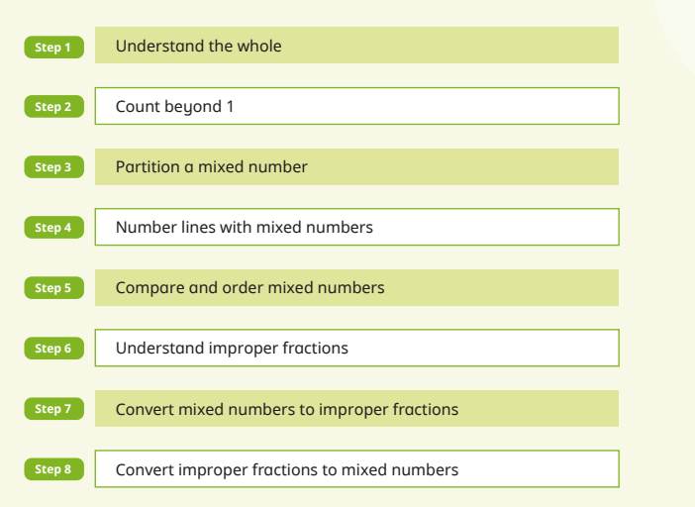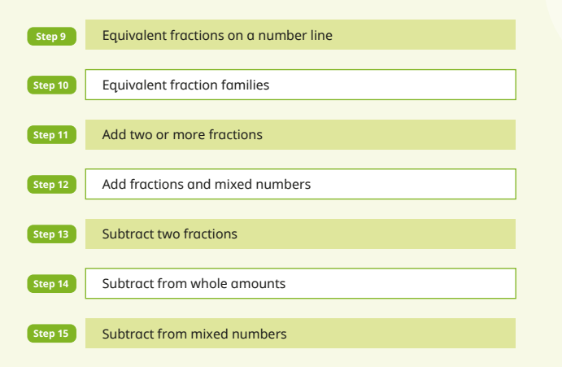
Weaknesses :
Fractions on a numberline
(Y3 too)
Equivalent fractions
Geometry
It is really important that chn learn names of polygons and their properties and differences. It has been moved earlier in the year to ensure coverage. Get the shapes out, use Infinity and primary quiz to overlearn please.
Also language such as parallel, regular and perpendicular.
e.g. Quadrilateral with 1 line of symmetry

Weakness: Understanding angles as a measure of turn and recognising which was larger
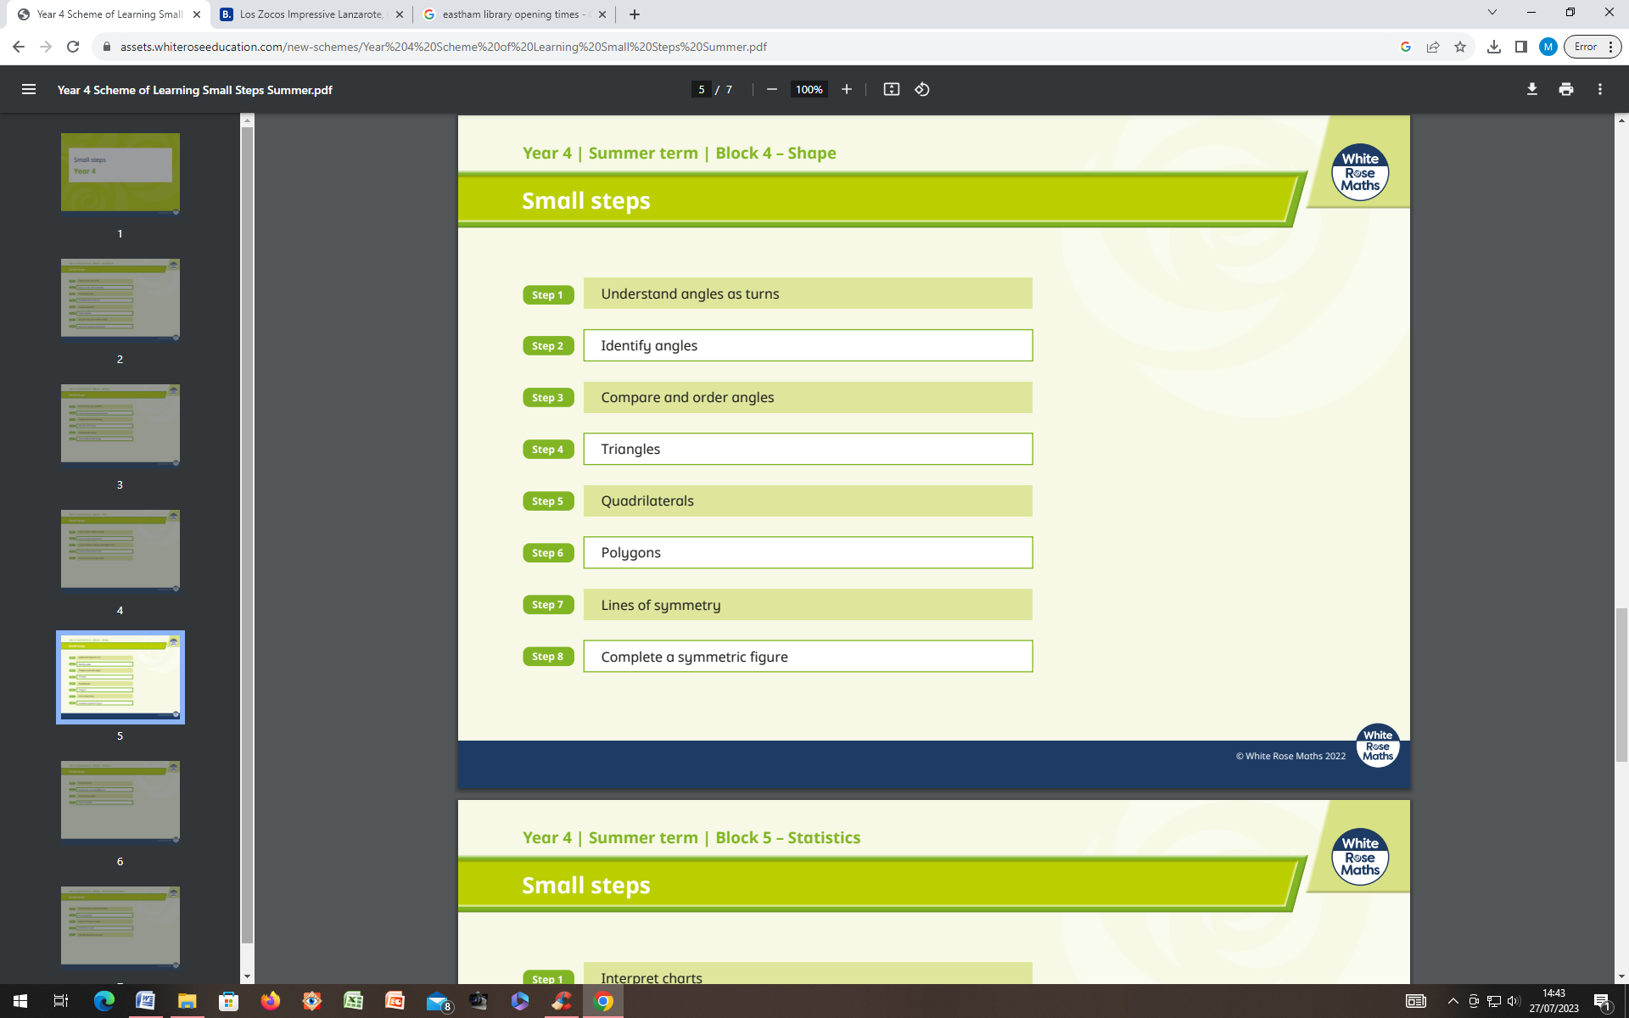
Perimeter
Perimeter is here so previous knowledge of polygons and shape properties can be drawn upon.
Weakness:
Missing dimension
Finding multiple possibilities
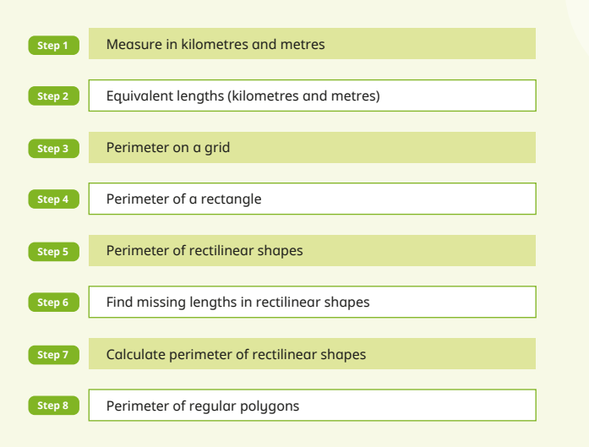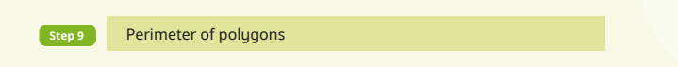
Decimals A
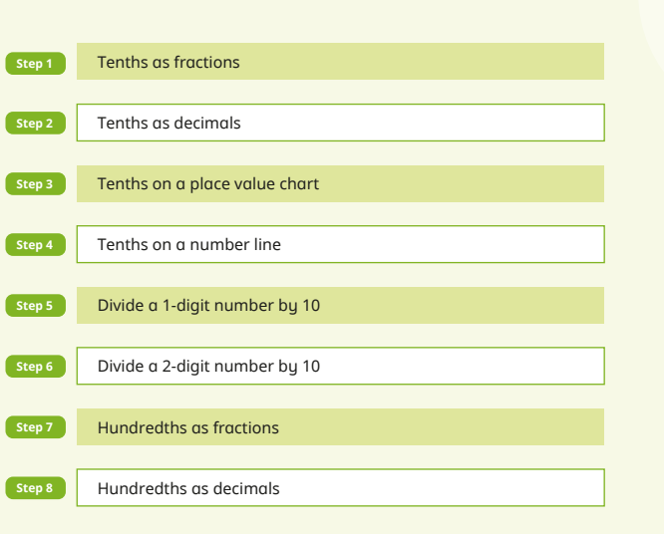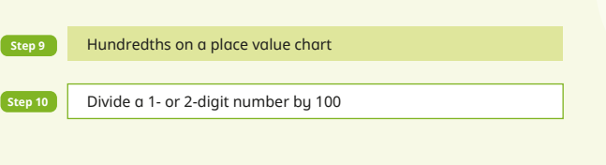
Ensure chn have access to counters and pv charts so they can represent numbers then slide them to divide by 10, 100. It doesn’t need to be PV counters.
Summer Term (Finish Decimals A)
Decimals B
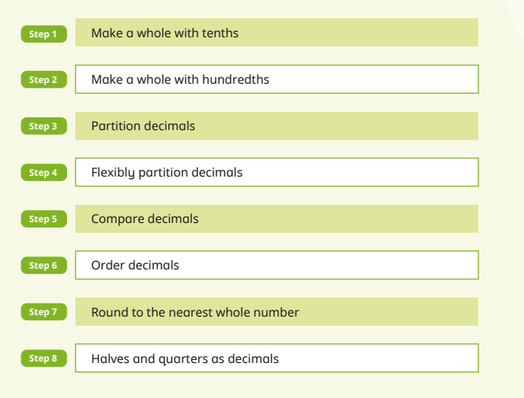
Ten frames should be used so chn understand ten tenths = 1 and avoid misconceptions such as 0.6 + 0.6 = 0.12
Weakness – partitioning and decimals that make 1 whole.

Money
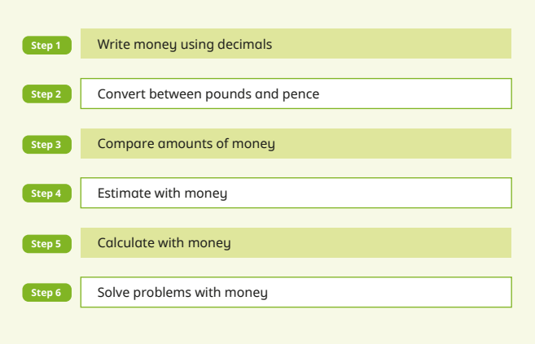
Add in - Multiplication and Division Extra Unit for MTC

Time
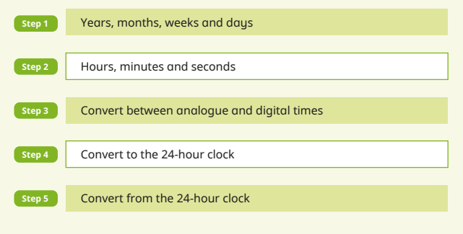
Weakness:
Time duration and conversion

Time needs to be built in as an ongoing classroom routine. It is a school weakness. E.g. at 10:20 we have a stretch.

Position and Direction
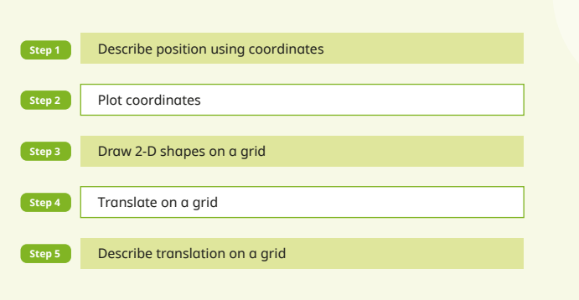
Weak on last two years’ unit assessment: translations - need to practice describing how they have been translated. Also joining points and naming shape.
Make translations a two day lesson please.

Statistics
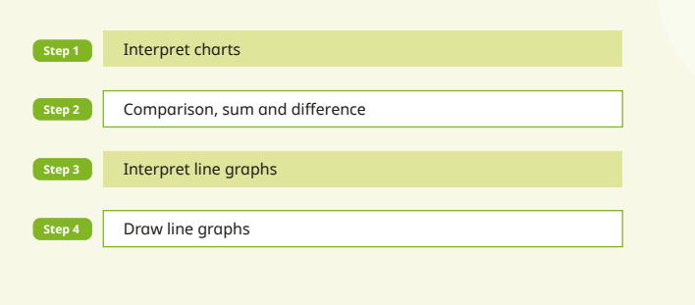
Ran out of time y3

