YEAR 5 LONG TERM ENGLISH PLAN (2022-2023)

 | Autumn 1 | Autumn 2 | Spring 1 | Spring 2 | Summer 1 | Summer 2
Texts |  | 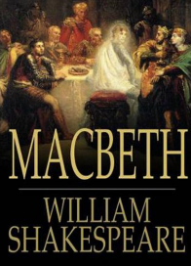  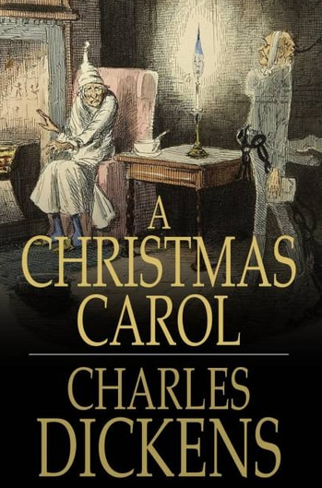 | 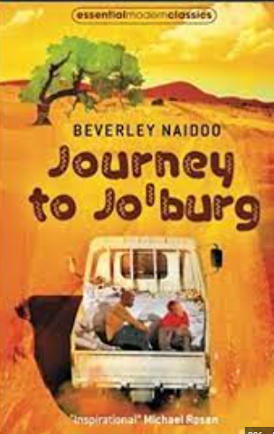 | 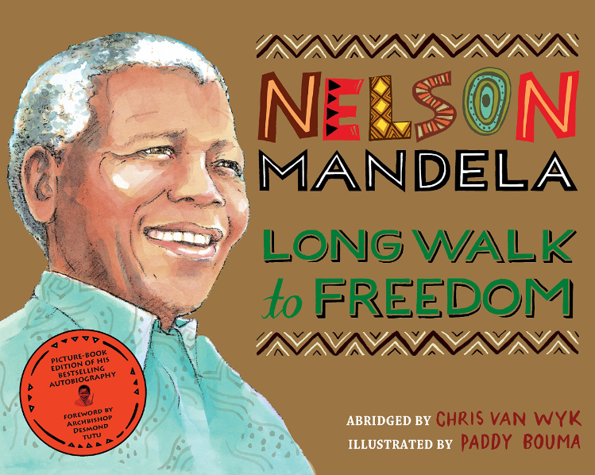  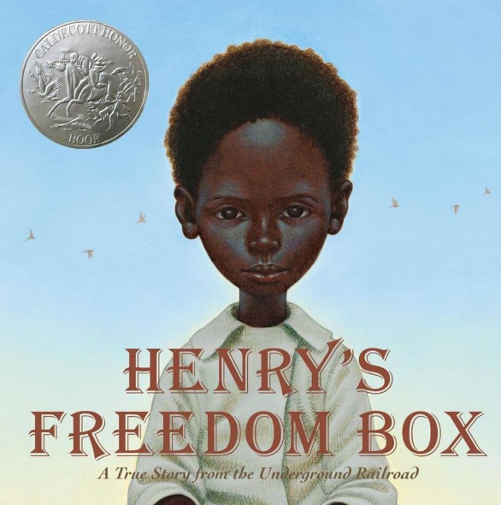 | 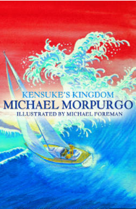  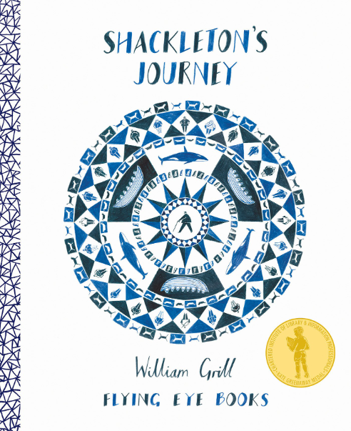 | 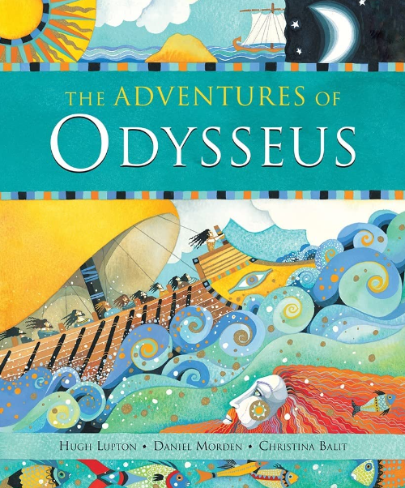
Writing purpose | Street Child:  Main outcome 1: Narrative Recount (fictional diary).  Diary entry  Short writing opportunities:  - Character and setting descriptions  - Feelings and emotions of key characters  Main outcome 2: Narrative  Suspense narrative  Short writing opportunities:  - Character and setting descriptions  Main outcome 3:  Formal speech (Eulogy) | Macbeth  Main outcome 1: Balanced argument  Short writing opportunities:  -character description  -Conscience alley  -Point, Evidence, Explain  Main outcome 2: Narrative  Play script to narrative  Short writing opportunities:  -character thoughts and feelings  -setting descriptions  -speech bubbles | Journey to Jo’burg  Main outcome 1: Narrative  Recount (letter)  Letter  Short writing opportunities:  -First person feelings  -summarising the main points of a story  Main outcome 2: Narrative  Rewrite a chapter  Short writing opportunities:  -using senses to describe setting | Long Walk to Freedom  Main outcome 1: Biography – Nelson Mandela  Short writing opportunities:  -bullet points to collect research  -time adverbial sentences  Henry’s Freedom Box  Main outcome 1: Newspaper report  Fictional narrative  Short writing opportunities:  - thoughts and feelings paragraph  -diary entry  -direct and reported speech sentences.  -5 W’s paragraph | Shackleton’s Journey  Main outcome: Narrative  Short writing opportunities  -Non-fiction information collecting facts.  -Job application letter  -setting descriptions  Kensuke’s Kingdom  Main outcome: Narrative  Letter  Short writing opportunities:  -rewriting text from an alternative perspective.  -Character description  -Character message | Adventures of Odysseus  Main outcome: Narrative (Myth)  Create own myth  Short writing opportunities:  -story board  -character and setting description  -character thought bubble
Grammar Focus  Alan Peat sentence type | Expand noun phrases by the addition of modifying adjectives, nouns and prepositions.  Relative clauses beginning with who,which,where, why, whose, that  have an omitted pronoun.  If, if, if, then sentence. | Variety of verb forms used correctly and consistently including the progressive and the present/past perfect forms.  Noun phrases expanded by the addition of modifying adjectives, nouns and prepositional phrases  Modal verbs (e.g. might,should,will, must). | Expressing time, place and cause using conjunctions or prepositions.  3 -ed sentences  Emotion, comma sentences. | Use direct and reported speech  Use parenthesis (brackets, dashes, commas)  Use 3 bad—(dash) question?  Fronted adverbials | Outside (Inside) sentences.  Relative clauses  ‘Personification of weather’ sentences | Progressively building a varied and rich vocabulary and an increasing range of sentence structures.  Fronted adverbials  Outside (Inside) sentences.
Punctuation Focus | Inverted commas for direct speech and using a comma after the reporting clause.  Ellipsis  Secure use of apostrophes for possession, including for plural nouns  Use commas for relative clauses. | Use and punctuate direct speech (using dialogue to show the relationship between characters), place apostrophe correctly for regular plurals,  Use commas after fronted adverbials. | Use of commas after fronted adverbials and subordinate clauses.  Use of commas, dashes and brackets for parenthesis. | Possessive apostrophes  Use of commas, dashes and brackets for parenthesis. |  | Brackets, dashes, comma
Reading Focus | Prediction  Inferring characters feelings at different points in the text. | Retrieval  PEE  Inferring characters feelings at different points in the text.  Explain | Sequence and summarise Prediction  Inferring characters feelings at different points in the text. | Retrieve  Sequence and summarise  Vocabulary - Effect of vocabulary on a reader Prediction | Predict -observe, infer and wonder | Retrieve  Inference  Sequence  Impression of character/plot
Spoken Language
Cross-Curricular writing links*
* Worked into Topic books/lessons

