
ASPIRE | SAFE | TRUST | RESPECT | KIND | PRIDE

Friday 4th September 2026
Dear Children, Parents and Carers,

Welcome to Year 6

We hope that you have all enjoyed a relaxing summer and are ready for the new academic year. We are looking forward to working with you to ensure your child achieves the best they possibly can in Year 6. This will be a fun and challenging year with many exciting opportunities.

Our topic for this term is World War 2. We will be exploring key dates and events during World War 2, looking at the countries involved and how the war affected families and children. We will also be looking at how we remember World War 2 and how it has impacted life today. Links to World War 2 will be made across the curriculum where possible.

At this current time, we are focusing on getting the children back into a routine and there will not be much mention of SATs. However, later on in the year, we will provide you with more information about the SATs, and how best to support your child. We do ask that you read regularly with your child, a minimum of 4 times per week; discussing a book makes a huge difference to a child’s progress and your support is greatly appreciated. Maths and Reading homework will be issued every Friday and will be due in for the following Friday. Your child will be given an overview of the weekly spellings for this term. Spelling tests will take place every Friday.

Music lessons will continue to take place every Monday and PE days will be Tuesday and Thursday. Please ensure your child comes into school in their PE kit on those days.

We are sure that the children are very excited about the forthcoming residential at the Conway Centre. We would like to invite parents, carers and children to join us in Dane Hall on Wednesday 23rd September at 3:15pm for a short meeting where we will discuss the arrangements for the trip. This will be an opportunity for you to meet both the Year 6 teachers and ask questions about the residential visit.

Monday | - Bring instrument for music lessons.
Tuesday and Thursday | - Wear PE kit.
Friday | - Spelling test.  - Maths and Reading homework due in and set for following week.

Yours sincerely,

Mrs Williams and Miss Croucher

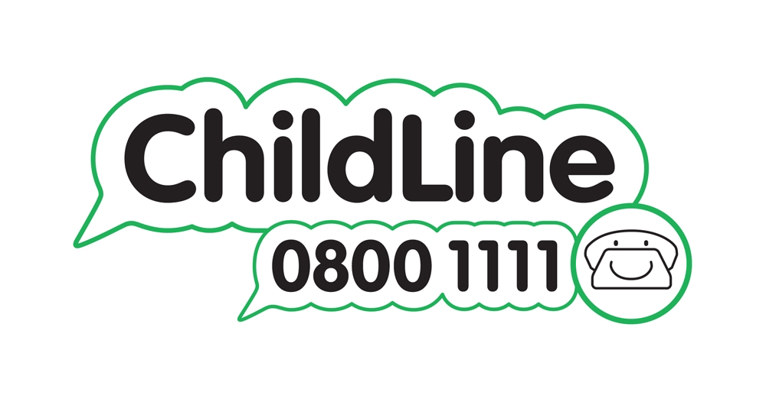





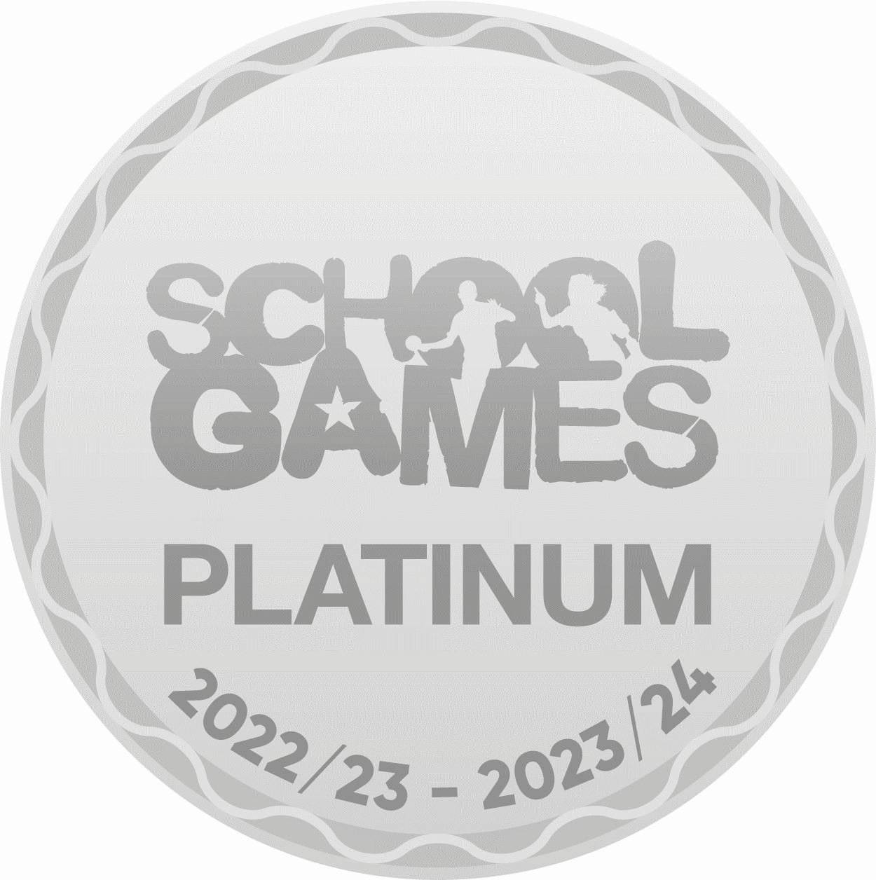

Winnington Park Primary School and Nursery, Firdale Road, Winnington, Northwich, Cheshire, CW8 4AZ
Tel: 01606 74371 email: admin@winningtonpark.cheshire.sch.uk website: www.winningtonpark.cheshire.sch.uk
Headteacher: Mr Rob Cole email: head@winningtonpark.cheshire.sch.uk

