ASPIRE | SAFE | TRUST | RESPECT | KIND | PRIDE
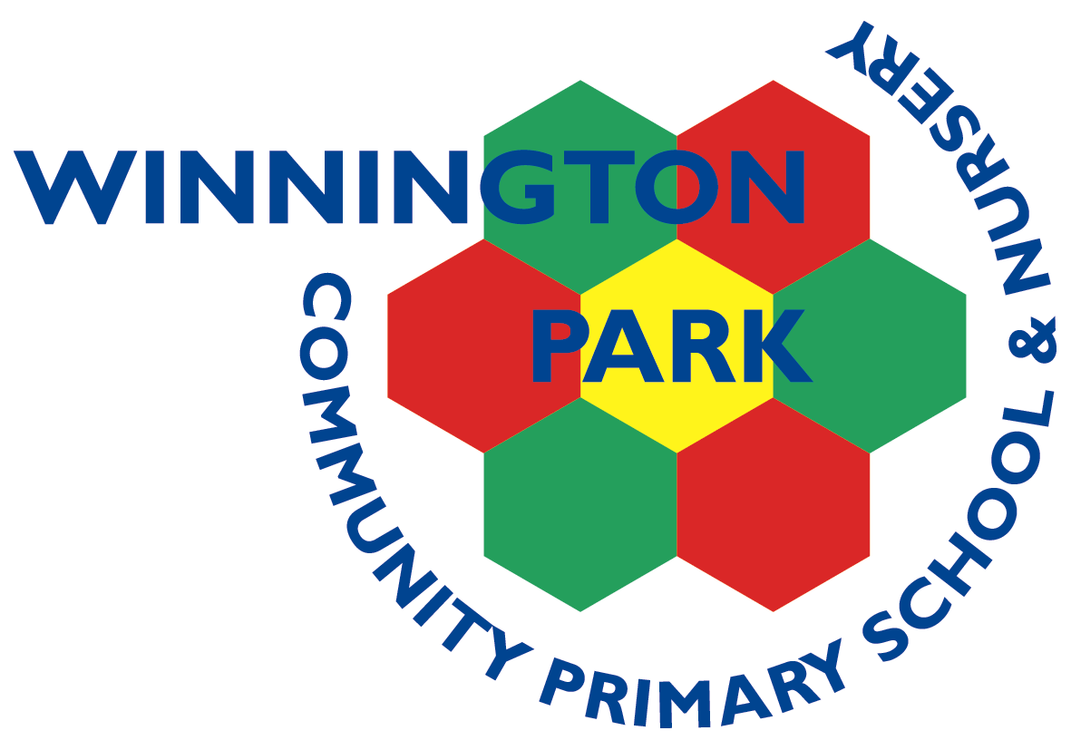

Tuesday 12th May 2026
Dear Parents and Carers,

Year 2 trip to The Museum of Science and Industry

On Monday 15th June 2026, Year 2 will be going on a school trip to visit the Museum of Science and Industry in Manchester. This trip links to our Science Curriculum and will be an exciting opportunity to enhance and enrich the pupils’ learning. Pupils will have a chance to explore the museum before taking part in an exciting ‘Horrible Science’ workshop. Children will also have the chance to explore the ‘hands-on’ Experiment Gallery!

Originally, this trip was part of a combined visit to the Menorah Synagogue in Wythenshawe. However, after careful consideration of recent events reported in the news, we have decided to postpone our planned visit to the Synagogue. We will ensure that this area of the curriculum continues to be explored in school through alternative activities and visitors into our school.

For the trip on Monday 15th June, your child will need a disposable packed lunch and drink. Please send your child’s packed lunch in a named plastic bag so that it can be disposed of easily. As children in key stage one receive school meals free of charge, the school can provide a lunch for your child. Please state below on the slip if you would like your child to have a lunch provided by school by Friday 22nd May. Children will need to wear full school uniform.

Below is an itinerary of the day:
Time | Activity
8.40am | Arrive at school as normal
9.30am | Leave school by coach
10.30am | Arrive at the Museum of Science and Industry
10.30-12pm | Explore the Museum
12pm | Lunch
12.30pm | Horrible Science Workshop
1.30pm | Experiment Gallery
2pm | Leave museum by coach
3.15pm | Arrive back at school for usual collection

The cost of the trip is £18, payable on Gateway. This covers the cost of the coach, entry to the museum, a teacher led workshop and our lunch room.

Please sign the attached slip to give permission for your child to attend. If you are able to help on the trip, please indicate below.

Thank you for your support and if you have any questions, please feel free to speak to us.

Mrs Gill, Mrs Hall and Mrs Flower

Year 2 trip to Museum of Science and Industry on Monday 15th June

I give permission for my child ___________________ to attend Manchester Science and Industry Museum and will pay £18 on gateway.

I give permission for my child to have their photograph taken and published on school’s social media. YES NO

I am able to help on the trip. YES NO

Emergency contact number ___________________________ (This number will be shared with other staff and destroyed after the event).

I would like the school to provide my child with a packed lunch (please order by 22nd May). YES NO

Please circle the sandwich option you child would like: Ham Cheese Tuna

Signed ____________________________________ Date _______________________________


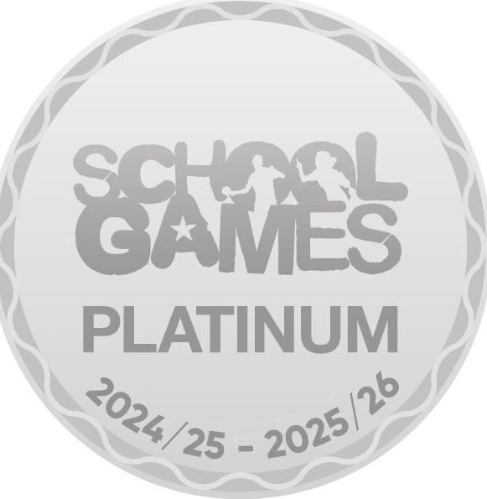
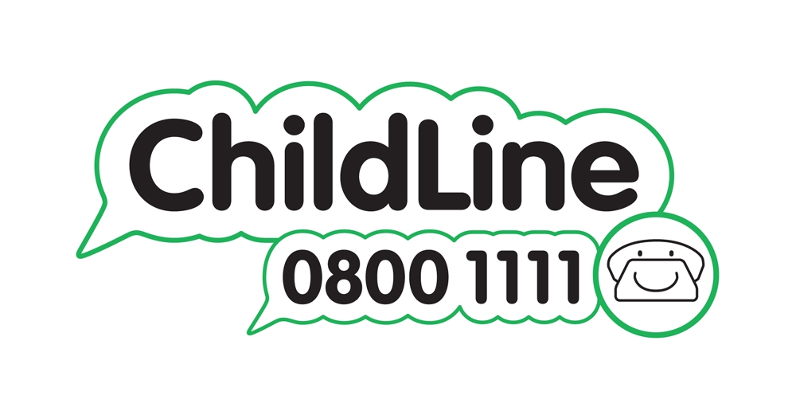

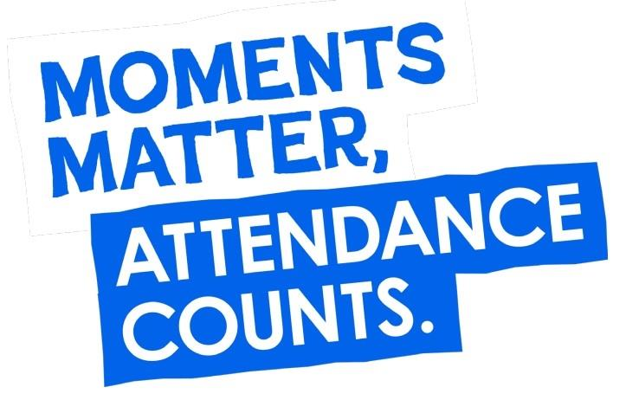

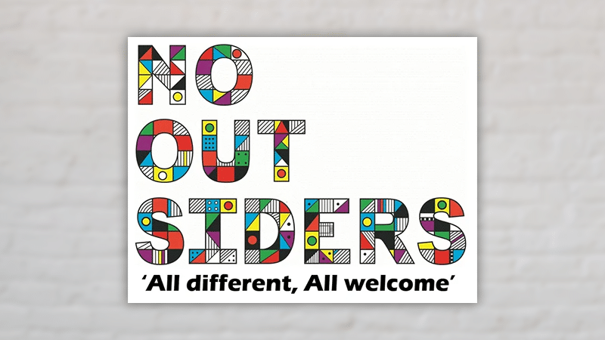
Winnington Park Primary School and Nursery, Firdale Road, Winnington, Northwich, Cheshire, CW8 4AZ
Tel: 01606 74371 email: admin@winningtonpark.cheshire.sch.uk website: www.winningtonpark.cheshire.sch.uk
Headteacher: Mr Rob Cole email: head@winningtonpark.cheshire.sch.uk

