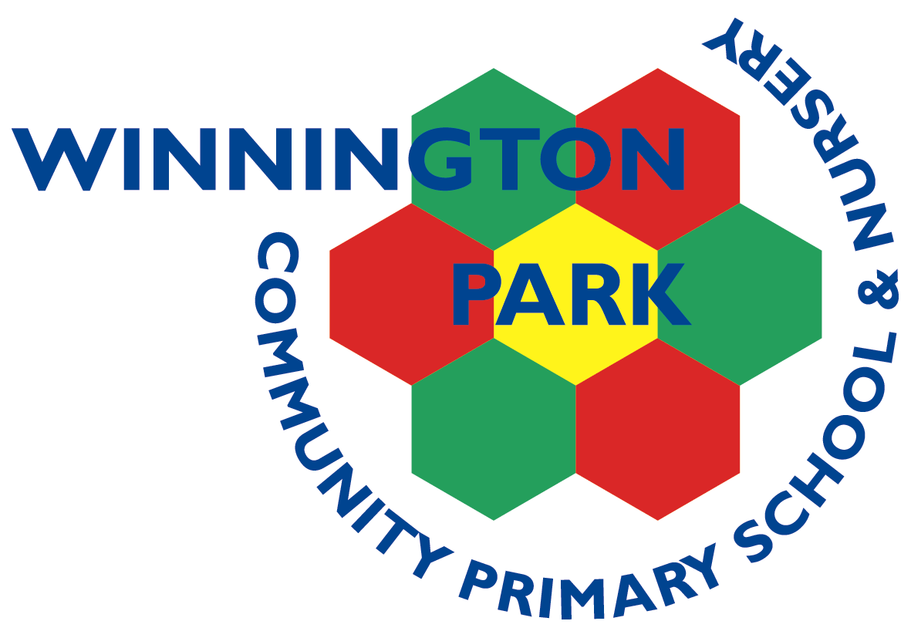
ASPIRE | SAFE | TRUST | RESPECT | KIND | PROUD

Wednesday 1st April 2026

Introducing ‘Talking Tuesdays’ – Weekly Show and Tell
Dear Parents and Carers,
We are excited to introduce a new weekly activity in our classroom called “Talking Tuesdays.”
Each Tuesday, we will be holding a special show-and-tell session where selected children will have the opportunity to share something meaningful with their classmates. This could include bringing in a special item, sharing photographs, or talking about an activity they have done or are looking forward to.
Your child will be allocated a specific date for their turn. On their assigned Tuesday, they are welcome to bring in their chosen item or come prepared to talk about their experience. This activity is designed to build confidence, develop speaking, oracy and listening skills and encourage children to express themselves in a supportive environment.
The date for your child is ____________________________________________
Thank you for your continued support. We look forward to hearing all about the children’s wonderful experiences!
Kind regards,
Mrs Vickie Allen
Deputy Head Teacher

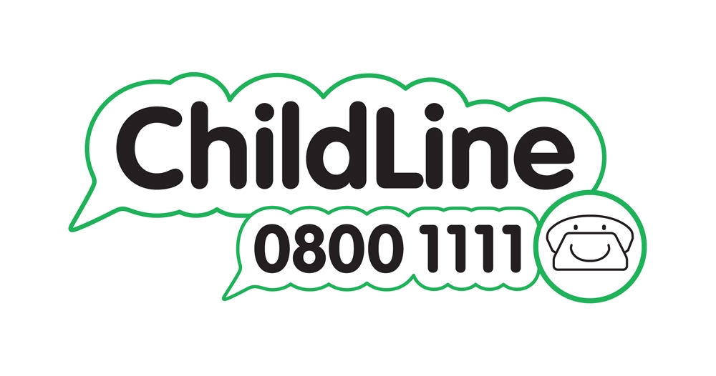





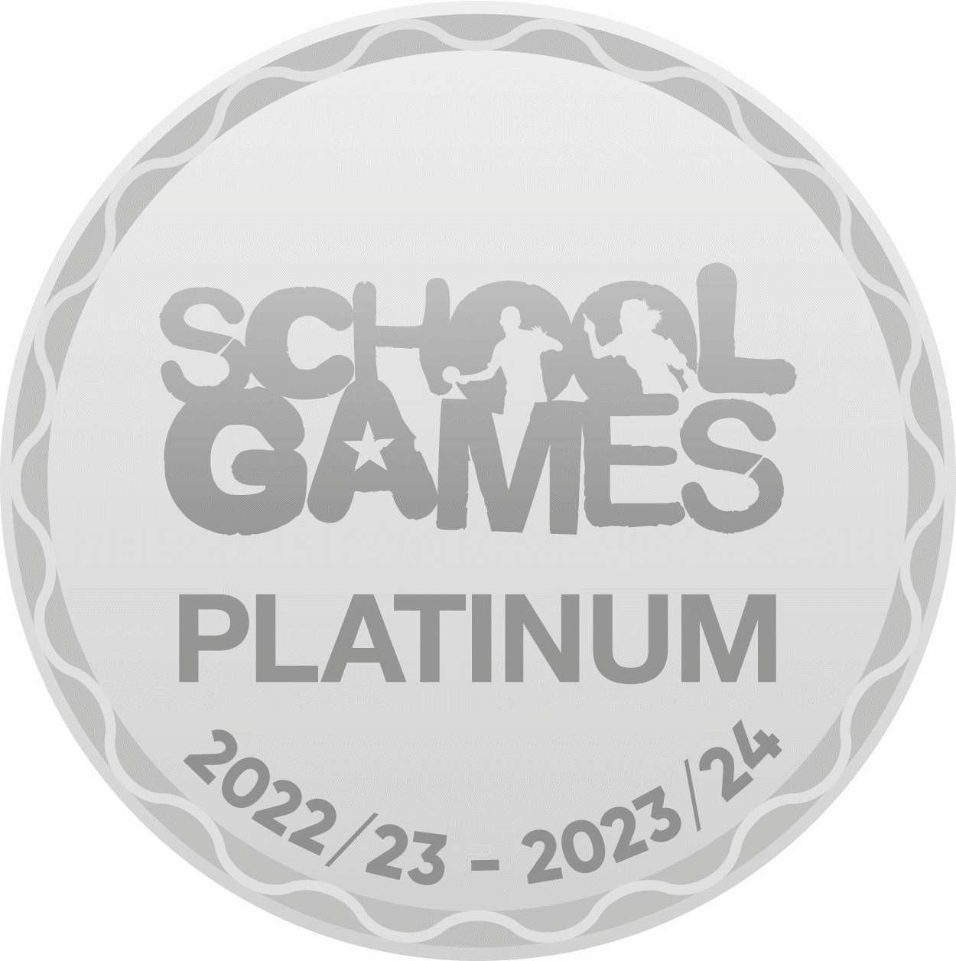

Winnington Park Primary School and Nursery, Firdale Road, Winnington, Northwich, Cheshire, CW8 4AZ
Tel: 01606 74371 email: admin@winningtonpark.cheshire.sch.uk website: www.winningtonpark.cheshire.sch.uk
Headteacher: Mr Rob Cole email: head@winningtonpark.cheshire.sch.uk

