Winnington Park Primary School
and Nursery

Spiritual, Moral, Social and Cultural
(SMSC) Policy

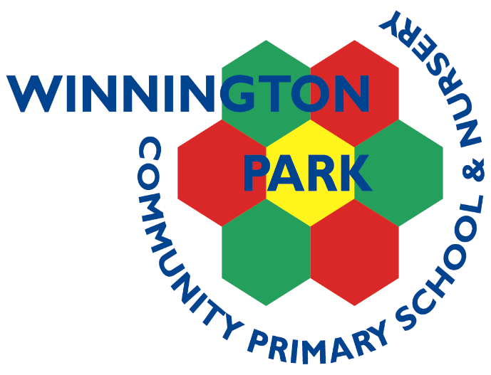

Completed by: Sara Jordan

Updated: Autumn 2025

Review date: Autumn 2026

(To be read in conjunction with RE, Relationships Education, Relationships and Sex Education (RSE) and Health Education and PSHE Policies)

OUR SCHOOL VISION
Our vision is of a community whose members: children, parents, teachers and staff work collaboratively towards achieving an exciting and inclusive school, with high expectations and standards for all, within a happy, caring and secure environment.

OUR CURRICULUM VISION
At Winnington Park Primary School and Nursery we aim to offer a creative and inclusive Curriculum which inspires, engages and challenges and in which children are partners in their own learning.
CURRICULUM INTENT
We ensure that children are given opportunities to widen their knowledge and understanding of the world and learn and apply skills which will make them successful learners for life as well as enhancing their spiritual, moral, social and cultural development.
Children will become confident, independent and resilient learners who are willing to take risks. They will have high aspirations and be proud of their achievements. We aim to give everyone the opportunity to fulfil their highest potential, both academically and in respect of their wider interests and talents.
IMPLEMENTATION
Our children learn through a creative and skills- based curriculum. We endeavour to engage our children and completely immerse them in their learning to become lifelong learners.
We celebrate and value all subjects and provide opportunities to apply and practice key skills in all areas of learning. We have high expectations of achievement, progress, behaviour and presentation. Our children enjoy developing their learning through enhanced projects such as writing and reading weeks, art workshops, trips and residentials.
You can find out the curriculum coverage for each year on your child's class page on this website. Each term parents receive a topic web providing information about topic and curriculum content.
IMPACT
Well prepared children ready for the next stage of learning and life – happy and engaged.
Evidenced through - pupil voice, school council, pupil and parent questionnaires, class books, displays, best books, work books, photos, learning journeys and the school website.
SMSC VISION STATEMENT

At Winnington Park we believe that every child can succeed in SMSC. We believe that it is important to develop well-rounded individuals with strong self-esteem and the respect and care for other people that will enable them to thrive in education, family life and their communities. We aim to respond to the diversity of children’s cultures, faiths and family backgrounds. Children will learn to appreciate what it means to be a positive member of a diverse multicultural society.

Aims and Objectives of this policy

At Winnington Park School and Nursery, we strive to create a learning environment which promotes respect, diversity and self-awareness and equips all of our pupils with the knowledge, skills, attitudes and values they will need to succeed in their future lives.

The curriculum provides a wide range of artistic, sporting and cultural opportunities that encourage pupils to work together and use imagination in their learning. Activities are planned that require pupils to reflect and empathise with others as well as giving them the confidence to provide their opinions and develop their own view points.
We use 1decision resources to support PSHE, SMSC development and Safeguarding.
As a school we believe that all children should experience the following, to promote their Spiritual, Moral, Social and Cultural development.

- Play / Taught / Perform with a tuned musical instrument
- Theatre visit
- Participate in a community event both in and out of school
- Take part in a performance
- Take part in a sporting event
- Outdoor experience
- Residential experience
- Involvement in a charitable event
- Visit a gallery or art exhibition
- Visit a museum
- Visit a religious building / religious speaker
- Experience live music
- Cross-phase experience (High School links)
- Experience of other culture
- Wider world – diversity (Global Learning)
- Explore British values

Spiritual Development
Pupils’ spiritual development is shown by their:
- beliefs, religious or otherwise, which inform their perspective on life and their interest in and respect for different people’s feelings and values
- sense of enjoyment and fascination in learning about themselves, others and the world around them, including the intangible
- use of imagination and creativity in their learning
- willingness to reflect on their experiences

Children are given opportunities to reflect upon the meaning of spiritual experiences.
Examples of experiences commonly regarded as spiritual include:
- Curiosity and mystery
- Awe and wonder
- Connection and belonging
- Heightened self-awareness
- Prayer and worship
- Deep feelings of what is felt to be ultimately important
- A sense of security, well-being, worth and purposefulness
The school will develop a climate or ethos within which all pupils can grow and flourish, respect others and be respected; accommodating difference and respecting the integrity of individuals.

Moral Development
Pupils’ moral development is shown by their:
- ability to recognise the difference between right and wrong, and their readiness to apply this understanding in their own lives
- understanding of the consequences of their actions
- interest in investigating, and offering reasoned views about, moral and ethical issues

At Winnington Park Primary School and Nursery we believe that a morally aware pupil will develop a wide range of skills. These can include the following:
- Distinguish right from wrong, based on knowledge of the moral codes of their own and other cultures
- Develop an ability to think through the consequences of their own and others’ actions
- Have an ability to make responsible and reasoned judgements
- Ensure a commitment to their own personal values and British values (Democracy; Rule of Law; Individual Liberty; Mutual Respect and Tolerance of those with different beliefs and faiths), that the school actively promotes.
- Have respect for others’ needs, interests and feelings, as well as their own
- Develop a desire to explore their own and others’ views, and an understanding of the need to review and re-assess their values, codes and principles in the light of experience

Our school develops pupil moral development by:
- Promoting racial, religious and other forms of equality through collective worship and global learning.
- Giving pupils opportunities across the curriculum to explore and develop moral concepts and values – for example, personal rights and responsibilities, truth, justice, equality of opportunity, right and wrong.
- Developing an open and safe learning environment in which pupils can express their views and practice moral decision making.
- Rewarding expressions of moral insights and good behaviour in line with our Behaviour Policy.
- Recognising and respecting the codes and morals of the different cultures represented in the school and wider community.
- Encouraging pupils to take responsibility for their actions.

Social Development
Pupils’ social development is shown by their:
- use of a range of social skills in different contexts, including working and socialising with pupils from different religious, ethnic and socioeconomic backgrounds
- willingness to participate in a variety of social settings, cooperating well with others and being able to resolve conflicts effectively
- interest in, and understanding of, the way communities and societies function at a variety of levels

At Winnington Park Primary School and Nursery we recognise that pupils who are becoming socially aware are likely to be developing the ability to:

- Adjust to a range of social contexts by appropriate and sensitive behaviour
- Relate well to other people’s social skills and personal qualities
- Work successfully, as a member of a group or team
- Share views and opinions with others
- Resolve conflicts maturely and appropriately
- Reflect on their own contribution to society
- Show respect for people, living things, property and the environment
- Exercise responsibility
- Understand how societies function and are organised in structures such as the family, the school
- Understand the notion of interdependence in an increasingly complex society

Our school develops pupil social development by:
- Identifying key values and principles on which school and community life is based
- Fostering a sense of community, with common, inclusive values
- Promoting racial, religious and other forms of equality
- Encouraging pupils to work co-operatively in lessons and in outside learning.
- Encouraging pupils to recognise and respect social differences and similarities through their global learning experiences and collective worship.
- Providing positive experiences to reinforce our values as a school community – for example, through assemblies, team building activities, residential experiences, school productions and performances.
- Helping pupils develop personal qualities which are valued in a civilised society, for example, kindness, responsibility, respect for difference, moral principles, self-respect and an awareness of others’ needs.
- Providing opportunities for engaging in the democratic process such as School Council elections.
- Providing opportunities for pupils to exercise leadership and responsibility; roles such as Peer Mentors, School Councillors, Eco Committee Members, Junior Road Safety Officers and ICT Safety Officers.
- Providing positive and effective links with the world of work and the wider community.

Cultural
Pupils’ cultural development is shown by their:
- understanding and appreciation of the wide range of cultural influences that have shaped their own heritage
- willingness to participate in, and respond to, for example, artistic, musical, sporting, mathematical, technological, scientific and cultural opportunities
- interest in exploring, understanding of, and respect for cultural diversity and the extent to which they understand, accept, respect and celebrate diversity, as shown by their attitudes towards different religious, ethnic and socio-economic groups in the local, national and global communities

Children should be made aware of the diversity of other cultures both within modern Britain and throughout the world.

Pupils who are becoming culturally aware are likely to be developing some or all of the following characteristics:
- An ability to reflect on important questions of meaning and identity
- An interest in exploring the relationship between human beings and the environment

Our school develops pupils’ cultural development by:
- Extending pupils’ knowledge and use of cultural imagery and language
- Encouraging them to think about special events in life and how they are celebrated
- Recognising and nurturing particular gifts and talents; providing opportunities for pupils to participate in literature, drama, music, art, crafts and other cultural events and encouraging pupils to reflect on their significance
- Developing partnerships with outside agencies and individuals to extend pupils’ cultural awareness, for example, theatre, museum and gallery visits

SMSC in the Early Years

SMSC in the Early Years will take place across all areas of learning. Children will be given the opportunity to explore and develop their own values and beliefs. Children will develop a positive, caring attitude towards other people, an understanding of their social and cultural traditions and an appreciation of the diversity of the cultures.

British Values

We promote the British Values of democracy, the rule of law, individual liberty and mutual respect and tolerance of those of different faiths and beliefs. This is done through making sure that all pupils have a voice that is listened to, assemblies, using teaching resources from a wide variety of sources to help pupils understand a range of faiths, visiting different places of worship, demonstrate how democracy works through school council elections.

Monitoring and Review

The planning and coordination of SMSC are the responsibility of the class teacher and also the SMSC subject coordinator. They will:

- Support colleagues in their teaching, by keeping informed about current developments in the subject, and by providing a strategic lead and direction for SMSC.

- Provide the Governing Body an annual summary report in which they evaluate the strengths and weaknesses in the subject, and indicate areas for further improvement.

- Speak to the children about different elements of SMSC and use this to inform future planning.

- Review planning of SMSC across the curriculum, evidence of the children’s work and observe elements of SMSC across the school.

- Ensure the quality of teaching and learning in SMSC is monitored through the school’s agreed cycle of lesson observations, book and planning scrutiny, learning walks and other monitoring procedures.

