Winnington Park Primary School and Nursery

Teaching & Learning Policy 25-26



Updated: Autumn 2025

Review date: 2026
Teaching and Learning Policy

Contents
- Legal framework
- Roles and responsibilities
- Learning environment
- The curriculum
- Planning and preparation
- Lesson delivery
- Prior Learning and Teaching Vocabulary
- Supporting pupils
- Marking and assessment
- Working with pupils and parents
- Behaviour and attitude
- Monitoring and reporting

Appendices 1: Learning Environment Checklist drawn up by Winnington Park Staff
Appendices 2: Teaching and Learning in Maths
Appendices 3: Quality First Teaching Checklist drawn up by Winnington Park Staff
Appendices 4: Children’s Work Books drawn up by Winnington Park Staff
Appendices 5: Vocabulary templates for teaching vocabulary
Appendices 6: Examples of vocabulary displays
Aims
Our School Vision: Our vision is of a community whose members: children, parents, teachers and staff work collaboratively towards achieving an exciting and inclusive school, with high expectations and standards for all, within a happy, caring and secure environment.
Every child has the right to the best possible education. Winnington Park Primary School and Nursery aims to ensure that all pupils reach their full potential and gain the skills and knowledge necessary to lead successful lives.
Our Teaching & Learning ethos aims to offer a creative and inclusive curriculum which inspires, engages and challenges and in which children are partners in their own learning. Children will become confident, independent and resilient learners who are willing to take risks. They will have high aspirations and be proud of their achievements. We aim to give everyone the opportunity to fulfil their highest potential, both academically and in respect of their wider interests and talents.
This policy provides procedures aimed towards ensuring high-quality teaching and learning throughout the school.

- Legal Framework
This policy has due regard to all relevant legislation and guidance including, but not limited to, the following:
- Equality Act 2010
- DfE (2015) ‘Special educational needs and disability code of practice: 0 to 25 years’

This policy operates in conjunction with the following school policies:
- Special Educational Needs and Disabilities (SEND) Policy
- Marking and Assessment Policy
- Behaviour Policy
- Early Years Policy
- Year 1 Teaching Policy

- Roles and Responsibilities
The governing board will be responsible for:
- Ensuring an effective approach to teaching and learning is implemented across the school.
- Ensuring high expectations are set for all pupils, regardless of their abilities or needs.
The headteacher will be responsible for:
- Overseeing the school’s approach to teaching and learning.
- Ensuring the needs of all pupils are met.
- Ensuring teachers are provided with support to deliver high-quality teaching.
- Promoting a culture of high-quality teaching across the school.
Teachers are responsible for:
- Monitoring and evaluating their teaching.
- Seeking opportunities to develop their teaching.
- Reviewing and evaluating their planning regularly.
- Setting appropriate and challenging targets for pupils based on their starting points
- Collaborating with colleagues to moderate pupil achievement.
- Involving parents and other professionals in the monitoring process.

- Learning Environment
The school will create and maintain a learning environment that will support pupils to achieve their full potential. Teachers will be responsible for ensuring their classrooms and other learning areas provide opportunities to maximise and enhance learning.
Teachers will ensure that learning spaces are used flexibly to facilitate different activities. Seating arrangements will be made in order to maximise pupils’ learning experiences. Arrangements will be changed to suit different activities and to allow pupils to work independently and in groups.
Classroom ‘celebration’ displays, showing children’s learning, will be changed on a termly basis and will be geared towards supporting learning, vocabulary development and celebrating the achievements of the children. ‘Working Wall’ displays and ‘WAGOLLS’ (what a good one looks like) will be regularly updated throughout each half term to reflect the learning current to the class. Talk for writing ‘washing line’ displays will support the current English work. Every child will have their written work displayed and the Star of the Day display, school rules and a visual timetable will be prominently displayed. Each classroom will have an inviting reading area with exciting and relevant books available to the children. Resources to support curriculum learning are easily accessible, labelled and in good condition. Coat pegs, drawers and boxes/trays of resources are clearly labelled with printed text. Class Books are displayed demonstrating the wider curriculum, SMSC and practical tasks. Classrooms promote equal opportunities and celebrate our SMSC values. School Values and Rules and British Values are displayed.
See appendices 1 for a further learning environment checklist drawn up by staff at Winnington Park Primary School to support teaching and learning.

- The Curriculum
The school follows the National Curriculum. Teachers will follow the relevant schemes of work outlined in the school’s Curriculum Policy. The school’s curriculum design will be regularly monitored and reviewed the curriculum leader.
The school will ensure that the curriculum is broad and balanced. It will be carefully timetabled, and the content will be suitable for the age and ability of the pupils. In addition, the curriculum will be made accessible to all through differentiation and the provision of the necessary resources. The school will also ensure that other aspects of learning, such as the development of social skills and self-esteem, also form a significant part of pupils’ education.
- Planning and preparation
Teachers will be expected to plan effectively and appropriately to ensure all pupils are given the opportunity to reach their full potential.
Teachers will be provided with appropriate preparation, planning and assessment (PPA) time.
In line with expectations set across the whole school, lesson plans will:
- Be clearly linked to the curriculum.
- Be differentiated, to clearly show how pupils of all abilities are catered for.
- Have clearly identified learning objectives showing continuity from one lesson to the next. Expected learning outcomes should be clear.
- Highlight the strategies for learning designed to achieve the learning objectives.
- Clearly state the activities that will be undertaken.
- Explain how pupils will be grouped.
- Show how Teaching Assistants and other staff or volunteers will be utilised to enhance learning.
- Contain a list of resources to be used during the lesson and how these resources will complement teaching.
- Highlight any opportunities for assessment and evaluation.
- Clearly state timings and structures of lessons.
- All learning should be at an appropriate pitch and pace for each individual, challenging and achievable. Pupils should be given opportunities to take responsibility for their own learning and challenge themselves.

Teachers will ensure their lessons are planned so they can be flexible to ensure the needs of all pupils are met. Lessons will be evaluated and further lessons in a sequence amended as appropriate to support the learning of all pupils.
- Lesson Delivery
Lessons will be balanced, in terms of teacher and pupil-led activities, and cater for different learning styles. A range of lesson types will be used including practical, visual, dramatic, investigative and group work.
Resources used to aid learning will be:
- Accessible to all pupils.
- Appropriate for the activities pupils undertake.
- The right quality for the task.
- Sufficient in range to allow pupils to make appropriate choices.
- Organised and regularly checked.

Teaching assistants will be actively involved in the lesson to aid pupils’ learning. They will be involved in prior planning and preparation, and will possess a good knowledge of the needs of individual pupils. They will support different focus groups at different times (for example, pupils with SEND and academically more-able pupils). In some circumstances, TAs will be utilised on a one-to-one basis with a child in need of additional help.
Effective learners will engage in a wide variety of learning processes including:
• Collaboration
• Problem solving/ reasoning
• Reflection
• Resilience
• Making connections
• Explaining to others
• Observing
• Predicting
• Reflecting
• Evaluating
• Linking prior and new knowledge
• Self-managed research
• Learning through experience
• Imitating, innovation and modelling
• Investigation
See appendices 2 and 3 for guidance on Teaching and Learning in Maths and a further checklist drawn up by staff at Winnington Park Primary School to support teaching and learning.

- Prior Learning and Vocabulary
As part of our lessons, we incorporate reviewing prior learning and the explicit teaching of new vocabulary at the beginning of each lesson.
Prior Learning
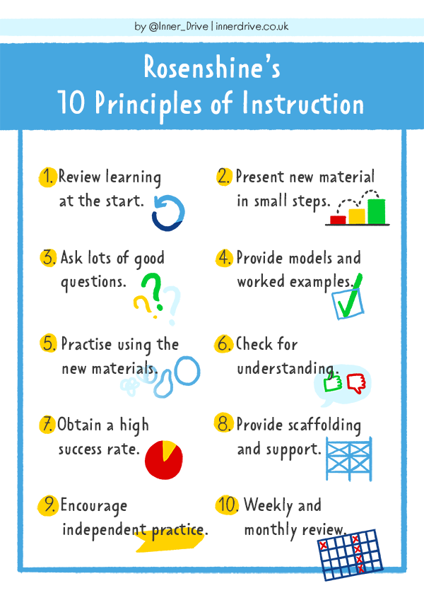
At the beginning of each lesson, it is important that pupils have time to unlock their prior knowledge of that subject; if we do not provide children with the opportunity to revisit this knowledge they will not retain it (and the knowledge will not be transferred from their short-term memory to their long-term memory).
Knowledge Organisers
At Winnington Park Primary, knowledge organisers are used for each topic or unit in Foundation Subjects to support pupils in retrieving prior knowledge. Knowledge organisers have been designed by teachers to be simple so that the key information that is essential for outcomes is prioritised. Key vocabulary and key knowledge is provided for pupils with definitions given. These are regularly referred to with pupils throughout the sequence of teaching to make the information meaningful.
10 ways to use knowledge organisers in the classroom
For teachers:
1. Sets the scene: show the knowledge organiser at the start of the lesson and draw attention to the facts pupils will explore and how these link to prior knowledge
2. Assess pupil’s knowledge: beginning, during and at the end
3. Checks previous knowledge: give pupils the knowledge organiser for a previously covered topic at intervals to help them revisit and retain key facts
4. Makes clear links with prior and future learning: use previous and future knowledge organisers to help with teacher planning
5. Shows progression: tailor key vocabulary to show progression
For pupils:
1. Flashcards: get pupils to make flashcards to include knowledge which is displayed on the knowledge organiser – useful for self-quizzing
2. Paired retrieval: quiz each other on a knowledge item.
3. Self-quizzing: for example definitions of words
4. Online quizzing: online quizzing platforms to create questions linked to the knowledge organiser
5. ‘Just a minute’: list facts from the knowledge organiser is just 1 minute
Other retrieval practice ideas for the classroom:
• Asking pupils to ‘speak like an expert’ / ‘be the teacher’
• Using flashcards – tell me what this word means / talk to your partner for 30 seconds about this
• Discussing images
• Using quick knowledge questions – verbal, corners, whiteboards, slide on your PowerPoint
• Bingo games
• Just a minute – minute timer – what do you know?
• Brain dump
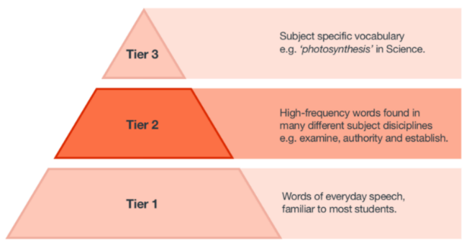
• Labelling images
• Odd one out
• What’s the link?
• Finish the sentence
Vocabulary Teaching
Once pupils’ have unlocked their prior knowledge of a subject, we introduce new vocabulary linked to that lesson. The vocabulary that we focus on and explicitly teach is identified on our vocabulary banks linked to that curriculum area – the words are a combination of Tier 2 and Tier 3 words (see diagram).
The strategies to teach vocabulary are varied but as new vocabulary is encountered, giving structure to what children do to familiarise with word meaning is important (reducing cognitive overload).
Teachers will explicitly teach 1 or 2 words from tier 2 or 3 per foundation subject lesson using the example models which best fit their cohort.
The number of words we explicitly teach can increase depending on the subject and the children’s familiarity and speed with the process.
Repeat the same model for 2-3 weeks so children become familiar with the process and adapt the model for the cohort.
EYFS – Year 3
Vocabulary will be recorded on flip charts and displayed in classrooms (using the adapted models) - strong imagery and focus on verbally practising new vocabulary.
Year 4 – 6
Vocabulary will be recorded by individual pupils on the model sheets and stuck into books or children record directly into their book. The vocabulary that has been explicitly taught will also be displayed within the classroom on washing lines, working walls and displays so that children can refer back to it during lessons.
See Appendix for the different models of teaching vocabulary.
- Supporting pupils
High expectations will be set for all pupils, regardless of ability, circumstances or needs.
The delivery and content of lessons will be sufficiently adapted to ensure all pupils can access and achieve within the curriculum. Teachers will take account of all pupils needs when developing their lessons and scaffolding and support will be provided where necessary.
Teachers will be aware of any pupils who may require specific support to ensure they can access the curriculum and ensure this support is implemented.
Pupils who are not progressing as expected will receive further appropriate support and may be referred to the school SENDCO. Personalised curriculum adaptations, parental involvement, small group and 1:1 work and support for the pupil’s wellbeing will be used.
The SENDCO will ensure that pupils with SEND receive the appropriate support, in line with EHC plans and the school’s Special Educational Needs and Disabilities (SEND) Policy.
Our school staff challenge pupils’ beliefs about themselves as learners, promoting a positive learning environment. This is characterised by ‘positive’ rather than ‘negative’ relationships between staff and pupils.
Instead of... | Try thinking…
I give up / I can’t do it | I can use a different strategy / I am going to train my brain
Its good enough / I can’t do better | Is this really my best effort? How can I improve this?
This is too hard  I will never be clever  My plan A didn't work  My friend can do it | This might take me a bit longer to master  I can learn how to do this  There is always a plan B  I will learn from them, ask them how they did it

- Marking and Assessment
Teachers will mark pupils’ work and provide feedback in line with the school’s Marking and Assessment Policy.
Pupils will be assessed both formally and informally throughout the academic year. The school’s approach to assessment is outlined in our Marking and Assessment Policy.
Assessment outcomes will be utilised to inform teaching and learning strategies, and along with teacher’s professional judgement, expertise and knowledge inform discussions about progress in termly pupil progress meetings.
- Working with pupils and parents
Pupils will be provided with opportunities to contribute to the teaching and learning strategies utilised in school. Teachers will ensure pupils fully understand their learning objectives and know what they need to do to meet these objectives.
The school will communicate with parents about their child’s learning in a variety of ways, including the following: parents evening, informal conversations in person or over the telephone, scheduled meetings, annual reports, through ‘stay and learn’ sessions and parent learning workshops.
- Behaviour and Attitude
All members of the school community will be responsible for developing a supportive learning culture. Staff will make sure that pupils understand that attitude to learning and behaviour are important aspects of maintaining a positive learning culture.
The principles of the school’s Behaviour Policy will be implemented at all times.
Pupils will be encouraged to:
- Listen to each other.
- Adopt various roles in groups.
- Volunteer thoughts and opinions.
- Respect the thoughts, ideas and contributions of others.
- Give honest and positive feedback.
Teachers will recognise and reward achievements and disruptive behaviour will all be managed by teachers in line with the school’s Behaviour Policy
To ensure that the quality of teaching is of the highest standard, all teachers will:
- Understand what excellent teaching is.
- Creatively plan and deliver lessons.
- Motivate pupils effectively.
- Enjoy and have a passion for teaching.
- Continue to learn and enhance their skills.
- Hold high expectations for all pupils.
- Understand how thinking and questioning develop learning.
- Be consummate professionals.
- Engage pupils of all abilities.
- Seek out and accept constructive feedback from peers, pupils and parents.
- Be given opportunities to lead.
- Involve parents and carers in their teaching.
- Understand and implement effective behaviour management strategies.

- Monitoring and Reporting
This policy will be reviewed annually by the headteacher and governing board with the input of teaching and support staff.
Teaching and learning is monitored in the following ways:
• The Leadership Team and curriculum Subject leaders may conduct classroom observations, monitor teachers’ plans, monitor books and talk to children.
• Staff meetings when Subject Leaders may monitor planning documents and share teaching and learning developments/issues.
• School learning walks by the Leadership Team and/or Governors and Subject Leaders.
• Pupil’s progress is individually tracked by class teachers, SENDCO and the Leadership Team and discussed formally at termly Pupil Progress meetings.
• Governor Curriculum Committee Meetings termly.
Good Teaching and Learning practice should be celebrated and shared. All staff have an open door policy to their colleagues to offer support and development opportunities in whatever format is most suitable at the time. This example list is not exhaustive: an informal discussion around strategies to motivate a particular pupil; a conversation around effective activities for teaching a specific objective; the sharing of a useful resource; an invitation to observe part of a lesson; a coaching conversation; or a referral to another experience colleague who may be able to help. All staff are able to seek the support of Senior Leaders whenever they wish and support will be offered in a timely and sensitive manner whenever it is identified as being necessary.
Appendices 1: Learning Environment Checklist
- Classrooms, the areas outside and outside areas are tidy, welcoming and well-organised with clearly defined areas.
- Reading areas are inviting and well-resourced with suitable, age appropriate texts that look exciting and interesting. Front facing books, labelled books and somewhere inviting to sit.
- Every room has British values, whole school values, school rules and a WAGOLL.
- Every child has a named piece of work displayed.
- Maths: a WAGOLL of the correct layout of each type of calculation should remain on display once taught and pictorial, abstract and concrete representations displayed when appropriate.
- There needs to be consistency between classes in year groups
- Children take care of their resources, displays and areas in and around the classroom.
- Displays balance the fine line of having all the information without it being over-stimulating
- A balance of celebration displays and working displays
- Resources are high quality, accessible to all, clearly labelled, maintained and replaced
- The majority of curriculum areas have a celebration or working display or subjects appear in the class book
- Across the school you see a progression in the children’s work, knowledge, skills and vocabulary on display

‘Working’ displays (working walls / flip chart sheets)

- Reflect current learning, are updated and replaced/removed;
- At a height and writing size the children can see;
- Children have the opportunity to contribute to and take ownership of;

‘Celebration’ displays

- Displays are visually pleasing, eye-catching,
- Celebrate children’s work (named),
- Contain topic information and key vocabulary
- Have an element of interactivity e.g. open questions, lift the flaps, look in the box; quizzes, activities
- Neatly organised and old staples, pins and blu-tak are removed; backing paper and border is refreshed or replaced each term

Appendices 2: Teaching and Learning in Maths

At Winnington Park Primary we strive to build the children’s confidence and resilience, ensuring that they are fluent and have conceptual understanding of key mathematical concepts. To ensure children are able to reason and problem solve in a range of mathematical contexts within maths lessons and in other areas of the curriculum. To ensure children have a positive view of mathematics and understand the power and purpose of mathematics in everyday life. We follow a mastery approach where all children are exposed to reasoning which is embedded throughout the teaching sequence.

Mathematics makes a significant contribution to modern society and at Winnington Park we consider it to be vital for the life opportunities of our children. We strive to enable fascination and an excitement to discover mathematical concepts and to broaden children’s knowledge and understanding of how mathematics is used in the wider world.

At Winnington Park we ensure children have transferable mathematical skills, the ability to reason and solve problems, and a well-developed vocabulary. We believe that the language of mathematics is international, the subject transcends cultural boundaries and its importance is universally recognised. We provide children with the opportunity to explore mathematics using a range of concrete, abstract and pictorial resources.

We aim that all pupils are:
• confident and competent with numbers and the number system
- are fluent in a range of different calculation strategies
• able to solve problems through decision-making and reasoning in a range of contexts and have a good understanding of the ways in which information is gathered and presented
• explore features of shape and space, and develop measuring skills in a range of contexts
• understand the importance of mathematics in everyday life.

The National Curriculum sets out the program of study for each year group. The programmes of study ensure all pupils become:

• fluent in the fundamentals of mathematics, including varied and frequent practice with a range of problem solving and reasoning questions, so that pupils have conceptual understanding and are able to recall and apply their knowledge rapidly and accurately to problems.
• reason mathematically by following a line of enquiry, conjecturing relationships and generalisations, and developing an argument, justification or proof using mathematical language.
• can solve problems by applying their mathematics to a variety of routine and non-routine problems with increasing sophistication, including breaking down problems into a series of simpler steps and persevering in seeking solutions.

In line with the National Curriculum, it is our expectation that all pupils acquire mathematical knowledge appropriate to their age and starting points, which enables them to recall it rapidly and apply it fluently and accurately, including when calculating efficiently. The ability to calculate mentally is an important part of mathematics, as well as being able to use the most appropriate written method, therefore we encourage children to use the most appropriate and effective method for solving calculations.

To enable children to move towards effective and efficient methods of more formal written calculations, with full understanding, a step by step approach is taken and is progressive across the school (see Calculation Policy and Power Maths sequence of work).
Decisions about when to move a child forward should always be based on a secure knowledge of pupils’ understanding and their readiness to progress to the next stage. Pupils who grasp concepts rapidly should be challenged through being offered rich and sophisticated problems before acceleration through new content. Those who are not sufficiently fluent with earlier material should consolidate their understanding, including through additional practice, before moving on. Manipulatives are used across the different year groups in the school. The decision to remove a manipulative is made in response to the pupils’ improved knowledge and understanding, not their age.

We aim for our pupils to love the challenge of learning and to be resilient to failure. Our pupils will become curious, interested learners who seek out and use new information to develop, consolidate and deepen their knowledge, understanding and skills.

Quality First Teaching

At Winnington Park we believe that good mathematics teaching is when teachers (and other school staff):

• Demonstrate secure subject and pedagogical knowledge in order to inspire
children and build on their understanding;
- Plan lessons effectively taking children’s prior learning and current assessment into account;
- Adapt their teaching in response to a variety of assessment information;
- Have a good knowledge of the common misconceptions and plan to address them through daily planning;
- Introduce subject content progressively and have high expectations of the pupils;
- Provide adequate time for practice to embed the pupils’ knowledge, understanding and skills securely;
- Use manipulatives appropriately with a clear rationale for why the manipulative will support pupils to understand mathematics;
- Enabling children to move onto pictorial and abstract methods when they are ready;
- Providing children with the opportunity to access variation in all lessons;
- Create lessons that are designed to consolidate, build upon and extend learning for all children;
- Emphasise the connections between different aspects of mathematics;
- Use questioning effectively to gauge and extend children’s skills, knowledge and understanding;
- Orchestrate productive classroom discussions by including regular opportunities for pupils to explain their approaches to mathematical tasks to themselves, the teacher and other pupils;
- Ensure that effective support is given in order that the children make good progress;
- Identify and support any pupil who is falling behind and enable almost all to catch up;
- Use precise mathematical language when examining mathematical structures;
- Use resources effectively, including other adults, to support children’s learning;
- Use technology effectively in order to support children’s learning;
- Mark work, identifying successes and next steps where appropriate so that children can improve their knowledge, understanding and skills. A good balance between oral and written feedback allows the children to effectively improve their learning. A partly completed/completed triangle will show the children’s level of understanding;
- Link mathematics to other areas of the curriculum where appropriate.

Curriculum Planning

Planning is monitored, and quality assured by the Senior Leadership Team regularly.

Long Term Planning
Whole School Overviews indicate the content to be covered from Foundation to Year Six for each individual year group based on the skills and knowledge outlined in the 2014 National Curriculum. Winnington Park use the Power Maths scheme to support the sequencing and delivery of maths.

Half Term Planning
School Overviews are separated into termly plans to ensure knowledge, skills and understanding of all areas in the Long-term plans are met. Clear progression is identified within the plans.

Short Term Planning
Weekly plans for Mathematics are completed by each class teacher supported by the Power Maths scheme. These should show progression throughout the week.

Teaching Time
Early Years Foundation Stage (EYFS):
Teachers and practitioners support children in developing their understanding of mathematics in a broad range of contexts in which they can explore, enjoy, learn, practise and talk about their developing understanding. Children use their knowledge and skills in these areas to solve problems, generate new questions and make connections across other areas of learning and development.

Years 1 – 6:
Teachers and practitioners provide adequate time for developing a range of mathematical concepts and skills. Each class teacher will teach a daily mathematics lesson. This will usually last an hour.
Children will have daily morning maths activities. These will be based on the four operations. These will be recorded in the back of the blue maths book (KS2) or morning maths books (KS1)

Each lesson will have a mental maths starter, include opportunities for children to be active where possible, include the class teacher working with a group to support their learning, and give the children opportunities to choose their own level of challenge.
Any work recorded in Maths books will be set out in the following way:
- One digit per square;
- There are two lines after a calculation for the children to write their answer in;

Classroom Environment
At Winnington Park we aim to engage pupils further in their learning through enhancing the classroom environment. Displays should inspire learning and celebrate the achievement of all pupils. A working wall for Mathematics will be updated regularly and provide good quality support prompts/ methods and guides that the children can access easily. Once new maths topics have been taught, displays will still show the four operations.

Assessment
In addition to ongoing assessment for learning, children will also complete assessments at various points in the year.

Appendices 3: Quality First Teaching
* Good relationships within the classroom
- atmosphere is calm, positive, purposeful and productive;
- polite language;
- established routines;
- adult approach is consistent;
- children are proud of their learning;
- behaviour policy is embedded within practice;
- children demonstrate resilience and perseverance;
- children aspire to high standards of presentation which is shown in all books;
- children are comfortable making mistakes and taking risks;
- all groups of children in the room participate and have ‘a voice’

* Range of teaching styles are used to engage all children in the class
- range of concrete and visual resources used;
- paired talk strategies; group work; collaborative learning
- short independent activities with feedback to the class;
- active and physical activities and calm quiet times;
- reduction in ‘teacher talk’ as the culture in the room focuses on the children working hard and contributing
- EYFS a balance of CI and adult led;
- children have the opportunity to be curious and creative and independent

* Assessment for learning is used throughout the lesson and informs the next steps.
- guided groups; selection of children for a group as misconceptions or level of understanding determines
- mini-plenaries;
- adjustments to questioning & content;
- reviewing content again in a different format (e.g. change of resources; new visual representation; change in vocabulary; change in context);
- amendments to planning; marking (end of lesson);
- organisation of post/pre-teaching

* Lessons are well resourced.
- teacher is well organised and prepared in advance;
- children’s pencil pots are tidy and fully stocked;
- high expectations about how equipment and the room should be treated and stored away;
- classroom organisations supports teaching and learning and routines;
- defined areas in the room and clear areas for equipment and each is resourced and labelled;
- children have roles, responsibilities and clear expectations in maintaining their learning environments

* Teacher has good subject knowledge and misconceptions are identified.
- planning and delivery of content demonstrates teacher’s knowledge of common misconceptions;
- Maths - amendment and highlighting of PM guide;
- planning and lesson sequencing demonstrates teachers know the building blocks needed for the learning;
- opportunities for deeper understanding provided;

* Lessons are well planned and sequenced.
- knowledge is built upon and learning is progressive over time;
- content is reviewed so children can retain and remember vocabulary and information;
- skills are given the opportunity to practise over time;
- appropriate level of challenge

* Knowledge and skills taught match our curriculum
- good subject knowledge informs concise teaching focused on specific knowledge and skills;
- activities in books directly support the learning of knowledge and application of skills on the objectives grid
* Lessons meet the needs of all children including those with SEND.
- mastery approach embedded;
- pre & post teaching organised; guided groups used;
- differentiation (scaffolds, support, challenge) when appropriate to allow all children to progress and succeed towards their own goals;
- additional adults are planned for and know their roles for teaching and learning;
- clear outcomes for the work SEND children are completing that links to their EHCP/SEND profile;
- all groups of children in the room feel able to participate and have ‘a voice’
- more-able children are catered for and their breadth of understanding is developed

* Feedback is clear and supports next steps
- marking is in line with the school marking policy; marking is effective for learning;
- feedback demonstrates teacher’s understanding of the curriculum and sequence of learning;
- children respond to their marking and apply it to future work;
- verbal feedback is timely and concise;
- peer to peer feedback strategies used only with a specific focus;
- same day interventions for Maths and English, phonics, reading available

* High standard of English used by all staff.
- spoken and written; accurate spelling in modelled work and displays

* Exciting and fun lessons to capture children’s interest and enthusiasm.
- well-paced delivery;
- children are active with different strategies to ensure inclusion and participation;
- contexts and scenarios are used that children find engaging and match their interests and age;
- wide range of activities;
Appendices 4: Children’s Work Books
All books
* Work is in line with National Curriculum expectations
* Work is of high quality and consistent across all areas of the curriculum
* Learning objectives are clear
* Children take pride in their work
* Work is cross curricular where possible
* Books evidence high expectations of the quality and quantity of work
* Each lesson should have the learning objective, which includes the knowledge and skills for each lesson and is linked to the curriculum
* Work has enough content to show progression through books
* Books are marked consistently and appropriately following the school’s marking policy
* There are a variety of activities to allow children to practise different skills
* Children respond to marking as appropriate
* Work is consistently well presented
* Regular work is evident in books in all subjects
* Learning objective, skills and knowledge are clear in books and the activities are clearly linked to this
* Work in foundation books matches the quality of that in English and Maths books

Maths books
* Work is evident with a clear objective in children’s Maths books when Power Maths books are not used
* Morning maths is recorded
* Use of mathematical vocabulary is evident in books
* Independent or teacher guided work is clearly identified

Guided reading books
* Carousel of activities is followed and demonstrated through work in books
* Relevant books and reading materials, with appropriate challenge, are used
* Guided reading texts and activities are suitable for reading ability

English books
* Success criteria is evident
* There is a variety of tasks and work
* Children respond to marking
* Tasks are meaningful and are linked to the success criteria

Other
* Webpages are up-to-date and informative
* Photos and evidence of practical lessons and activities in class books, classroom displays, Tapestry in EYFS, work celebrated online on Facebook, class web pages
* PSHE and computing files are up to date

Appendices 5: Vocabulary Templates
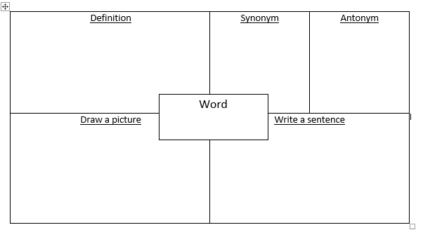
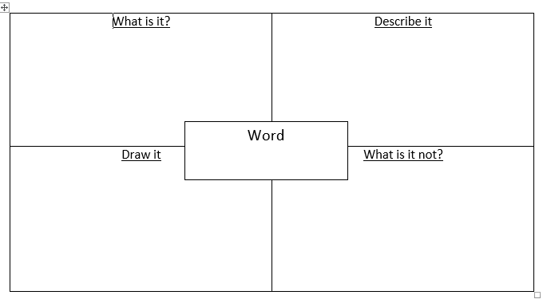

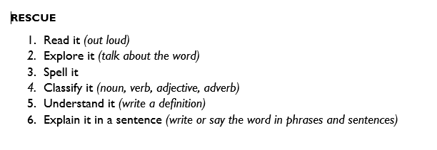

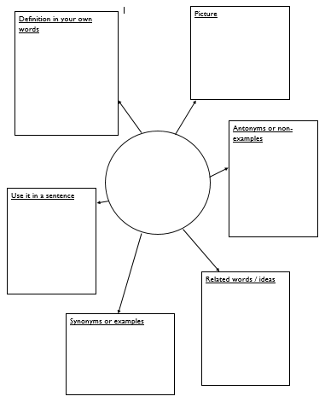

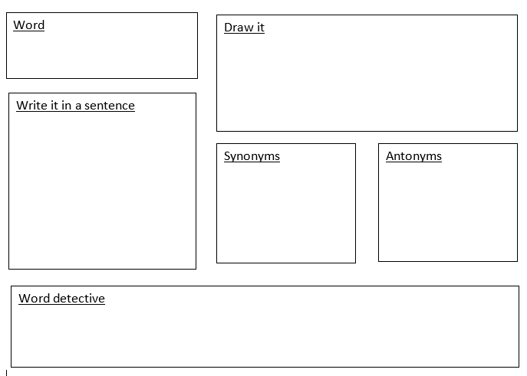

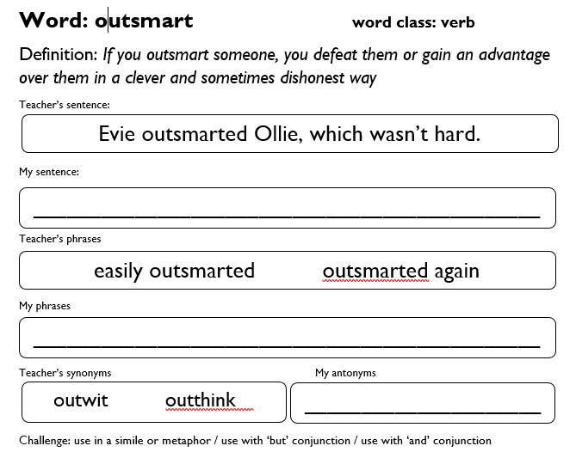
.

Appendices 6: Examples of vocabulary displays

