ASPIRE | SAFE | TRUST | RESPECT | KIND | PRIDE


Friday 7th November

Dear Parents, Carers and Children,

We hope you all had a lovely half term break.

Year 4 Residential
Well done to all the children in Year 4 for their brilliant attitudes towards the adventurous activities they have been involved with this week on their residential visit to the Petty Pool Outdoor Centre. The children have scaled 10m climbing walls, completed the ‘leap of faith’, traversed a high ropes course, travelled on a zip line, been on a night walk, taken part in bush craft activities and improved their archery skills. They have also been brave, determined, resilient, independent, kind, polite and fun and we are very proud of them all. Thank you to Mrs Worsley, Mrs Adams, Mrs Hainsworth, Mrs Ollier, Miss Croucher and Mrs Allen for giving their time to take the children on this overnight visit.

Friendship Week
This year Anti-Bullying week falls on the week beginning Monday 10th November to Friday 14th November with the theme ‘Power for Good’. At Winnington Park, the teachers involve their classes in different activities but we call the week ‘Friendship Week’, as we feel this is more positive, and in keeping with the excellent behaviour and relationships we work hard to achieve throughout school. We will update Facebook with our learning next week.

Staffing Updates
Congratulations to Miss Hope who is pregnant and expecting twins in the new year! Miss Hope will start her maternity leave at Christmas. Mrs Williams, an experienced inclusion leader, will be joining WPPS&N as SENDCo and Mrs Turner, who currently teaches Year 1 with Mrs Ford, will be increasing her working days in school to also teach in Reception with Mrs Allen. A thorough transition plan will allow families of the children with SEND to meet Mrs Williams in advance of Miss Hope’s maternity leave starting, and the children in Mrs Allen’s and Miss Hope’s class will also have plenty of opportunity to get to know Mrs Turner before Christmas.

We’re also very pleased to welcome Mrs Oliver and Mrs Chadwick to our team of Midday Assistants, Mrs Healey to our site staff and Mrs Cookson to our office team. They will all be fantastic additions to our warm and welcoming school and we very much looking forward to working with them.

Stranger Danger
There has been some concern in the local area. Local PCSOs have advised there is no official communication from Cheshire Police however, please do speak to your children about keeping themselves safe when playing out and about and when walking to and from school. The following links are useful for parents and carers talking to children: Cheshire Police Stranger Danger NSPCC Safe Outside the Home We will speak to the children in school.

Coats
Please always send your child to school with a coat. We like the children to play outside whenever the weather allows. Please write your child’s name inside their coat.

Remembrance
Tuesday 11th November is Remembrance Day. The children will learn about Remembrance day in their classrooms in an age appropriate way next weekend we will be marking Armistice Day in school next week by observing the 2-minute silence at 11.00am.

Every year, the Royal British Legion ask us to support their poppy appeal with the sale of poppy related items. Our Year 6 children have been selling these on the playground this morning and will sell anything remaining at the end of the day. Suggested donations for the different items range from £1.00 to £1.50. Thank you for your support.

Children in Need
Children in Need is on Friday 14th November. The children are invited to wear their own clothes with something spotty or a spotty outfit to school and to make a voluntary donation for Children in Need.

NSPCC Online Safety Learning for Parents and Carers
Last academic year, we were fortunate as Amy Holland from the NSPCC was able to visit school to lead online safety workshops for parents and carers. Unfortunately, funding changes mean these are unable to happen this year. However, the NSPCC have been able to provide details of their Teams online safety sessions, open to all parents in the UK, with the final date being in December.

Thursday 20th November | 6.00pm – 7.00pm | https://events.teams.microsoft.com/event/899237a0-5d68-42fb-8776-f71a516c88ec@3c4f002a-8d6d-4ede-8372-faf47ca8473f
Wednesday 10th December | 5.00pm – 6.00pm | Microsoft Virtual Events Powered by Teams

For general safeguarding, any adult can complete a 10 minute e-learning via our webpage: Listen up, Speak up | NSPCC

Book Fair
Our book fair will be back in school from Thursday 20th November until Thursday 27th November. The fair will be open 8.30am-9.30am and 2.45pm-3.30pm. Open times are to allow adults the chance to buy some books without the children being present but also for a quick look around for families together. The children will also get an opportunity to visit with their classes to explore the books and to read a story with their teacher. Entrance for adults is through the back door to school on the playground, near Winnington Winners, and the fair is located in the office area. Further details will follow in a separate letter.

Parents Evening
Parents Evening appointments are next week and online booking is available until Monday 10th November at 12.00pm. If there is anything you would specifically like to ask your child’s teacher, you can write this in the comments sections when you book your appointment.

Tuesday 11th November 3.30pm - 6.00pm (all classes)

Wednesday 12th November 3.30pm - 6.00pm (Year 6 only)

4.00pm - 6.00pm (Nursery only)

Thursday 13th November 3.30pm - 6.00pm (Nursery to Year 5)

Please visit https://winningtonpark.parentseveningsystem.co.uk to book your appointments.
Login with the following information:
Pupil’s First Name:
Pupil’s Surname:
Class Teacher:

Classroom Open Mornings Reminder
We look forward to welcoming family members into school next week. Please return your reply slips or speak to your child’s class teacher to let them know you are attending. To ensure we have enough space inside the classrooms, please can only one family member visit for each pupil. To safeguard pupils, please do not leave the classroom without a member of staff and turn off your mobile phone when inside school.

 | Monday 17th November | Tuesday 18th November | Wednesday 19th November | Thursday 20th November | Friday 21st November
9.00am | Year 6 | Year 1  Year 3 | Year 5 | Reception  Year 2 | Nursery  Year 4

Is your child Eligible for Free School Meals and the Pupil Premium?
Some families who currently pay for their child’s school meal may be entitled to receive free school meals. If your child is in Reception and Key Stage 1 they receive a ‘universal’ free school meal every day, but they may also be entitled to receive Pupil Premium funding. This is an amount of money paid to school for children in families who qualify for free school meals that we are able to put towards improving their education. If you think you might qualify for free school meals, even if your child receives the universal free school meal, please apply online using this link Free School Meals.

Have a lovely weekend.

Yours sincerely,
Mr Rob Cole
(Headteacher)
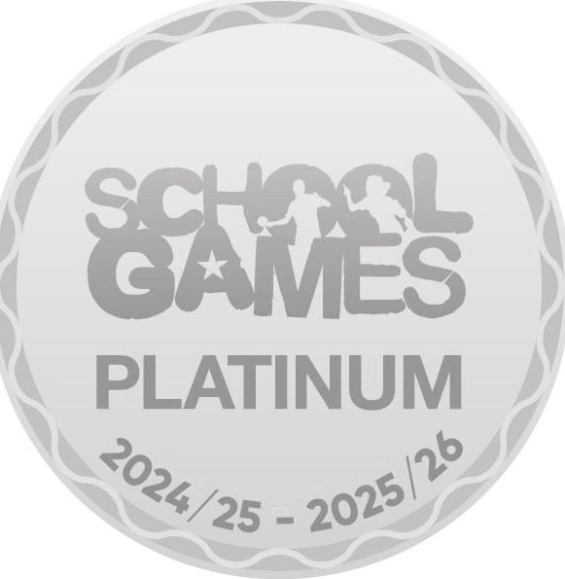
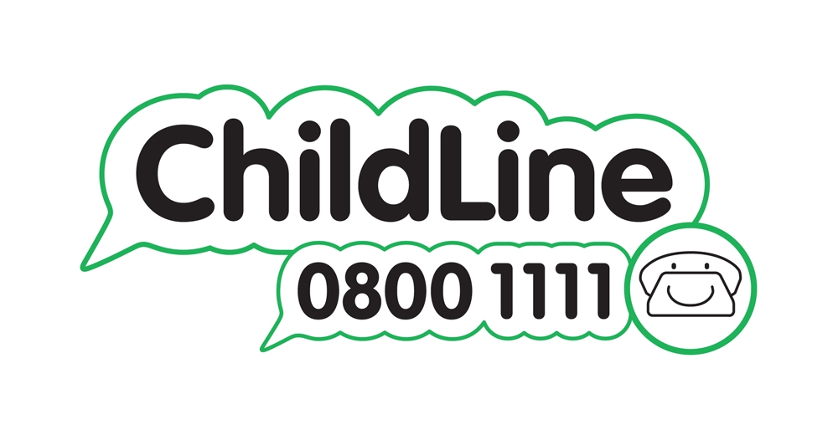

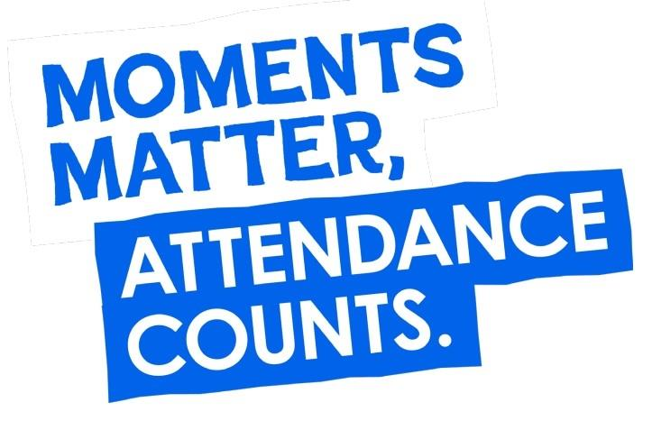



Winnington Park Primary School and Nursery, Firdale Road, Winnington, Northwich, Cheshire, CW8 4AZ
Tel: 01606 74371 email: admin@winningtonpark.cheshire.sch.uk website: www.winningtonpark.cheshire.sch.uk
Headteacher: Mr Rob Cole email: head@winningtonpark.cheshire.sch.uk

