Winnington Park Primary and Nursery School

Early Years Foundation Stage
Policy 2025-26

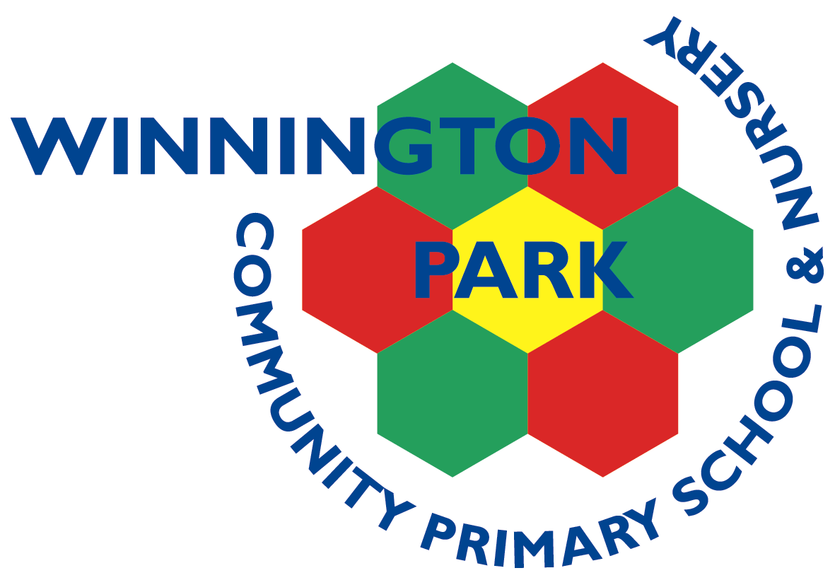

Updated: Autumn 2025

Review date: Autumn 2026

At Winnington Park Primary School and Nursery, we believe every child deserves the best possible start in life. Our Early Years Foundation Stage (EYFS) offers a nurturing, safe and stimulating environment where your child is valued and supported. At Winnington Park, we believe that the Early Years are vital for laying strong foundations for lifelong learning. Our experienced and caring team work closely with families to ensure that children feel happy, secure and excited to come to school each day. We follow the national Early Years Foundation Stage framework, which focuses on developing children’s skills across all areas of learning through play, exploration and carefully planned activities tailored to their individual interests and needs.
At WPPS&N, the Early Years Foundation Stage (EYFS) is made up of two year groups: Nursery, which children can join from the term after their third birthday, and Reception, which children enter in the autumn term following their fourth birthday.
Although our Nursery and Reception teams work closely together, we ensure clear progression across both year groups. Our Nursery provision focuses on preparing children to be ‘school ready,’ while our Reception curriculum ensures that children leave the EYFS fully prepared for the expectations of the National Curriculum in Year 1.

Our Curriculum Vision
In the Early Years Foundation Stage at our school, we are committed to providing a nurturing, inspiring, and ambitious start to every child’s learning journey. Our curriculum is designed to celebrate curiosity, encourage independence, and lay the foundations for a lifelong love of learning.
We believe that children learn best through meaningful play, high-quality interactions, and a rich balance of child-led exploration and adult-guided experiences. Through carefully planned provision, we aim to develop the whole child—supporting their communication, confidence, physical development, creativity, emotional well-being, and early academic skills.
Our Nursery and Reception teams work closely together to ensure a cohesive and progressive learning experience, that secures strong foundations, across the EYFS. We provide an environment where children feel safe, valued, and motivated to take risks, explore new ideas, and persevere. By the end of Nursery, our children are well prepared for the routines, expectations, and learning behaviours of school life. By the end of Reception, they leave the EYFS confident, enthusiastic learners who are ready to thrive within the National Curriculum in Year 1.
We are dedicated to building strong partnerships with families, recognising that they are the child’s first educators, and working collaboratively to support each child’s unique development. Our aim is to ensure that every child is given the best possible start, enabling them to flourish academically, socially, and emotionally.

Intent
At Winnington Park Primary School and Nursery, our Early Years curriculum is designed to give every child the strongest possible start to their learning journey. We believe the early years are a vital foundation for future success, and we are committed to providing a nurturing, stimulating, and ambitious environment where all children can thrive.
We create a warm, inclusive setting that values each child as an individual. Children arrive with different experiences, interests, and starting points, and we are dedicated to meeting their needs through a carefully planned, child-centred curriculum. Learning is accessible for all children, including our most vulnerable learners and those with additional needs, ensuring every child can participate, progress, and experience success.
Our Nursery and Reception teams work closely together to ensure a cohesive and progressive learning experience. Our Nursery provision prepares children to be confident, independent, and “school ready,” while our Reception curriculum ensures children leave the EYFS fully prepared for the expectations of the National Curriculum in Year 1.
We place strong emphasis on communication, language development, early reading, number sense, creativity, personal and social growth, and the acquisition of all areas of learning. We foster independence, curiosity, resilience, and a love of learning, while building strong partnerships with families to support each child’s unique development.

Implementation
At Winnington Park Primary School and Nursery, we implement our Early Years curriculum through a structured, well-resourced, and child-centred approach that ensures all children—including our most vulnerable and those with additional needs—receive the support, challenge, and opportunities they need to thrive.
A Carefully Planned and Progressive Curriculum: Nursery and Reception teams plan together to ensure continuity and progression across the EYFS. Long-term, medium-term, and weekly plans are designed around children’s interests, developmental stages, and key learning priorities. Learning is sequenced to revisit and deepen knowledge and skills, preparing children for Year 1.
Enabling Environments Indoors and Outdoors: We provide rich, stimulating environments that promote curiosity, exploration, and independence. Continuous provision is enhanced regularly to introduce new concepts, vocabulary, and challenges. Both indoor and outdoor learning experiences support physical, social, emotional, and academic development.
High-Quality Interactions and Skilled Practitioners: Our practitioners are highly trained in early childhood development and provide purposeful, high-quality interactions. Through modelling, scaffolding, and effective questioning, we deepen children’s understanding and support them to articulate ideas, solve problems, and make meaningful connections in their learning.
Inclusive Practice and Collaborative Support: We liaise closely with all stakeholders—including families, other settings, and external agencies involved with the children—to ensure the very best learning opportunities. Learning is accessible to all, including children with additional needs or vulnerabilities, through tailored support, adaptive teaching, and high-quality provision. Practitioners work alongside the SENDCo, external specialists, and families to identify needs early and implement timely, effective interventions. Visual supports, structured routines, and personalised resources remove barriers and enable every child to fully engage and succeed.
A Strong Focus on Communication, Reading, Writing, and Maths: We prioritise communication and language, early reading, writing, and number sense. Daily phonics sessions are delivered using Little Wandle, ensuring a systematic and consistent approach. Literacy development is further supported through high-quality texts, rich storytelling, and language-building activities. Writing opportunities are provided through Talk 4 Writing in Nursery and Drawing Club in Reception, allowing children to develop fine motor skills, creativity, and early writing in meaningful contexts.
In Maths, children develop a strong foundation in counting, number relationships, and problem-solving through both structured teaching and meaningful play, following the Mastery of Number (Nursery) and Power Maths programme (Reception). This ensures learning is progressive, engaging, and hands-on.
Fostering Independence and Learning Behaviours: From the start of Nursery, we promote independence and self-regulation. Children learn to manage routines, make choices, communicate needs, solve conflicts, and take responsibility for their learning. We model and celebrate resilience, curiosity, concentration, and collaboration to build strong learning behaviours.
Observation, Assessment, and Next Steps: Ongoing observations assess children’s progress and inform planning, enabling practitioners to provide appropriate scaffolding or challenge. Children’s achievements are celebrated, and targeted support ensures all children can progress from their starting points.
Working in Partnership with Families: We build strong relationships with parents and carers through regular communication, Parents’ Evenings (Autumn and Spring term), written end of year report (Summer term) stay-and-play sessions, workshops, home-school books, and open dialogue. Families are valued as partners, contributing to their child’s learning and development from the start.

Impact
The impact of our Early Years curriculum is reflected in the progress, confidence, and independence of every child at Winnington Park Primary School and Nursery. Children leave the EYFS well-prepared for Year 1, equipped with the knowledge, skills, and dispositions necessary to thrive within the National Curriculum.
Our children make strong progress in all areas of learning, including communication and language, literacy, numeracy, physical development, and personal, social, and emotional development. They develop a love of learning and demonstrate curiosity, resilience, and creativity in both adult-led and child-initiated activities.
Through our inclusive approach, all children—including those with additional needs or vulnerabilities—make measurable progress from their starting points. Tailored support, high-quality provision, and close collaboration with families, other settings, and external agencies ensure that every child can access the curriculum and achieve their potential.
Children develop independence, self-regulation, and positive learning behaviours, enabling them to take responsibility for their own learning and participate confidently in school life. They leave the EYFS with the skills, confidence, and enthusiasm to embrace new challenges and continue their educational journey successfully in Year 1 and beyond.
The ultimate measure of impact is the readiness, engagement, and happiness of our children as they transition into Key Stage 1, demonstrating that the strong foundations laid in the Early Years have provided them with the very best start to their education.

EYFS Statutory Framework
At Winnington Park, we follow the Early Years Foundation Stage (EYFS) Statutory Framework, which provides a structured yet flexible approach to early education. This national framework supports young children’s development by focusing on key areas essential for building strong foundations for future learning and well-being.

The curriculum is divided into seven key areas of learning, grouped into Prime Areas and Specific Areas:
Prime Areas
These are the core areas that support children's overall development and learning:
- Communication and Language – helping children to develop their listening, speaking, and understanding skills.
- Physical Development – encouraging movement, coordination and healthy personal care habits.
- Personal, Social and Emotional Development – supporting children in building confidence, forming relationships and managing emotions.

Specific Areas
These areas build on the prime areas and introduce children to more formal aspects of learning:
- Literacy – introducing early reading and writing through stories, songs and mark-making.
- Mathematics – helping children to explore numbers, shapes, patterns and basic problem-solving.
- Understanding the World – encouraging curiosity about people, places, nature and technology.
- Expressive Arts and Design – giving children opportunities to be creative through art, music, movement and imaginative play.

Characteristics of Effective Learning
At Winnington Park, we not only focus on what children learn but also how they learn. The Characteristics of Effective Learning are a vital part of the Early Years Foundation Stage (EYFS) and help us to understand and support each child’s approach to learning.
These characteristics guide the way children engage with their environment and develop positive attitudes toward learning:

1. Playing and Exploring
Children learn best when they feel safe to investigate and try new things. Through play, they develop confidence and enjoy discovering the world around them.
- Showing curiosity and interest
- Trying new activities
- Taking risks and using imagination

2. Active Learning
This involves children staying focused and motivated. They learn to keep trying even when things are difficult and to take pride in what they achieve.
- Staying involved and concentrating
- Showing persistence when facing challenges
- Enjoying a sense of achievement

3. Creating and Thinking Critically
Children are encouraged to think for themselves, make decisions, and solve problems. This helps them to become independent and reflective learners.
- Having their own ideas
- Making links between ideas
- Choosing ways to do things and finding solutions
At Winnington Park Primary School and Nursery, our staff carefully observe and support children in developing the Characteristics of Effective Learning through meaningful, play-based activities. By fostering these early learning habits, we help children build the foundations needed to become confident, capable, and enthusiastic learners.
We recognise that every child is unique and develops at their own pace. Children may progress in different areas at different times, and this is a normal part of early development. Our approach is centred on nurturing each child’s growth in a way that is tailored to their individual needs, ensuring that all children are supported to reach their full potential.

Learning Through Play
At Winnington Park Primary School and Nursery, we believe that children learn best through play. Our EYFS curriculum is designed to inspire curiosity, creativity, and a love of learning through hands-on, meaningful activities both indoors and outdoors. Play supports the development of essential skills across all areas of learning and allows children to progress at their own pace. Learning takes place through a balance of child-led and adult-led activities, both of which play a vital role in children’s development.
Child-Led Learning: Child-led learning allows children to take the lead in choosing what they want to explore. Through play and investigation, children follow their own interests, ideas, and questions. This type of learning fosters independence, creativity, and problem-solving skills. For example, a child may choose to build with blocks, paint, or explore the outdoor environment—all activities that encourage learning in a way that suits their own pace and style.
Adult-Led Learning: Adult-led learning involves teachers planning and guiding activities to develop specific skills or knowledge. These sessions are carefully designed to support children’s progress and introduce new concepts. For example, teachers may lead activities to practice letters and sounds, count objects, or develop social skills such as sharing and turn-taking. Adult-led learning provides structure and ensures children meet important learning objectives.
At Winnington Park, we maintain a balanced approach between child-led and adult-led learning. This creates a rich and engaging environment where children enjoy freedom and choice during play while benefiting from targeted teaching that supports their growth. Through this approach, every child develops confidence, curiosity, and a lifelong love of learning.
Assessment
All children in Reception complete the National Baseline Assessment (NBA) during the first few weeks of September. The NBA consists of a series of short, structured activities in literacy and mathematics designed to assess each child’s early skills and knowledge. This provides valuable insight into children’s starting points and helps practitioners plan effectively to support their learning across the curriculum.
Throughout the year, children’s progress is closely tracked using the Insight Tracker. Formative and summative teacher assessments, along with half-termly phonics assessments, allow us to monitor development and tailor provision to meet individual needs, ensuring every child reaches their full potential. We also use Wellcomm for all children on entry to assess and support children’s development in speech and language.
At the end of Reception, children are assessed against the statutory Early Learning Goals (ELGs), which cover the seven areas of learning: Communication and Language, Physical Development, Personal, Social and Emotional Development, Literacy, Mathematics, Understanding the World, and Expressive Arts and Design. The ELGs summarise the knowledge, skills, and understanding children are expected to have achieved by the end of Reception. Attainment is reported as either ‘emerging’ (working towards the expected level) or ‘expected’ (working at the expected level), providing a clear measure of each child’s progress and readiness for Year 1.
If concerns arise regarding a child’s attainment or progress, we communicate promptly with families, the SENDCo, and external agencies where appropriate. Provision is then carefully adapted to address individual needs and support each child to achieve their full potential.

Health, Medical Care, and Safer Eating
At Winnington Park Primary School and Nursery, the health, safety, and wellbeing of every child are our highest priorities. Any child with a medical need is closely supported by all staff, in line with the school’s First Aid Policy. Medicines are stored safely and administered correctly, and every administration is logged to ensure accurate monitoring.
All Early Years staff are qualified first aiders and are trained to respond promptly and appropriately to any injuries, accidents, or health concerns during the school day. In the event a child becomes unwell while at school, parents or carers will be contacted immediately. The school maintains up-to-date records of all children’s emergency contact details and medical information. Parents and carers are required to inform the school of any medical conditions, allergies, or changes to a child’s health. In the event of a head bump or other significant incident, parents and carers will be notified promptly via email, and a written record will be provided when the child is collected. Accurate health and contact information is essential to ensure the school can respond effectively to any health or safety concerns.
The school follows the 2025 Early Years Foundation Stage (EYFS) framework, which includes statutory requirements for safer eating, with a focus on choking prevention and allergy management. This guidance has informed the school’s Food and Nutrient Policy (for children aged 3-5 in the EYFS). As part of this, children participate in structured snack times, where they sit while eating, and all food and snacks provided in the Early Years are prepared in accordance with this guidance. Winnington Park provides healthy, balanced lunches prepared on-site, catering for all dietary requirements. Children in Reception eat lunch together in the dining hall, developing important social skills and independence. Children in Nursery eat their lunch in the Reception snack area. Nursery are able to purchase a school meal or bring in their own packed lunch. All children in Reception are entitled to free school meals, although they may bring a packed lunch if preferred. Daily, children are offered fresh fruit or vegetables for snack, with access to milk and water throughout the day to support hydration and healthy eating. Any specific dietary requirements must be communicated to the school office, and the necessary documentation will be provided and followed to ensure safe provision.

Safeguarding and Child Protection
The safety and wellbeing of all children at Winnington Park Primary School and Nursery are our highest priorities. The school is committed to providing a secure and caring environment in which children feel safe, respected, and supported. Procedures are in place to ensure children are collected only by authorised adults. If a child is to be collected by someone other than their usual caregiver, staff must be informed at drop-off or via the school office by email or telephone in advance.
All staff are fully trained in safeguarding and child protection procedures and adhere to the school’s robust policies to ensure that every child is protected. The school works closely with families to promote both the emotional and physical wellbeing of all children.
The Designated Safeguarding Lead (DSL) is Mr Cole, and the Deputy Safeguarding Lead (DDSL) is Mrs Allen, who is the Early Years Lead. Any safeguarding concerns or requests to speak with the DSL or DDSL should be arranged through the school office. The school ensures that all concerns are taken seriously and responded to promptly, in line with statutory guidance and school policy.
Inclusion
At Winnington Park Primary School and Nursery, we are committed to an inclusive practice in the Early Years. We recognise and celebrate that every child is unique, and we strive to ensure that all children, regardless of their background, abilities, or additional needs, have equal access to high-quality learning opportunities. Provision is adapted to meet individual needs, and targeted support is provided where necessary to enable every child to reach their full potential.
As part of our commitment to equality and diversity, we implement the No Outsiders programme on a half-termly basis, ensuring that children learn about fairness, respect, and the value of difference from an early age. This approach promotes positive attitudes, empathy, and understanding, fostering an environment where all children feel valued and included.

Uniform
Our school uniform helps children feel a sense of belonging and pride in being part of our school community. It also supports a smooth transition into school life by encouraging independence and readiness for learning. More information regarding the School Uniform can be found on the Uniform and Jewellery Policy, available on the school website.

EYFS Uniform Includes:
- Grey or black trousers, shorts (knee-length), skirt, or pinafore – suitable for both summer and winter
- Red, green or blue summer dress (summer term only)
- Red, green or blue polo shirt, with or without the school logo (worn in both summer and winter)
- Red, green or blue jumper or cardigan, with or without the school logo (worn in both summer and winter)
- Black shoes that are comfortable and practical, as children are active throughout the day—running, climbing, and playing both indoors and outdoors.

Transitions
At Winnington Park Primary School and Nursery, we ensure smooth and supportive transitions for children moving from Nursery to Reception and from Reception to Year 1. We liaise with different settings, including other early years providers, to share information and provide continuity of support, ensuring that all children experience a seamless transition. Staff work closely across year groups to identify individual needs and put appropriate steps in place to support every child during these transitions.
Nursery children are encouraged to become familiar with school routines and expectations by wearing some elements of the school uniform and taking home both a reading book and a reading for pleasure book. These practices are mirrored in Reception to provide continuity and support children in developing independent learning habits.
In Reception, children also experience P.E. days, where they wear a P.E. kit, Forest School days and are expected to bring in a water bottle and book bag daily. These routines help prepare children for the expectations of Year 1 and ensure they develop independence, responsibility, and readiness for new learning experiences. By embedding these practices, we support children to feel confident, settled, and fully prepared as they progress through the school.

Early Years Pupil Premium (EYPP)
Some children in the Early Years Foundation Stage may be eligible for additional funding through the Early Years Pupil Premium (EYPP). This funding enables the school to provide extra support and opportunities to help children thrive. EYPP may be used to enhance children’s early education through a range of approaches, including targeted learning activities, additional resources, or extra support for social and emotional development.
A child may be entitled to EYPP if they meet certain criteria, including:
- Currently being in the care of a local authority
- Being adopted or under a special guardianship or child arrangements order
- Coming from a family in receipt of Income Support, Universal Credit, or other qualifying benefits
The current income threshold for families receiving Universal Credit is a net earned income of £7,400 or less per year, which also qualifies children for Free School Meals in Key Stage 2.
Applying for EYPP ensures that children receive the support they need to make the best possible progress. This funding does not affect any benefits the family receives, and all information provided is treated confidentially. Families who believe their child may be eligible or who require further information should contact the school office, where staff can provide guidance and support through the application process.
Staffing
At Winnington Park, our staff are highly committed to providing the highest quality care and education for all children in our Early Years Foundation Stage. We work together to create a nurturing, stimulating, and inclusive environment where every child can thrive, ensuring their individual needs are met and their learning is supported across all areas of development.
Winnington Park Early Years Foundation Stage is staffed by three qualified teachers, five Teaching Assistants (NNEB Level 3 / NVQ Level 3), and two play workers. Ratios are always met within our settings (Nursery ratio 1:13 when a qualified teacher is present and Reception 1:30 when a qualified teacher is present).
Our experienced and dedicated team collaborates closely to deliver a broad and engaging curriculum, implement high-quality provision, and foster positive relationships with children and families. The expertise, knowledge, and commitment of our staff ensure that all children are supported to develop confidence, independence, and a lifelong love of learning.

