

- Parent / Carer Information Booklet

- The Nursery Class



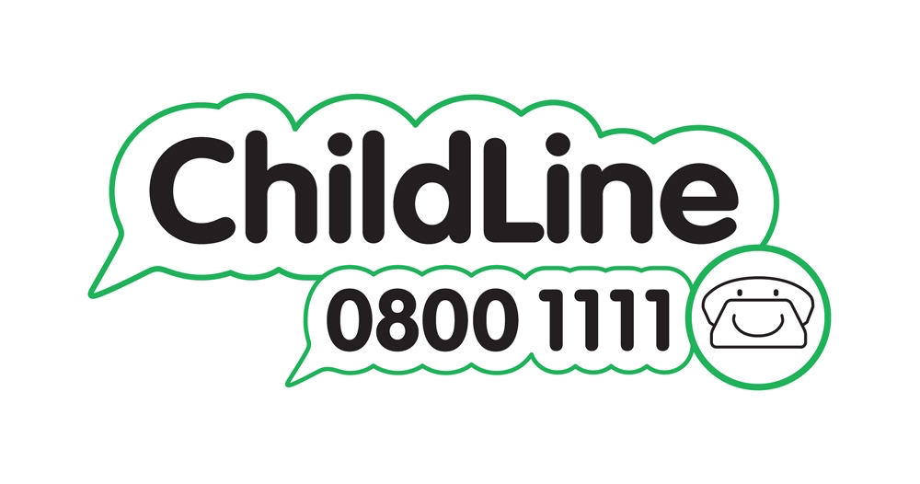


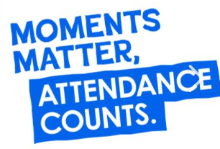


We are delighted to welcome you and your child to Winnington Park Primary School and Nursery. Starting Nursery is a big step and we are here to make the transition smooth and exciting. At Winnington Park Primary School and Nursery, we believe every child deserves the best possible start in life. Our Nursery provides a safe, secure and nurturing environment with a happy atmosphere, to promote confidence and increasing independence.

Our Approach to Learning
At Winnington Park, we believe that the Early Years (Nursery and Reception Classes) are vital for laying strong foundations for lifelong learning. Our experienced and caring team work closely with families to ensure that your child feels happy, secure and excited to come to school each day. Our Nursery class is staffed by a qualified experienced EYFS/Nursery teacher and a classroom assistant on a 1 to 13 adult/child ratio. Each staff member is caring, enthusiastic and passionate about their role.
We follow the national Early Years Foundation Stage Framework, which focuses on developing your child’s skills across all areas of learning through play, exploration and carefully planned activities tailored to their individual interests and needs.

Our Early Years Curriculum
The Early Years Foundation Stage (EYFS) statutory framework, provides a structured yet flexible approach to early education. This national framework supports young children’s development by focusing on key areas essential for building strong foundations for future learning and well-being.

The curriculum is divided into seven key areas of learning, grouped into Prime Areas and Specific Areas:
Prime Areas
These are the core areas that support children's overall development and learning:
- Communication and Language – helping children to develop their listening, speaking, and understanding skills.
- Physical Development – encouraging movement, coordination and healthy personal care habits.
- Personal, Social and Emotional Development – supporting children in building confidence, forming relationships and managing emotions.

Specific Areas
These areas build on the prime areas and introduce children to more formal aspects of learning:
- Literacy – introducing early reading and writing through stories, songs and mark-making.
- Mathematics – helping children to explore numbers, shapes, patterns and basic problem-solving.
- Understanding the World – encouraging curiosity about people, places, nature and technology.
- Expressive Arts and Design – giving children opportunities to be creative through art, music, movement and imaginative play.

In Nursery we focus primarily on the Prime Areas of learning. The curriculum emphasises the importance of learning through high quality play. Play underpins all development and learning for young children. The value of high quality play experiences is recognised in our school and is given priority in the planning and provision of resources. Children in Nursery learn by playing, exploring, being active and through creative and critical thinking which takes place both indoors and outside. Play allows children to develop essential skills across all areas, at their own pace. Your child's day will consist of a range of child-led play and teacher-led activities. Both play a vital role in your child’s development. Children enjoy freedom and choice during play while also benefiting from focused teaching that supports their growth in key areas. This approach helps every child develop confidence, curiosity and a love of learning.

Child-led
Child-led means that your child takes the lead in choosing what they want to explore. Through play and investigation, children follow their own interests, ideas and questions. This kind of learning encourages independence, creativity and problem-solving skills. For example, a child might decide to build with blocks, paint a picture—all activities where they learn at their own pace and style.

Adult-led
Adult-led involves teachers planning and guiding activities that help children develop specific skills or knowledge. These activities are carefully designed to support your child’s progress and introduce new concepts. For example, a teacher might lead a group activity to count objects, or practice sharing and turn-taking.

Characteristics of Effective Learning
At Winnington Park, we not only focus on what children learn but also how they learn. The Characteristics of Effective Learning are a vital part of the Early Years Foundation Stage (EYFS) and help us to understand and support each child’s approach to learning.
These characteristics guide the way children engage with their environment and develop positive attitudes toward learning:

1. Playing and Exploring
Children learn best when they feel safe to investigate and try new things. Through play, they develop confidence and enjoy discovering the world around them.
- Showing curiosity and interest
- Trying new activities
- Taking risks and using imagination

2. Active Learning
This involves children staying focused and motivated. They learn to keep trying even when things are difficult and to take pride in what they achieve.
- Staying involved and concentrating
- Showing persistence when facing challenges
- Enjoying a sense of achievement

3. Creating and Thinking Critically
Children are encouraged to think for themselves, make decisions, and solve problems. This helps them to become independent and reflective learners.
- Having their own ideas
- Making links between ideas
- Choosing ways to do things and finding solutions
Our staff carefully observe and support children in developing these characteristics through meaningful, playful activities. By nurturing these early learning habits, we help children build the foundations they need to become confident, capable and enthusiastic learners. At Winnington Park, we understand that every child is unique and develops at their own pace. Children learn and progress in different areas at different times and that’s completely normal. Please don’t worry if your child is developing at a different rate to others. We are here to nurture their growth in a way that’s right for them.

Communication with Parents
We understand and value the importance of forming excellent relationships with our parents. We know and understand that starting Nursery can be a stressful time for both parents and children, so we do everything we can to ensure that each child has a gradual admission to Nursery and that they are happy and feel safe in their new environment. If you ever have a question regarding your child or want to know more about what your child is learning or how they are settling please speak to a member of the Nursery Team, we are always there to listen.
We value our partnerships with families and believe that communication is key between school and home, to support children’s learning, development, and wellbeing.
We provide updates through newsletters, emails and Tapestry (online learning journal) with some images on Facebook. Tapestry allows you to be actively involved in your child’s education. You will be able to see photographs of your child whilst they are at school and it enables you to share your child’s at-home learning activities with us.
At Winnington Park, our priority is always to be present with the children: supporting their play, guiding their learning and forming strong, trusting relationships. While we value Tapestry and Facebook as a useful tool for sharing snapshots of your child’s development, we believe that the most meaningful learning happens when our staff are actively involved with the children, not behind a screen. Being fully present allows us to:
- Observe learning in real time
- Respond instantly to children's interests and questions
- Support language, social skills, and problem-solving as they happen
- Build secure relationships and emotional wellbeing
We hold several open mornings each term where you are invited to come into school to ‘Stay and Play’ with your child.
In the Autumn and Spring terms we hold a parent’s evening where you are invited to come into school at an agreed time and discuss your child’s progress with the Nursery Class Teacher. You will also receive a detailed written report regarding your child’s progress at the end of the Summer term.

Where to find the Nursery Classroom
The Nursery class is situated in the main school building, it has an outside enclosed play area as well as a spacious well equipped interior. The Reception classroom is situated next door. During your child’s time in Nursery they will have regularly taken part in whole school activities, visited different classes and be familiar with many of the school staff and pupils. They will be particularly familiar with the staff in the Reception classes and this results in children making a happy and natural transition to this class at the age of 4.

Sessions
Children can attend a morning, afternoon session or for a full day. A morning session is 8:40-12:00pm. An afternoon session is 12:00-3:15pm. A full day is 8:40-3:15pm. Children start Nursery the term following their 3rd birthday. If eligible, parents will need to apply for and validate a 30-hour code via the Childcare Choices website before the start of term when their child starts Nursery.
A Nursery session starts with the children being welcomed into the classroom and registration taking place, this is followed by a short adult-led session where we share our focus story/theme for that half term. Following this the children can choose their own activity (child-led) and move onto another when they are ready. Some children need encouragement to take part in a wider range of activities. There will always be at least one adult-led activity available that all children are encouraged to participate in. During this time the children can move freely between the classroom or outside area.
The children will take part in an adult-led Phonics and Maths session each day. We follow the Little Wandle Phonics Programme and Power Maths to plan for these sessions. The children will also take part in daily adult-led sessions where stories, songs and rhymes are shared.
Children are encouraged to take a reading book home each day in their book bag to share at home. They choose the book themselves and we aim to change the book each session. We provide a reading diary for you and your child to record thoughts regarding the book taken home.

Uniform
School uniform is optional in the Nursery Class but most children do wear it. Our school uniform helps children feel a sense of belonging and pride in being part of our school community. It also supports a smooth transition into school life by encouraging independence and readiness for learning.

EYFS Uniform Includes:
- Grey or black trousers, shorts (knee-length), skirt, or pinafore – suitable for both summer and winter. In Nursery many children choose to wear leggings/joggers.
- Red, green or blue summer dress (summer term only)
- Red, green or blue polo shirt, with or without the school logo (worn in both summer and winter)
- Red, green or blue jumper or cardigan, with or without the school logo (worn in both summer and winter)
- Black shoes that are comfortable and practical, as children are active throughout the day, running, climbing, and playing both indoors and outdoors.
- A school book bag is extremely useful for taking home reading books, work and letters. These can be obtained from Buccaneer Promotions, telephone 01606 212817.
Please ensure all items of clothing are clearly labelled with your child’s name to help us return any lost items quickly. For full details, including guidance on accessories and jewellery, please refer to our Uniform and Jewellery Policy, available on the school website.

Wrap-Around Care
To support busy families, we offer wrap-around care with a breakfast club starting at 7:30am and after-school care available until 6:00pm. These sessions provide a safe, welcoming environment where children can enjoy a nutritious meal, play, and relax beyond the regular school day. Currently, the breakfast club fee is £5.50 per session and after-school care is £12 per session. Please note that prices may increase slightly from September. Children attending breakfast club will be provided with a healthy breakfast and those staying after school will receive a light tea. All sessions can be conveniently booked through the School Gateway app.

Lunches and Snacks
We provide healthy, balanced lunches prepared on-site, catering to all dietary requirements. These cost £2.95. Children in Nursery also welcome to bring a packed lunch from home if preferred. Each day, children are offered snacks of fresh fruit or vegetables and they have access to milk and water throughout the school day to stay hydrated and healthy. If your child has any specific dietary needs, please contact the school office and we will guide you through the necessary documentation.

Safeguarding and Wellbeing
Your child’s safety and wellbeing are our highest priority at Winnington Park. We are committed to providing a secure, caring environment where children feel safe and respected. If your child is being collected by someone other than their usual adult, please let a member of staff know at drop-off or contact the school office via email or phone as early as possible. All of the staff are fully trained in safeguarding procedures and the school follows clear and robust policies to ensure every child is protected. We work in close partnership with families to promote both emotional and physical wellbeing.
Our Designated Safeguarding Lead is Mr Cole, and the Deputy Safeguarding Lead is Mrs Allen. If you have any concerns or would like to speak with either of them, please arrange an appointment through the school office. We are always here to listen and to help.

First Aid
All staff are qualified first aiders and are trained to respond promptly and appropriately to any injuries or health concerns during the school day. If your child becomes unwell while at school, we will contact you immediately. To help us care for your child effectively, please ensure that we have up-to-date emergency contact details and that you inform us of any medical conditions or changes to your child’s health. In the event of a head bump, we will notify you via email and also provide a written slip when your child is collected. Your child’s health and safety are very important to us and we appreciate your cooperation in keeping us informed.

Contact Details
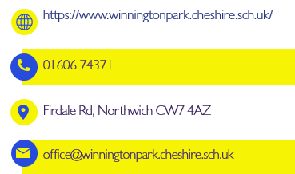
Thank you for taking the time to learn about our school and the Nursery experience we offer. At Winnington Park, we are committed to creating a nurturing, inclusive and inspiring environment where every child can flourish and develop a lifelong love of learning. We look forward to welcoming you and your family to our school community. If you have any questions, please don’t hesitate to contact us.
Together, we can give your child the best possible start to their educational journey.

