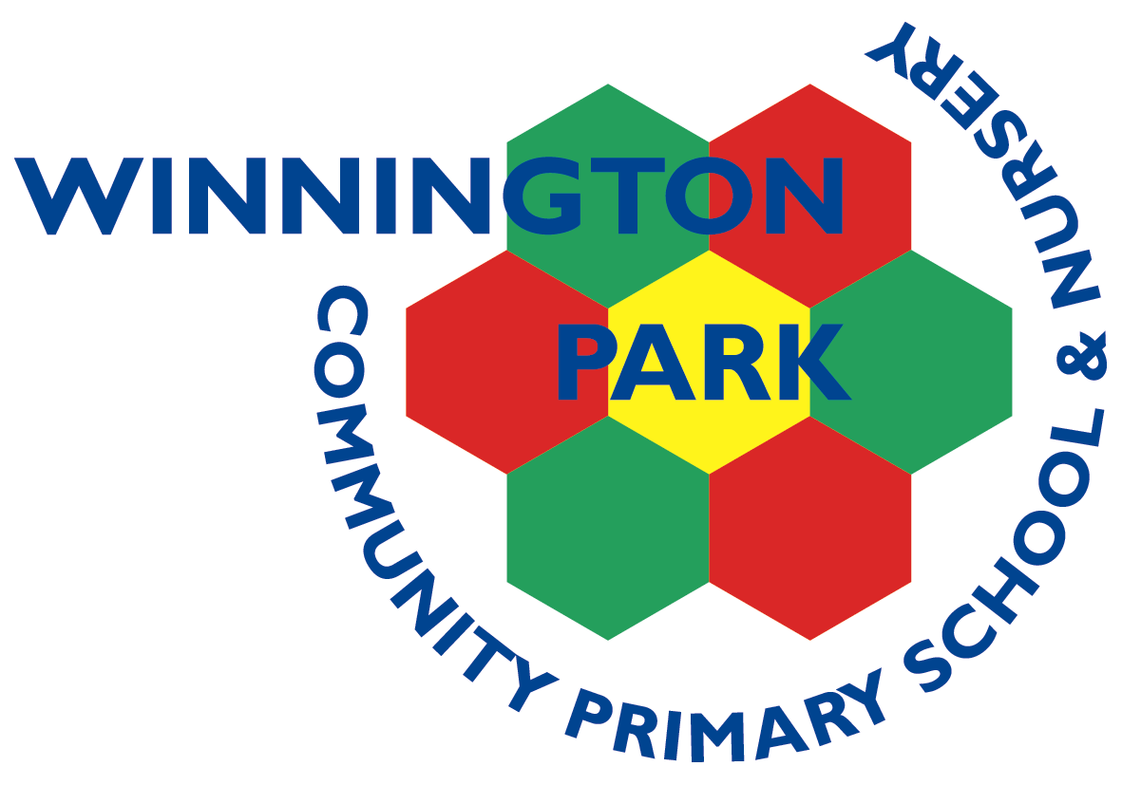
ASPIRE | SAFE | TRUST | RESPECT | KIND | PRIDE

Reading Resources

Some useful links:
- https://www.littlewandle.org.uk/resources/for-parents/

- https://www.youtube.com/channel/UCP_FbjYUP_UtldV2K_-niWw

- https://literacytrust.org.uk/information/what-is-literacy/what-phonics/

- https://schoolreadinglist.co.uk/reading-lists-for-ks1-school-pupils/100-best-picture-books-to-read-before-you-are-5-years-old/


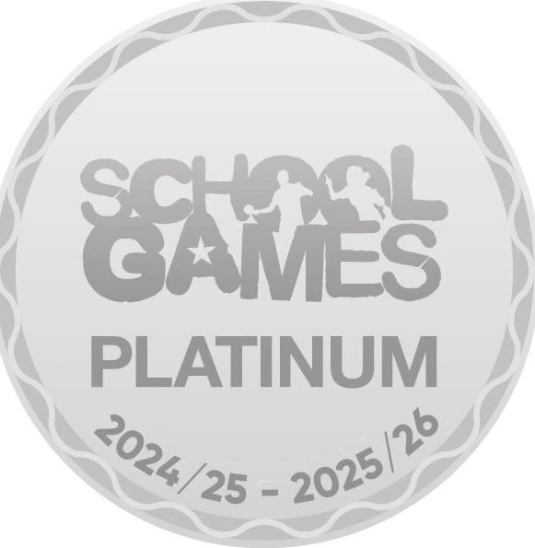
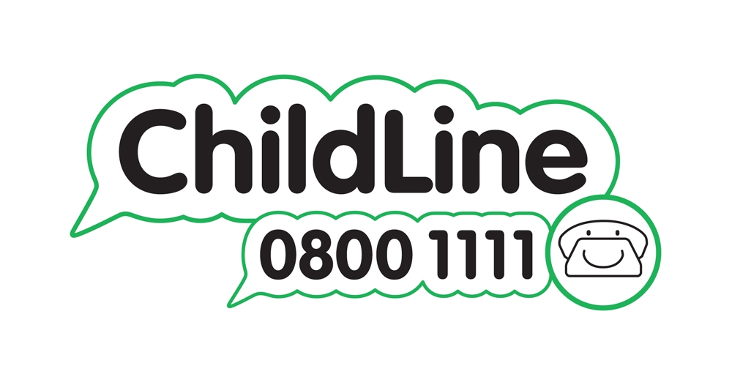

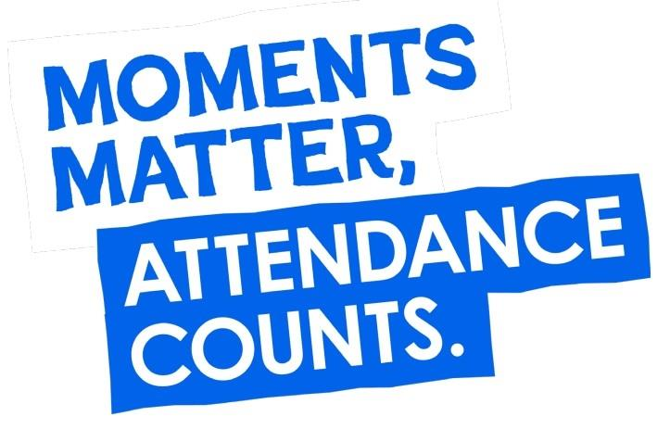
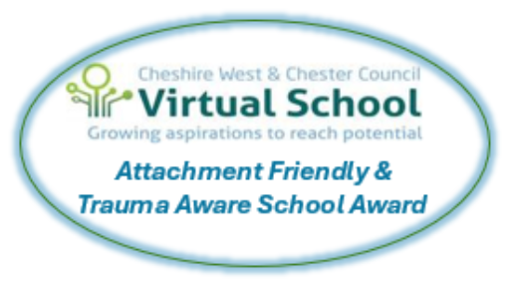

Winnington Park Primary School and Nursery, Firdale Road, Winnington, Northwich, Cheshire, CW8 4AZ
Tel: 01606 74371 email: admin@winningtonpark.cheshire.sch.uk website: www.winningtonpark.cheshire.sch.uk
Headteacher: Mr Rob Cole email: head@winningtonpark.cheshire.sch.uk

