Science Fridge Words History Fridge Words DT Fridge Words
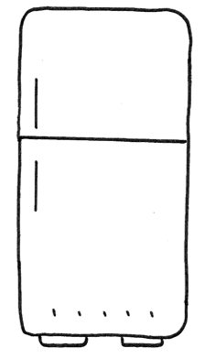
Fixed pivot

When something moves quickly back and forth or up and down.

How loud or soft a sound is.

How far something is from another.

Where something comes from or begins.

Moving from one place to another.
Vibrations

Volume

Distance
Source
Travel
A list of events in time order.

A large group of people who share certain ways of living and working.

A study of time and how events are ordered.

BC stands for Before Christ and AD stands for Anno Domini meaning ‘in the year of our Lord.’

Something belonging to a very distant past.

A new idea or new product or way to do something.
Timeline

Civilisation

Chronology

BC & AD

Ancient
Innovations
e

A system of links joined together to change movement.

What you need for a project.

A mechanism that allows movement back and forth or side to side.

A mechanism which does not allow movement.
Linkage
Design brief
Loose pivot

