Home learning Grid – Spring 1
History.
This half term we are looking at how the earliest civilisations have impacted our world today. Is there a significant person in your life who has impacted your life today? Could be in your life personally or a celebrity. Create a fact file about them and how they impacted your life today. If you know them personally, conduct an interview with them to gather information. If they are a celebrity research them to gather information.
Maths
Complete the maths worksheet each week on Dojo or collect a paper copy from class.
You also need to continue practising your times tables every week! Think about having fun, play the websites, make your own board game or snap cards and play on TT Rockstars.
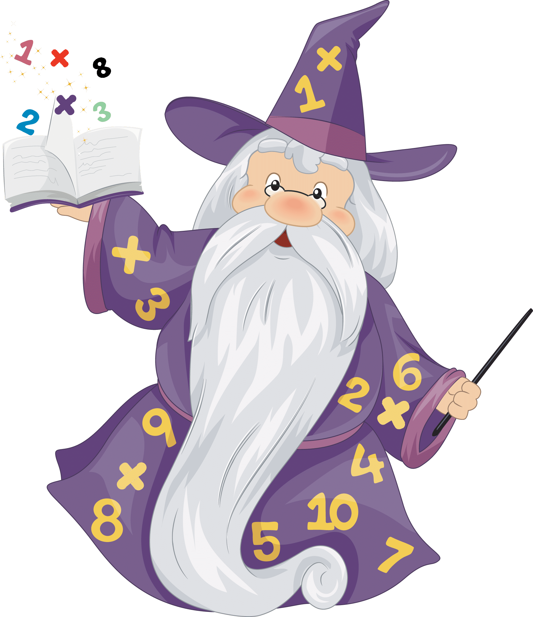

Beech Class
When you complete an activity, upload a picture onto
Class Dojo or bring it into school so we can all celebrate it.
You can do the activities in any order.
This is due in by Friday 13th February 2026
All resources will be uploaded on to Class Dojo, if you require paper copies please let your class teacher know.

Reading
Reading is an exercise for the mind and opens you up to a whole new world of vocabulary. Read the book you bring home from school at least three times a week.


Design and Technology

We are focusing on linkages and levers this half term. Create a pop-up book or poster using linkages and levers. Could you link your book or poster to one of the topics we have been learning about recently?
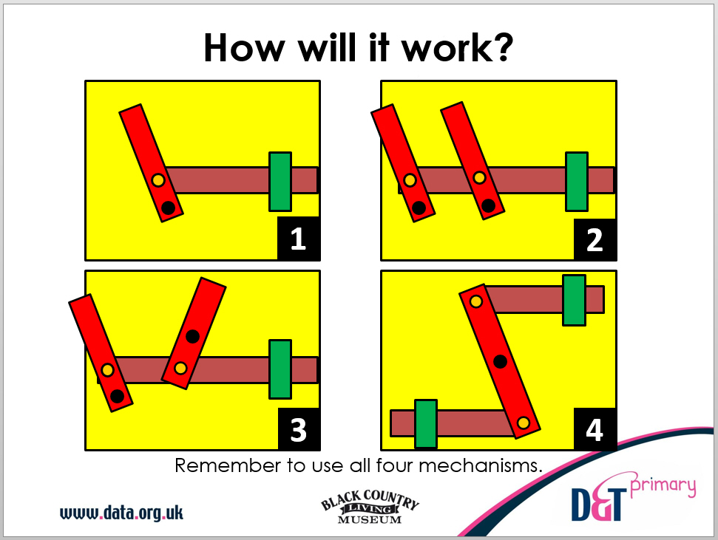
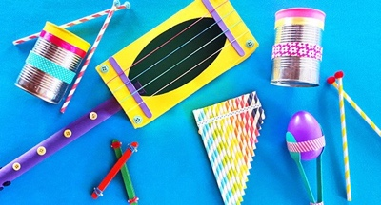
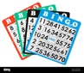
Science
In Science, we are learning all about sound: how sounds are made and how they travel from the source to our ears.
Different objects and instruments create sounds in different ways such as banging, shaking, blowing or plucking. Using items you can find around your house, make an instrument and describe how it makes sound.

Game Time! - BINGO

Create a grid using a times table of your choice.
Roll a dice or spin a wheel. Multiply the number by the times table you have chosen. If you have the answer: cross it off your grid. Continue till you have crossed off all your numbers and shout BINGO!

