Pupil Acceptable Use Agreement
Key Stage 2 (Years 3-6)

I understand that I must use Roebuck systems in a responsible way, to ensure that there is no risk to my safety or to the safety and security of the systems and other users.
For my own personal safety:
- I understand that Roebuck School will monitor my use of the systems, devices and digital communications.
- I will keep my username and password safe and secure – I will not share it, nor will I try to use any other person’s username and password. I understand that I should not write down or store a password where it is possible that someone may steal it.
- I will be aware of “stranger danger”, when I am communicating on-line.
- I will not disclose or share personal information about myself or others when on-line (this could include names, addresses, email addresses, telephone numbers, age, gender, educational details, financial details etc )
- I will immediately report any unpleasant or inappropriate material or messages or anything that makes me feel uncomfortable when I see it on-line.
I understand that everyone has equal rights to use technology as a resource and:
- I understand that Roebuck School devices are for educational use and that I will not use them for personal or recreational use unless I have permission.
- I will not try to download or upload anything from the internet.
- I will not use Roebuck School systems or devices for on-line gaming, on-line gambling, internet shopping, file sharing, or video broadcasting (eg YouTube).
I will act as I expect others to act toward me:
- I will respect others’ work and property and will not access, copy, remove or otherwise alter any other user’s files, without the owner’s knowledge and permission.
- I will be polite and responsible when I communicate with others, I will not use strong, aggressive or inappropriate language and I appreciate that others may have different opinions.
- I will not take or distribute images of anyone without their permission.
I recognise that the school has a responsibility to maintain the security of the technology it offers me and to ensure the smooth running of the school:
- I will not bring my own personal devices (mobile phones / USB devices etc) into school.
- I will immediately report any damage or faults involving equipment or software, however this may have happened
- I will not open any hyperlinks in emails or any attachments to emails, unless I know and trust the person / organisation who sent the email
- I will not install or attempt to install or store programmes of any type on any school device, nor will I try to alter computer settings
- I will not use social media sites in school
When using the internet for research, I recognise that:
- I should ensure that I have permission to use the original work of others in my own work
- Where work is protected by copyright, I will not download copies (including music and videos)
- When I am using the internet to find information, I should take care to check that the information that I access is accurate, as I understand that the work of others may not be truthful and may be a deliberate attempt to mislead me.
I understand that I am responsible for my actions, both in and out of school:
- I understand that Roebuck School also has the right to take action against me if I am involved in incidents of inappropriate behaviour, that are covered in this agreement, when I am out of school (examples would be cyber-bullying, use of images or personal information).
- I understand that if I fail to comply with this Acceptable Use Policy Agreement, I may no longer be allowed to access the school network and internet.
- I understand that Roebuck School will contact my parents if I fail to comply with this Acceptable Use Agreement.

Name of Pupil: Class:
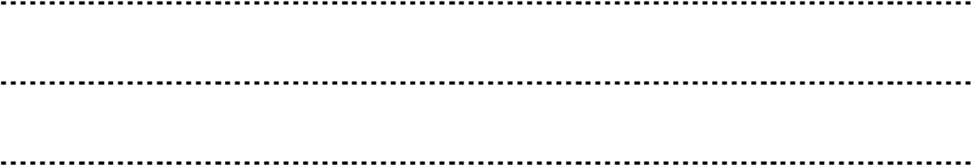
Signed: Date:

