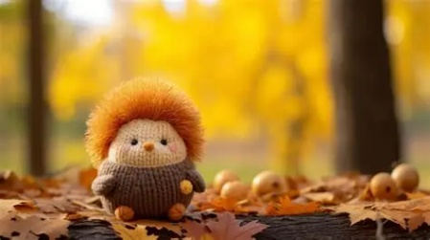
Brambles 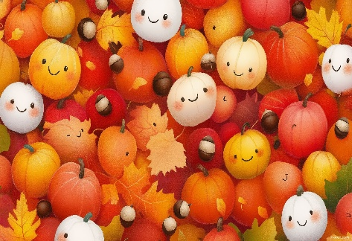

Learning Overview

Autumn 1

🍂 Welcome to Brambles! 🍂
We hope you have all had a wonderful summer break and are looking forward to the exciting term ahead. This half term we will be exploring the theme of Autumn, learning about seasonal changes, harvest time and woodland animals through a range of practical, sensory and fun learning experiences. Our curriculum is designed to support each child's communication, independence and personal development through meaningful activities that are engaging and enjoyable. We can't wait to see the children grow in confidence as they explore, discover and learn together!

My Communication
This half term we will continue to develop our communication skills through stories, role play, music and sensory experiences. We will share ideas, answer questions, make choices and communicate in many different ways. Our stories will include The Leaf Thief, Leaf Man, The Little Red Hen and other autumn-themed books.

My English
We will continue practising name writing, phonics and reading every day. Children will work on listening to stories, learning new vocabulary and sequencing events. We will encourage mark making, writing and communication through a range of engaging activities.

My Maths
In Maths we will be exploring weight, capacity and number. Activities will include comparing heavy and light objects, investigating full and empty containers, counting autumn treasures, conservation of number activities and comparing groups of objects. Learning will be practical and hands-on through water play, cooking and outdoor exploration.

The World Around Me
We will explore the signs of Autumn and observe changes in the weather and environment. The children will investigate leaves, pine cones and woodland animals and learn about harvest and how animals prepare for winter. They will use their senses to explore the Outdoor Classroom.

My Independence
This half term we will continue to develop everyday life skills through cooking, dressing and road safety activities. The children will prepare snacks and make simple foods such as apple crumble. They will be following new routines and practising skills which allow them to become more independent.

My Play and Leisure
The children will take part in games and activities that develop turn-taking, sharing and cooperation. We will enjoy small world play, construction activities, outdoor challenges and games that encourage imaginative play and positive social interactions.

My Sensory
Sensory activities will include exploring Autumn textures, crunchy leaves, pine cones, seasonal scents, sensory trays, water play and messy play. These experiences help support engagement, exploration and communication.

📚 Reading books should be brought into school every day. Please try to read with your child at least three times each week.
🌳 We will be visiting the outdoor classroom every week as part of our outdoor learning.
If you have any questions or concerns, please do not hesitate to speak to a member of the Brambles team or contact us via Dojo.
Mrs Speight and the Brambles Team 🍁🦔

