Topic: Prediction



Float or Sink?
Think! Will each item float or sink:
 | Float | Sink | Result
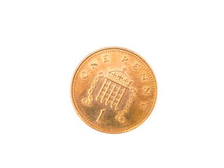
Penny
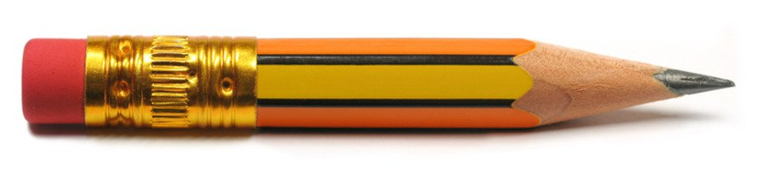
Pencil
Cotton ball
Rubber band
Plastic spoon
Teaspoon
Did you predict the correct result?



