This weeks tasks =)

English & Phonics tasks
Monday Most of our activities this week will relate to ‘Jelly’.
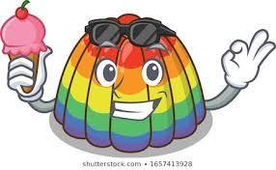

A song to help you learn the sound
https://www.youtube.com/watch?v=-b9asCO1Uxk

Can you say its sound and action?
Try to find some objects beginning with the sound j.

Tuesday – Listen to the story ‘Red Rockets and Rainbow Jelly’ by Sue Heap and Nick Sharratt
https://www.youtube.com/watch?v=n9goNsbFbZk
Discuss the story together

Who are the characters in the story?
Which colours were in the book?
What things does Nick like?
What things does Sue like?
What colours were there on the jelly?

Watch the story again
Turn the sound off, can you tell the story in your own words using the pictures as clues?

Wednesday – Make your own jelly (please don’t eat all your jelly, once it is made, as we are going to use it as part of our topic work tomorrow)
Using a packet of your favourite flavour jelly, follow the instructions on the back of the packet to make your jelly with an adult helper.

Thursday – Create your own instruction poster on ‘Making My Jelly’
Try to do some writing and pictures, (it does not have to be the correct letters or spelling – the children just need the confidence to make marks to represent their ideas).
Read your instructions to a teddy and people in your family

Friday – Rainbow writing Using lots of different coloured pen/ pencils/ crayons/ chalks. Write your name in a different colour each time.
Practise writing your surname using a different colour for each letter

Maths and creative

Monday – Look everywhere for shapes, listen to the shape song and see if you can find the shapes around your house
https://www.youtube.com/watch?v=pfRuLS-Vnjs
Are you able to draw a picture using the shapes circle, square, triangle and oblong (you may want to add some extra shapes too ie star)
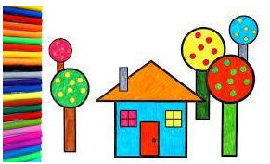

Tues 9th – Using a packet of jelly beans (or any other sweet which are different colours ie smarties, jelly tots), sort the sweets into different colour groups
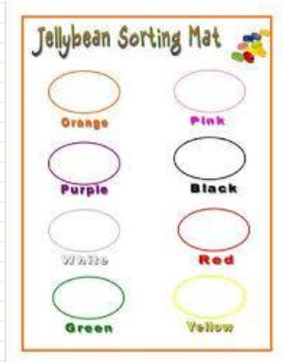

Which is your favourite colour sweet? (you could ask other people in your family too
Count how many sweets you have of each colour
Which was the most popular colour sweet?
Which was the least popular colour sweet?
Were there any colours which had no sweets?

Wednesday – Watch Numberblocks to learn all about number 5
https://www.bbc.co.uk/iplayer/episode/b08d630h/numberblocks-series-1-five

Can you count out 5 objects?
Can you see the number 5 anywhere around your house or in books?

Thursday – Ask an adult to help you play a Number Detective Game. Can you find me 5 ……. (teddies, boxes, books etc).

- Put the objects in a line to count them (remember to touch each one as you count).
- Put them in a circle, how many do you have?

To extend the game show the number 5 rather than saying it.
If you are given 5 objects can you count them and say how many you have?
Draw 5 spots, remember to count each one as you draw.

Friday – Count up to 10 and beyond if you can
Play the Monster Counting Game on CBeebies, you may need help to recognise some of the numbers once you have counted the objects.

https://www.bbc.co.uk/cbeebies/puzzles/school-of-roars-monster-maths-quiz

