Sheet A | + | Time | Fractions | Make£1.74p  With 5 coins | Shape
Monday | 43 + = 20 + 36 | 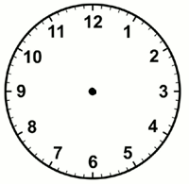 | ½ of 28=  ¼ of 28 = |  | 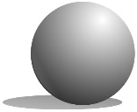  This is a __________
Tuesday | 27 + = 14 + 30 |  | ½ of 8=  ¼ of 8 = | With 6 coins | How many faces?
Wednesday | 18 + = 29 +19 |  | ½ of 12=  ¼ of 12 = | With 7 coins | How many edges?
Thursday | 62 + = 37 +43 |  | ½ of 16=  ¼ of 16 = | With 8 coins | How many vertices?
Friday | 53 + = 19 + 62 |  | ½ of 4=  ¼ of 4 = | With 9 coins | It is like a ____________
Sheet B | + | Time | Fractions | Make 74p | Shape
Monday | 18 + = 27 |  | ½ of 28=  ¼ of 28 = |  | This is a __________
Tuesday | 39 + = 52 |  | ½ of 8=  ¼ of 8 = |  | How many faces?
Wednesday | + 19 = 36 |  | ½ of 12=  ¼ of 12 = |  | How many edges?
Thursday | + 28 = 47 |  | ½ of 16=  ¼ of 16 = |  | How many vertices?
Friday | + 22 = 53 |  | ½ of 4=  ¼ of 4 = |  | It is like a ____________
Sheet C | + | Time | Fractions | Make £25 | Other
Monday | 47 + 5 |  | ½ of 28=  ¼ of 28 = |  | 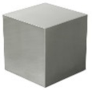  This is a __________
Tuesday | 29 + 7 |  | ½ of 8=  ¼ of 8 = |  | This is a __________
Wednesday | 4 + 79 |  | ½ of 12=  ¼ of 12 = |  |   This is a __________
Thursday | 6 + 46 |  | ½ of 4=  ¼ of 4 = |  | 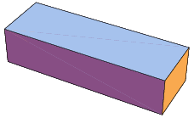  This is a __________
Friday

