English

The focus this week will be handwriting, aiming to form certain letters correctly that the children find harder. Each day there will be a different letter. Children are to learn the handwriting story to go with each letter off by heart, watch the video (with the sound off because we would rather the children say the handwriting story as they write) and practise the correct formation of the letter until it becomes easier/more natural.
Monday 20th: Letter g – this letter is part of the ‘c’ family so should be formed as a ‘c’ first. Encourage children to ensure this letter hangs below the line.
- Up we go… around the girl’s face, down her hair and give her a curl
- https://www.youtube.com/watch?v=GPIywbNhias

Tuesday 21st: Letter ‘d’ – also part of the ‘c’ family so should be formed as a ‘c’ first.
- Up we go… around the dinosaur’s bottom, up his tall neck and down to his toes
- https://www.youtube.com/watch?v=dyueHN6iP4Y

Wednesday 22nd: Letter ‘e’
- Up we go… lift off the top and scoop out the egg
- https://www.youtube.com/watch?v=gU9RRdCfCrE

Thursday 23rd: Letter ‘s’
- Up we go… slither down the snake
- https://www.youtube.com/watch?v=Z88An0KpuYo (don’t do the flick at the end)

Friday 24th: Letter ‘p’ – encourage children to ensure this hangs below the line
- Up we go… down the pirate’s plait and around his face
- https://www.youtube.com/watch?v=qeVjcMYcETQ (the flick at the end not necessary)

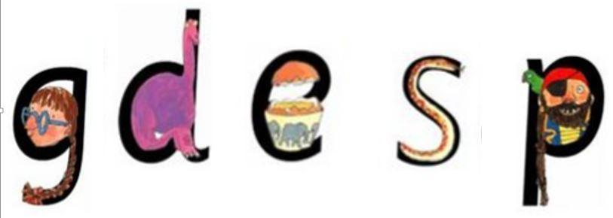

Maths
Monday – Sing a days of the week song

https://www.youtube.com/watch?v=qNJRGHk7sN8

Can you say the days in the right order?

Tuesday – Start a weather diary, recording the weather each day for the next few week

 | Monday | Tuesday | Wednesday | Thursday | Friday | Saturday | Sunday
Week 1 |  | 
Week 2
Week 3

Wednesday - Watch Numberblocks to learn all about number 3

www.bbc.co.uk/iplayer/episode/b08bzgxx/numberblocks-series-1-three

Can you count out 3 objects?

Thursday – Ask an adult to help you play a Number Detective Game. Can you find me 3 ……. (teddies, boxes, books)
To extend the game show the number 3 rather than saying it.
If you are given 3 objects can you count them and say how many you have? You can play this for different numbers.

Friday – On your daily exercise, can you see any numbers? What number do you live at?

Creative
Topic (SMSC/PSHE) - As part of our PSHE this week, we will be looking at ‘personal hygiene’ and how/why we keep ourselves clean. There has been a whole host of videos posted online recently by musicians, footballers and celebrities of them washing their hands (and often singing along whilst doing so!), which is particularly important at this current time. So, we would like you to create your own instructional video, using that key instructional vocabulary that we learnt earlier on this year (first, second, next, after that, etc.), which your parents and guardians can record and share online with family and friends.

Be creative. Have fun. Keep washing those hands. And stay safe and well!

Mrs Flanagan

