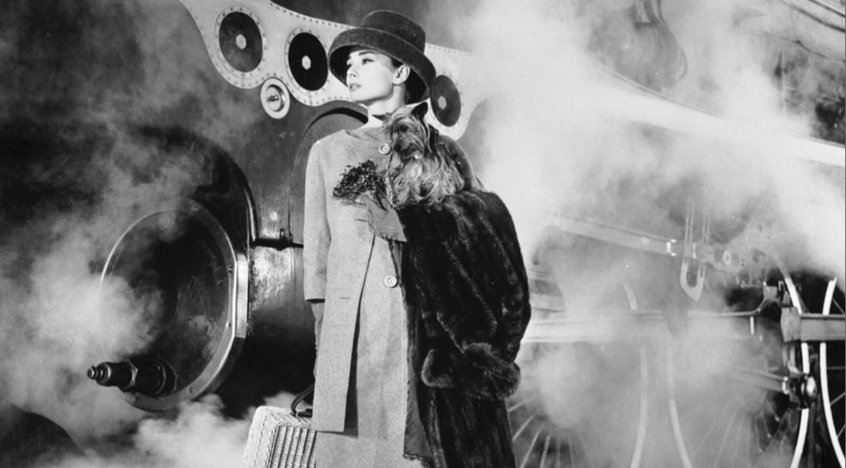

Icy fingers of foggy air swirled around her legs, as she walked slowly across the platform. She could hear the impatient rumble from the belly of the brooding metal monster beside her, which growled like a tired and hungry dragon.

Behind her, the silent steamy mist began to surround the figures on the station’s walkway, making them look like smudged paintings, and she wondered if she was doing the right thing; could this be a big mistake?

Walking slowly, she gazed at the engine. It was as black as the night above her, and shone like a mirror, reflecting her frozen features. It was a demon sent to challenge her ideas; to mock her plans and to laugh at her silliness. Turning away, she began to brood on the future that was still so uncertain. Like the mist around her, it swirled and chilled her to the bone.

She shuddered.

Quietly, dissolving like salt in a boiling pan of water, a figure began to appear through the gloom at the end of the platform. She held her bated breath, straining her eyes in
anticipation. Was she ready? Like a rabbit caught in the lights of an on-coming train, she recognised the man. Strong and sure, he strode purposefully in her direction, smiling slightly at the clear look of terror on her vulnerable and fragile face.
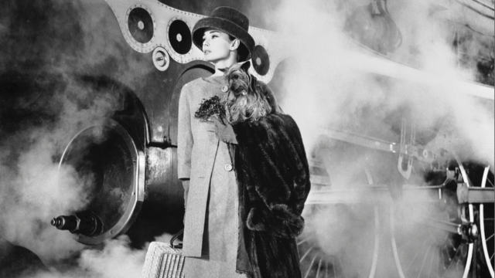
Atmospheric and Descriptive Writing
_________________________________
_________________________________
________________________________________________________
________________________________________________________
________________________________________________________
________________________________________________________
________________________________________________________
________________________________________________________
________________________________________________________
________________________________________________________
________________________________________________________
________________________________________________________
________________________________________________________
________________________________________________________
________________________________________________________
________________________________________________________
________________________________________________________
________________________________________________________
________________________________________________________
________________________________________________________
________________________________________________________
________________________________________________________
________________________________________________________

