Sheet A | + | Time | Fractions | Make £3.84 | Shape
Monday | 13 + + 20 = 36 | 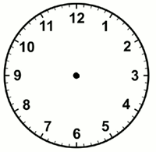 | ½ of 8=  ¼ of 8 = |  | 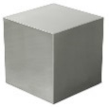  This is a __________
Tuesday | 17 + + 14 = 40 |  | ½ of 28=  ¼ of 28 = |  | 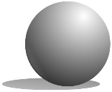  This is a __________
Wednesday | 28 + + 9 = 39 |  | What is double 5?  What is double 2? |  |   This is a __________
Thursday | 32 + + 7 = 42 |  | 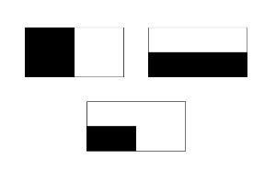  Tick the shapes that have exactly half shaded |  | 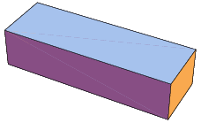  This is a __________
Friday | 35 + +17 = 62 |  | Archie rolls 2 dice, he gets double 4. What does double 4 add up to. |  | 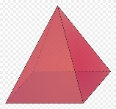  This is a __________
Sheet B | + and - | Time | Fractions | Make 84p | Shape
Monday | 38 + 27 |  | ½ of 8=  ¼ of 8 = |  | This is a __________
Tuesday | 59 + 32 |  | ½ of 20=  ¼ of 20 = |  | This is a __________
Wednesday | 37- 19 |  | What is double 5?  What is double 2?  What is double 5?  What is double 2? |  | This is a __________
Thursday | 47 - 18 |  | 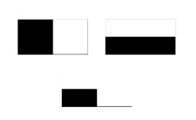  Tick the shapes that have exactly half shaded |  | This is a __________
Friday | 44 - 25 |  | Archie rolls 2 dice, he gets double 4. What does double 4 add up to. |  | This is a __________
Sheet C | + | Time | Fractions | Make £25 | Other
Monday | 47 + 5 |  | ½ of 28=  ¼ of 28 = |  | This is a __________
Tuesday | 29 + 7 |  | ½ of 8=  ¼ of 8 = |  | This is a __________
Wednesday | 4 + 79 |  | ½ of 12=  ¼ of 12 = |  | This is a __________
Thursday | 6 + 46 |  | ½ of 4=  ¼ of 4 = |  | This is a __________
Friday |  |  |  |  | This is a __________

