Jesus’ body is placed in a tomb
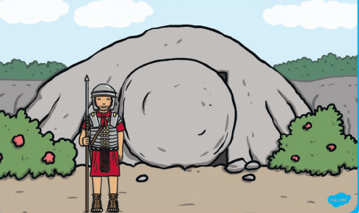

Jesus’ friends find the tomb empty

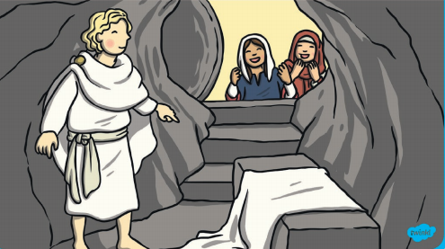

Jesus ascends to Heaven
