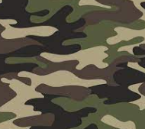
Year 6
Autumn Term One Homework Project
World War II

It is time to get creative year 6. I would like you to use materials that you have at home to make one of the following:

- Make a model of an Anderson Shelter and explain how they would have built one.

- Research one of the key events from WWII and create a poster or Power point presentation about your findings.

- Create a world map showing the allies and the axis.

I look forward to seeing your amazing projects by Thursday 22nd October.

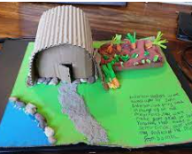
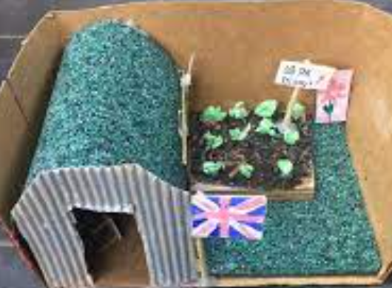

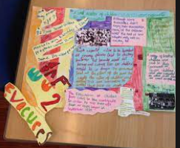
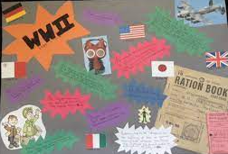

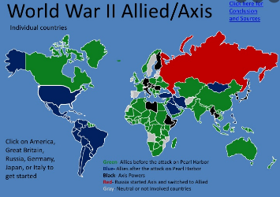
Or create your own idea as long as it is related to WWII.

