Year 6 2026-27
Curriculum Leaflet
Autumn Term One

Subject | We will be learning about
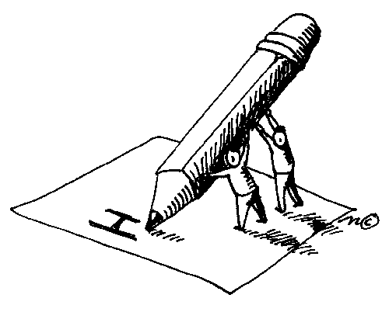  Writing | - Autobiographies, speech, War poetry, sonnets, dialogue and narratives with a moral.  - How to apply colons and semi-colons accurately  - How to experiment with vocabulary to enhance their articulacy  - How to use personification and metaphors
Reading  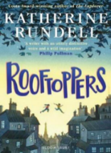 | - Our core text is Rooftoppers  - We will focus on summary, retrieval and understanding themes.  - We will also develop our skills when creating comparisons and personal responses.  - Our class read is Goodnight Mister Tom which focuses on the neglect, resilience and reality of the impact of war on children.
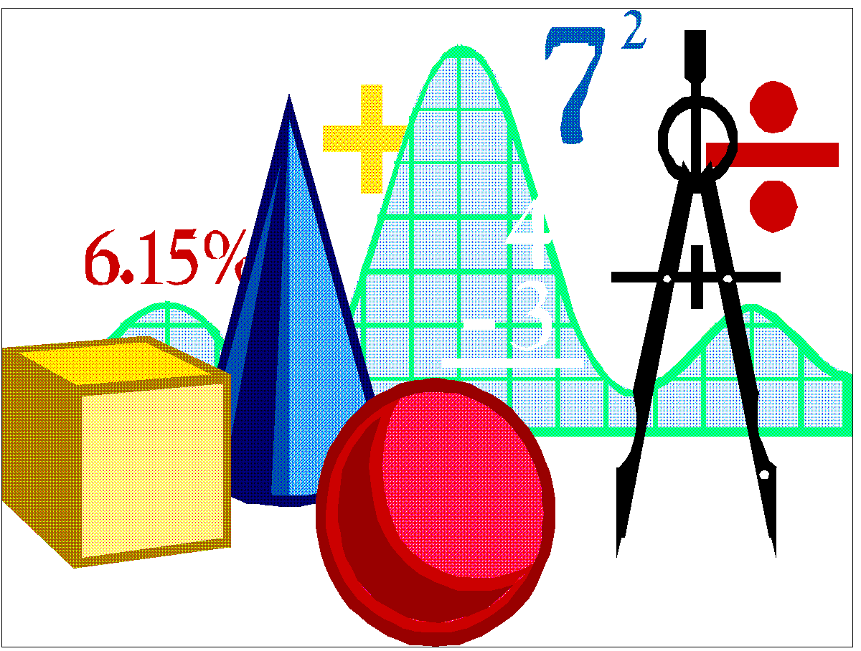  Maths | - place value and decimal numbers  - reading different scales and intervals  - applying the standard written methods for all 4 rules of number to solve problems  - negative numbers and differences  - 2d shapes and their correct names and properties  - Percentages of amounts
  Art | - Frida Kahlo (1907 – 1954)  - Pupils will create abstract forms using enlarged images and draw to scale.  - Pupils will also create portraits including how to draw features in proportion and include details.
Science   | - Pupils will learn how to associate the brightness of a lamp or the volume of a buzzer with the number and voltage of cells used in the circuit  - compare and give reasons for variations in how components function, including the brightness of bulbs, the loudness of buzzers and the on/off position of switches  - use recognised symbols when representing a simple circuit in a diagram
  Music | - Reading lyrics and understanding how the melody and tempo can enhance the meaning of a song.  - Pupils will learn and perform a sung version of the poem, ‘In Flander’s Field.’
PE  | - P.E. lessons will take place on Monday & Friday afternoons. Please ensure that your child wears their school jumper/cardigan with their PE kit. Children should wear navy shorts, leggings or joggers and a plain white t-shirt or polo shirt. They can come into school wearing their PE kit on these days.
  RE | - The comparisons and contrasts between Christianity and Islam.  - Pupils will consider the everyday practises of both religions and will consider what they do the same and what is different.  Year 6 will visit All Saints Church for a Harvest Service in October. The date will be shared with you once confirmed and you are all welcome to join us at the 10:00am service to listen to your children.
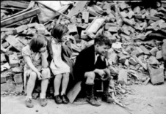  History | - Why World War II began  - The impact it had on Salford and our local area  - Developing their enquiry skills to further aid their learning and thinking skills as a historian.
PSHE  | - Our hopes and aspirations  - How to achieve our goals and support others in reaching theirs  - Those who can influence our decisions
  French | - Where I live – ou habites-tu?  - Spoken articulation  - Written accuracy

Home Learning | You can help me at home by…
Spellings | - Practising my weekly spellings with me and discuss vocabulary meanings.  Homework sheets will be handed out each Monday; sentence and associated vocabulary work to be handed in each Thursday.
Maths | - Practising my times tables, prime numbers and squared numbers with me.  - Accessing BBC Revise Wise and play games associated with the areas mentioned in our maths section.  - Ordering the CGP revision books when the form is handed out.
Reading | - Reading at least 4 times per week – although Y6 are older, it is still nice to listen to them read aloud sometimes. Check for fluency and accuracy as well as intonation and expression.  - Completing my reading record on BOOM Reader.  - Making sure that I change my book in the class library when I am ready to.
Homework Project | - Checking what the homework project is and when the deadline is.  - Making sure that I start my research for the project in plenty of time and that I make a start sooner rather than later.  - Making sure that I bring my project into school by the deadline.

